Fall, 1999

CLASSⅡ Information Technology Engineer Examination - Afternoon
Select questions to answer as described in the following chart:
Question Nos. | Q1, Q2 | Q3 to Q6 | Q7 to Q10 | Q11 to Q14 | Q15 to Q17
Question Selection | Compulsory | Select 2 of 4 | Select 1 of 4 | Select 1 of 4 | Select 1 of 3
Examination Time | 13:00 ~ 15:30 150 minutes
Notes:
C
1. Use an HB pencil.
If you need to change an answer, erase your previous answer completely and neatly. Wipe away any eraser fragments.
2. Mark your answers in accordance with the instructions below. Your test will not be graded if you fail to comply with the instructions. Do not mark or write on the answer sheet outside of the prescribed places.
COBOL
(1) Examinee Number
Write your examinee number in the space provided, and mark the appropriate space below each digit.
(2) Date of Birth
Fortran
Write your date of birth (in numbers) exactly as it is printed on your exam ticket, and mark the appropriate space below each digit.
(3) Question Selection
Mark the questions that you select to answer as follows: [SYMBOL]
(4) Answers
Assembler
Mark your answer as shown in the following How to Mark Your Answers
sample question.
Right Wrong

[Sample Question] Select the correct answer to insert in the from the choices provided.
The Fall Information Technology Engineer Examination is held in
a
Answer group: A. October B. November C. December
Since the correct answer is "A" (October), mark your answer sheet as follows:
a |  | [B.] | [C.]
3. Assembler specifications are provided as a reference at the end of this booklet. The information provided on page 69 and beyond, however, is only intended for use with Q17.
Do not open the exam book until instructed to do so. Inquiries about the exam questions will not be answered.

Q1 and Q2 are both compulsory. Answer both questions.

Q1. Examine the flow chart that follows and read the explanation below before answering the sub-question.

[Explanation of Flow Chart]
(1) This flow chart inserts the character string that is stored in Array B in a specified position in the character string stored in Array A.
(2) The size of Array A is stored in AMAX, the length of the character string is stored in AX, and the individual characters are stored in A[1], A[2], ..., A[AX].
(3) The length of the character string to be inserted is stored in BX, and the individual characters are stored in B[1], B[2], ..., B[BX].
(4) The position where the character string is to be inserted is stored in PX (1≤PX≤AMAX).
(5) If PX is greater than AX+1, a space is inserted at A[AX+1] ~ A[PX–1].
(6) Any text that overflows from Array A as a result of the insertion is discarded.
(7) The operation of the MIN function that is used in this flowchart is as follows:
MIN(X,Y): Returns X when X<Y; returns Y in all other cases.
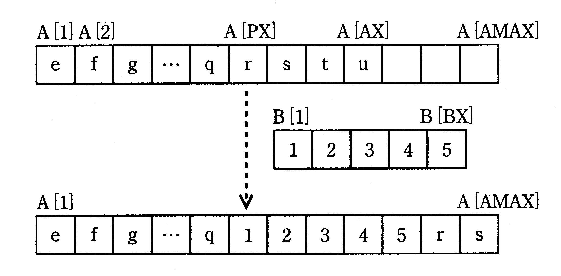
Example:
Before insertion

After insertion

[Flow Chart]

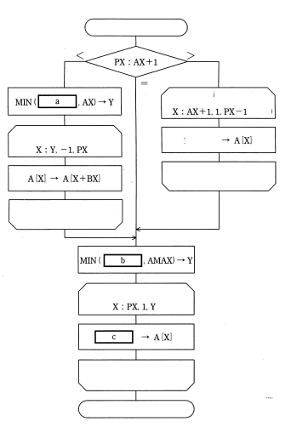
Start

Space insertion processing
(Note)

Move processing
Space

Space insertion
processing

Move processing

Character string
insertion processing
(Note)

Character string
insertion processing
Note: The specification of the loop
conditions is as follows:
variable name: initial value,
step, end value
End

Sub-question: Select the correct answers to
insert in the in the flow chart from the choices provided.

Answer group for a:
A. AMAX–BX B. AMAX–BX+1 C. AMAX–BX–1
D. AMAX–PX E. AMAX–PX+1 F. AMAX–PX–1

Answer group for b:
A. AX+BX B. AX+BX+1 C. AX+BX–1
D. PX+BX E. PX+BX+1 F. PX+BX–1

Answer group for c:
A. B[X+PX] B. B[X+PX+1] C. B[X+PX–1]
D. B[X–PX] E. B[X–PX+1] F. B[X–PX–1]

Ans: Đáp án a- A, b-A, c-E. Đầu bài yêu cầu chèn xâu B vào trong xâu A với các thông số sau:
+ Độ dài mảng A là AX, độ dài lớn nhất mảng A là AMAX, độ dài mảng B là BX, vị trí cần đặt vào là PX (1<=PX<=AMAX)
+ Khi chèn vào nếu PX>AX + 1 thì chèn các phần tử trắng vào từ AX+1 tới PX-1 và tất cả các phần tử vượt quá độ lớn mảng A thì bị bỏ đi.
Thuật toán chèn là:
\ Dịch chuyển các vị trí mảng A hoặc thêm vào các phần tử trắng cần thiết
+ Trường hợp PX = AX + 1 -> các phần tử mảng A không bị ảnh hưởng
+ Trường hợp PX > AX + 1 -> Thêm vào các phần tử trắng từ AX + 1 đến PX – 1
+ Trường hợp PX < AX + 1 -> Các phần tử của mảng A từ PX đến AX cần dịch chuyển đi BX vị trí, Do đó, ta xét theo chiều ngược lại, với AX + BX > AMAX thì dịch chuyển các phần tử từ PX đến AMAX – BX lên BX đơn vị, còn không thì dịch chuyển các phần tử từ PX đến AX -> xét phần tử Y = MIN(AMAX-BX, AX). (đáp án a-A)
\ Chèn các phần tử mảng B vào
+ Trường hợp AX + BX <= AMAX, các phần tử của B được chèn vào hết
+ Trường hợp AX + BX > AMAX, các phần tử của B chỉ được chèn cho hết AMAX -> xét phần tử Y = MIN(AX + BX, AMAX) (đáp án b-A)
Phần tử 1 của mảng B được chèn vị trí A[PX], phần tử 2 của mảng B được chèn vị trí A[PX + 1] -> mối quan hệ của phần tử B[j] với A[X] là X = j + PX -1 hay j = X – PX + 1 (đáp án c-E)

Q2. Examine the flow chart that follows and read the explanation below before answering the sub-questions.

[Explanation of Flow Chart]
This flow chart uses the arrays shown in Fig. 1 and Fig. 2 to calculate passenger fares for travel over a given distance. Fractions of a kilometer traveled are rounded up to the next integer. The array suffixes start from "1." The elements in Array D give distances, the elements in Array P are used in the fare calculation.
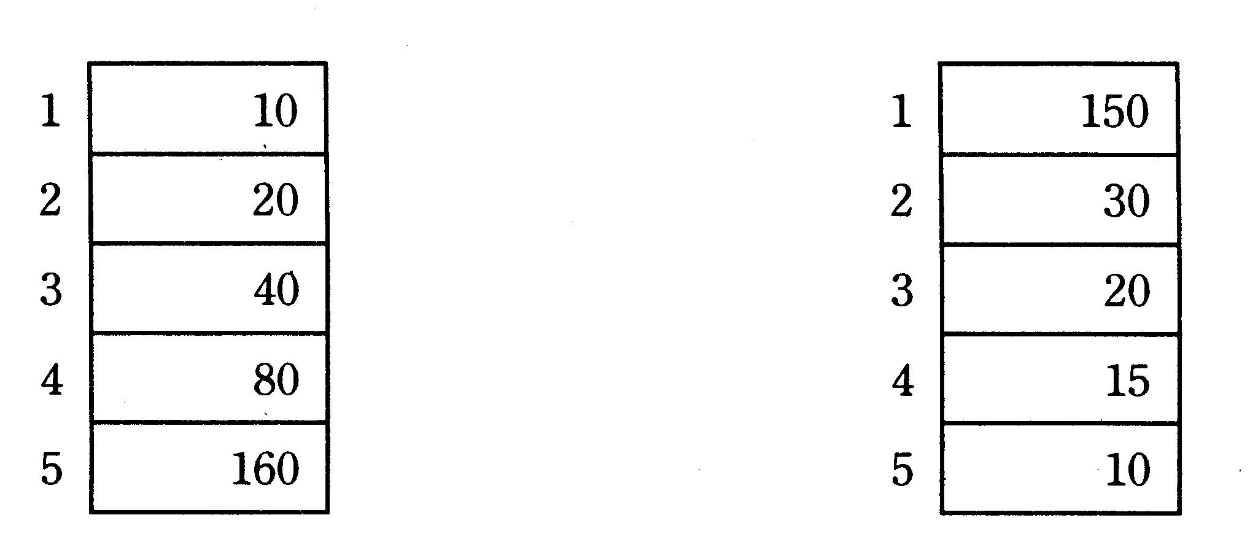

Fig. 1 Array D
Fig. 2 Array P

[Flow Chart]
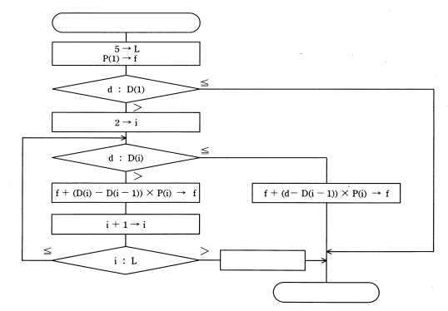
L: Upper limit on suffix
d: Input distance (unit: km)
f: Calculated fare (unit: yen)
Start

Error processing

End
Sub-question 1. What is the fare for a passenger who travels 35km? Select the correct answer from the choices provided.

Answer group:

A. 650 | B. 700 | C. 750
D. 850 | E. 1,450

Sub-question 2. Change Array P (Fig. 3) and the flow chart so that the fare is calculated by adding a fixed additional fare for each increment of additional distance traveled, as shown in the table below. (Do not change Array D.)

Table. Relationship between Increment of
Distance and Additional Fare
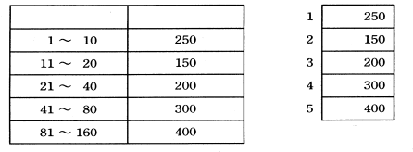

Increment of distance
(km)
Additional fare (yen)

Fig. 3 Array P

Select the correct answers to insert in the in the flow chart from the choices provided.

[Flow Chart after Changes]

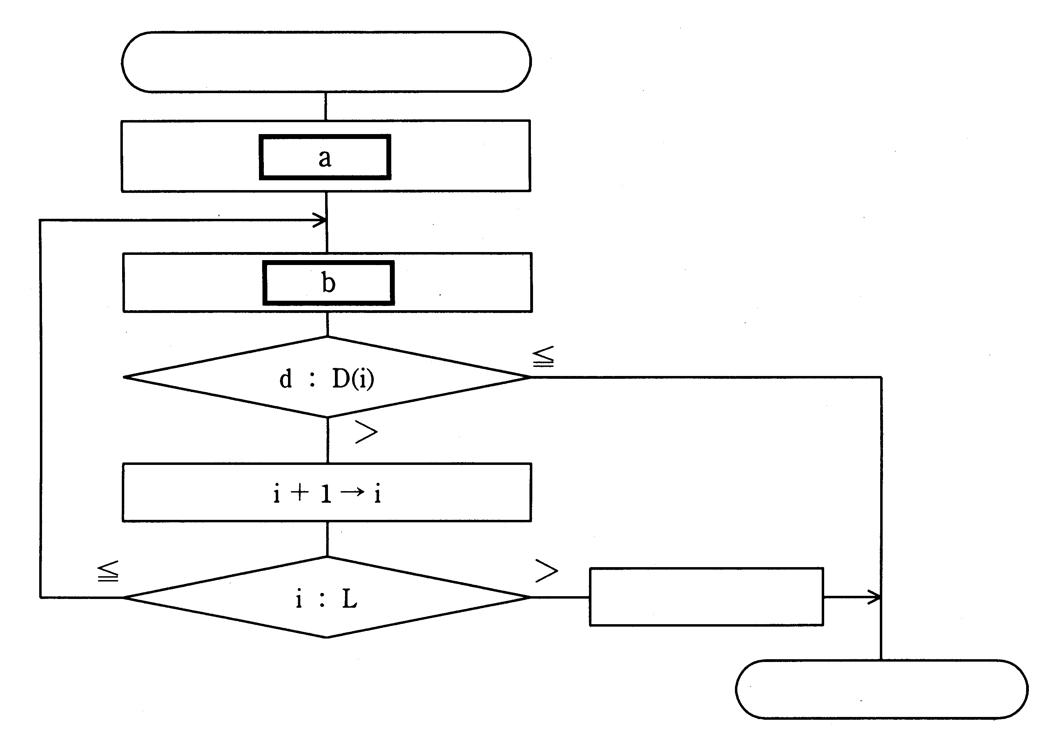
Start

Error processing

End

Answer group for a:

A. 0 → L  2 → i  0 → f | B. 0 → L  2 → i  P(i) → f | C. 5 → L  1 → i  0 → f | D. 5 → L  2 → i  0 → f | E. 5 → L  1 → i  P(i) → f

Answer group for b:
A. D(i) → f |  | B. P(i) → f
C. f + D(i) → f |  | D. f + P(i) → f
E. f + D(i – 1)×P(i) → f

Ans: Sub1 – C, Sub2- a-C, b-D . Thuật toán đầu tiên tính số tiền tương ứng với khoảng cách cụ thể đã cho với D(i) là quãng đường tương ứng, và P(i) là số tiền cần trả cho mỗi km bên D(i). Với Sub1 thì ta có d = 35km ứng với khoảng từ D(2) -> D(3). Số tiền phải trả = P[1] + P[2]* (D[2] – D[1]) + P[3] * (d – D[2]) = 150 + 30 * 10 + 20 * 15 = 150 + 300 + 300 = 750.
Thuật toán thứ 2 thì số tiền tương ứng được ứng theo các phần khoảng cách khác nhau. Nó sẽ so sánh tương ứng xem d nằm trong khoảng nào (D[i -1]->D[i]) và f=tổng P[j] với j = 1 tới i. Khởi tạo ban đầu, L = 5, i = 1 và f = 0 (Đáp án a-C). Sau đó f = P[i] + f vì với mỗi lần lặp thì f sẽ tăng lên P[i]. (Đáp án b-D)

Select two questions from Question 3 to Question 6, and mark which questions you have selected on your answer sheet. If you select three or more questions, only the first two questions will be graded.

Q3. Carefully read the explanation of the following program, the explanation of the pseudo-language description format, and the program, and then answer Sub-questions 1 and 2.

[Explanation of Program]
This program merges two product files into one product file. The program merges file A (Fig. 1) with file B (Fig. 2) to create file C (Fig. 3). Assume that there are no records in file A and file B that share the same product code.

Product codeProduct nameRecord 1150TowelRecord 2250CupRecord 3350Pen
Fig. 2 file B

Product codeProduct nameRecord 1100ToothbrushRecord 2200Rinse
Fig. 1 file A

Product codeProduct nameRecord 1100ToothbrushRecord 2150TowelRecord 3200RinseRecord 4250CupRecord 5350Pen
Fig. 3 file C

[Explanation of Artificial Language Description Format]

Format | Explanation
┌  Declaration block  └ | This area is where procedures, variables, names, types, etc., are declared.
○ | Declares names, types, etc., of procedures, variables, etc.
┌  Processing block  └ | This area is where processing is performed.
● variable ← expression | Assigns the value of an expression to a variable.
● procedure name (argument, …) | Calls a procedure.
conditional expression  Yes processing 1  No processing 2 | Executes processing 1 when the condition is true.  Executes processing 2 when the condition is false.
■ loop conditional expression  processing   | Repeatedly executes the processing while the condition is true.
 | Indicates a block of processing.
=, <, > | Comparators that are used in conditional expressions and loop conditional expressions.
{ } | Comments.

[Program]
○ Program name: File Merge
○ Integers: stsA, stsB, endf
○ Files: fileA, fileB, fileC {sequential access files}
Declaration block
- Records: rcdA, rcdB
- Procedures: Record input (file, record, status)
{This procedure reads one record from the file specified by "file", and stores the data in the area specified by "record". When a record is input, a "0" is stored in the variable specified by "status"; when no record is input, a "1" is stored in the variable specified by "status".}
○ Procedure: Record output (file, record)
{This procedure stores the contents of the area specified by "record" in the file specified by "file".}

● Record input (fileA, rcdA, stsA)
● Record input (fileB, rcdB, stsB)
● endf ← 0
■ endf = 0 {Repeat while endf = 0.}
stsA = 1
Yes stsB = 1
α
Yes  endf ← 1
Processing block
No  Record output (fileC, rcdB)
● Record input (fileB, rcdB, stsB)

No stsB = 1
Yes  Record output (fileC, rcdA)
● Record input (fileA, rcdA, stsA)
β
No rcdA product code < rcdB product code
Yes  Record output (fileC, rcdA)
● Record input (fileA, rcdA, stsA)
No  Record output (fileC, rcdB)
■  Record input (fileB, rcdB, stsB)

Sub-question 1. How many times will the "Yes" portion of the program (indicated by "α ⇒ ") be executed? Select the correct answer from the choices provided.

Answer group
A. 1 | B. 2 | C. 3 | D. 4 | E. 5

Sub-question 2. Select the correct answer to insert in the in the following description from the choices provided.

(1) Assume that the conditional expression indicated by "β ⇒" in the program was incorrectly as follows.
rcdA product code > rcdB product code
The contents of file C would then be a .
(2) Assume that, in the original program, the file shown in Fig. 4 was input as file A instead of the file shown in Fig. 1. The contents of file C would then be b .
Product codeProduct name200Rinse100Toothbrush
Fig. 4 file A

Answer group
A.
Product  code | Product  name
100 | Toothbrush
150 | Towel
200 | Rinse
250 | Cup
350 | Pen

B.
Product  code | Product  name
100 | Toothbrush
150 | Towel
200 | Rinse
350 | Pen
250 | Cup

C.
Product  code | Product  name
100 | Toothbrush
200 | Rinse
150 | Towel
350 | Pen
250 | Cup

D.
Product  code | Product  name
150 | Towel
100 | Toothbrush
200 | Rinse
350 | Pen
250 | Cup

E.
Product  code | Product  name
150 | Towel
200 | Rinse
100 | Toothbrush
250 | Cup
350 | Pen

F.
Product  code | Product  name
150 | Towel
250 | Cup
350 | Pen
100 | Toothbrush
200 | Rinse

G.
Product  code | Product  name
200 | Rinse
150 | Towel
250 | Cup
350 | Pen
100 | Toothbrush

H.
Product  code | Product  name
350 | Pen
250 | Cup
200 | Rinse
150 | Towel
100 | Toothbrush

Ans: Sub1 – C, Sub2 – a – F, b – E. Đề bài yêu cầu viết giả mã cho chương trình ghép 2 file A,B thành 1 file C với giả sử không có 2 record giống nhau về trường product code trên 2 file. Theo thuật toán trên, phần điều kiện yes sẽ được thực hiện 3 lần
rcdA stsA rcdB stsB C
1 100 0 150 0 (100 < 150 -> doc A)
2 200 0 150 0 (200>150->doc B)
3 200 0 250 0 (200<250->doc A)
4 xxx 1 250 0 (doc B)
5 xxx 1 350 0 (docB)
6 xxx 1 xxx 1 -> stop; endf = 1
Vậy điều kiện stsA = 1 sẽ được thực hiện 3 lần.(Đáp án Sub1 – C)

Nếu điều kiện là rcdA product code > rcdB product code thì ta có file C sẽ được ghi như sau:
rcdA stsA rcdB stsB C
1 100 0 150 0 (100 < 150 -> doc B) (150)
2 100 0 250 0 (100 < 250->doc B) (250)
3 100 0 350 0 (100<350->doc B) (350)
4 100 0 xxx 1 (doc A ) (100)
5 200 0 xxx 1 (doc A) (200)
6 xxx 1 xxx 1 -> stop; endf = 1
Đáp án Sub2 –a- F.
Với điều kiện thay đổi đầu vào, ta có file C sẽ được ghi như sau:
rcdA stsA rcdB stsB C
1 200 0 150 0 (200 > 150 -> doc B) (150)
2 200 0 250 0 (200 < 250->doc A) (200)
3 100 0 250 0 (100<250->doc A) (100)
4 xxx 1 250 0 (doc B ) (250)
5 xxx 1 350 1 (doc B) (350)
6 xxx 1 xxx 1 -> stop; endf = 1
Đáp án Sub2-b-E

Q4. Carefully read the following explanation of database commitment control, and then answer the sub-question.

In a centralized data base, consistency of the data is maintained through commitment control, which determines whether to perform all or none of the processing associated with a transaction. This prevents partial execution of the processing (Fig. 1). In the following diagram, m and n represent data, m' and n' represent the respective values after being updated, and parentheses indicate that the updating of the data values has not yet been finalized.
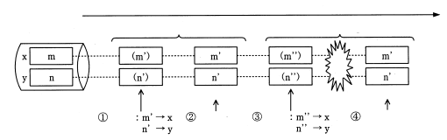
Time
Transaction 1
Transaction 2
Data base
<Finalization of update>
Fault
<Cancellation of update>
Update
Commitment
Update
Rollback
Fig. 1Centralized Data Base Update

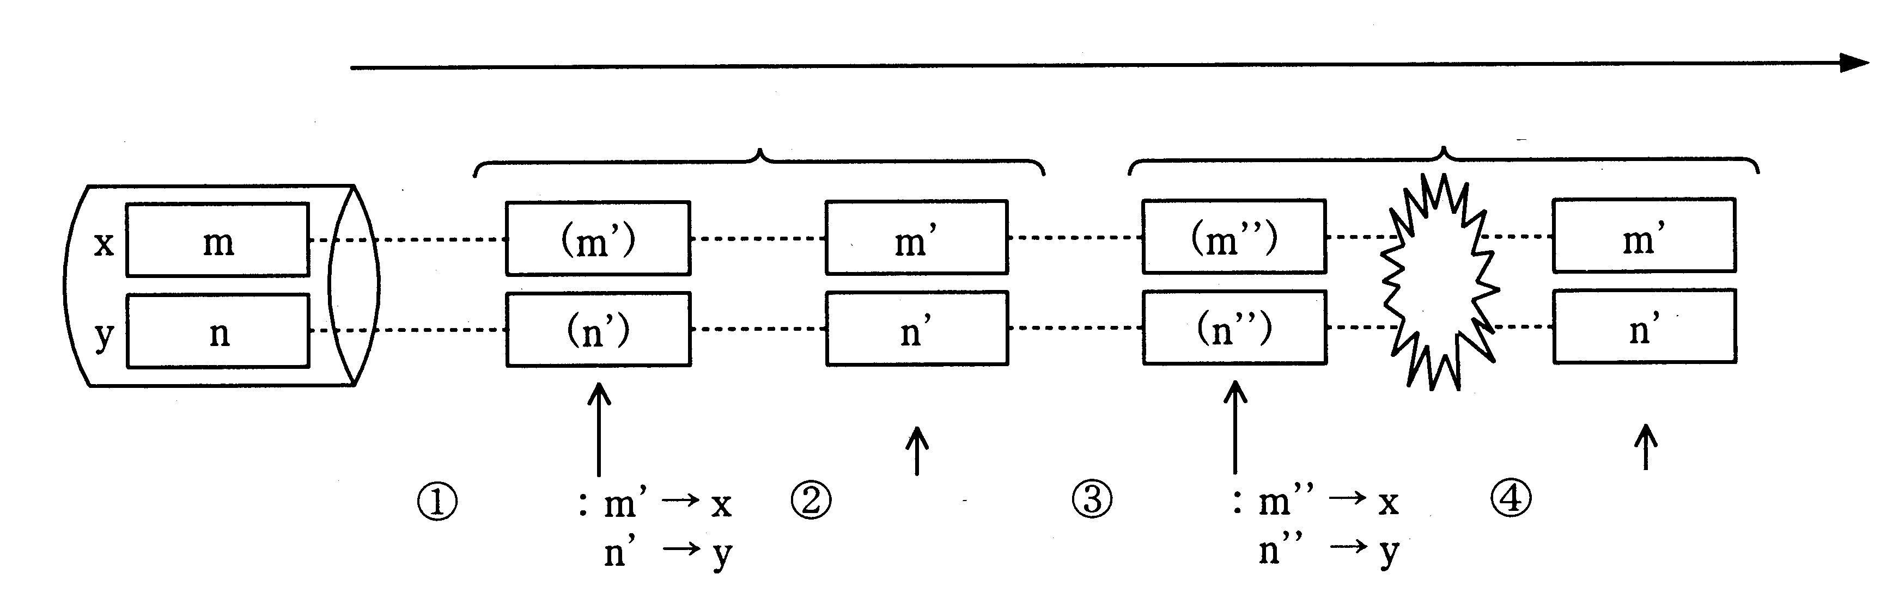

In a distributed data base, the processing for one transaction from the main site (the request originator) updates the data bases at multiple sites. This gives rise to the following problem: If commitment processing is performed for each of the data bases at site A and site B in response to a commitment request form the main site (② in Fig. 2), but the processing ends normally at site A and ends abnormally at site B, the data at the two sites will no longer be in agreement as a result of the update processing.
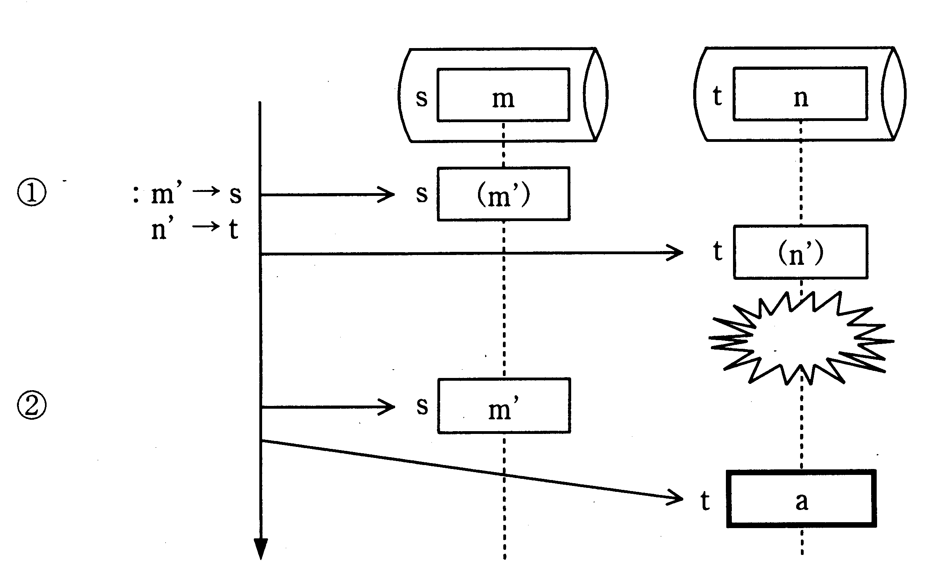
Main site
Update
Time
Site A
Fault
<Cancellation of update>
<Finalization of update>
Commitment
Site B
Fig. 2Distributed Data Base Update 1
Rollback after recovering

To address this problem, consider an arrangement in which each site does not finalize transaction processing immediately. Instead, each site establishes an intermediate state in which commitment and rollback are still both possible, and then executes finalization processing later. (Fig. 3) This is called "two-phase commitment control."
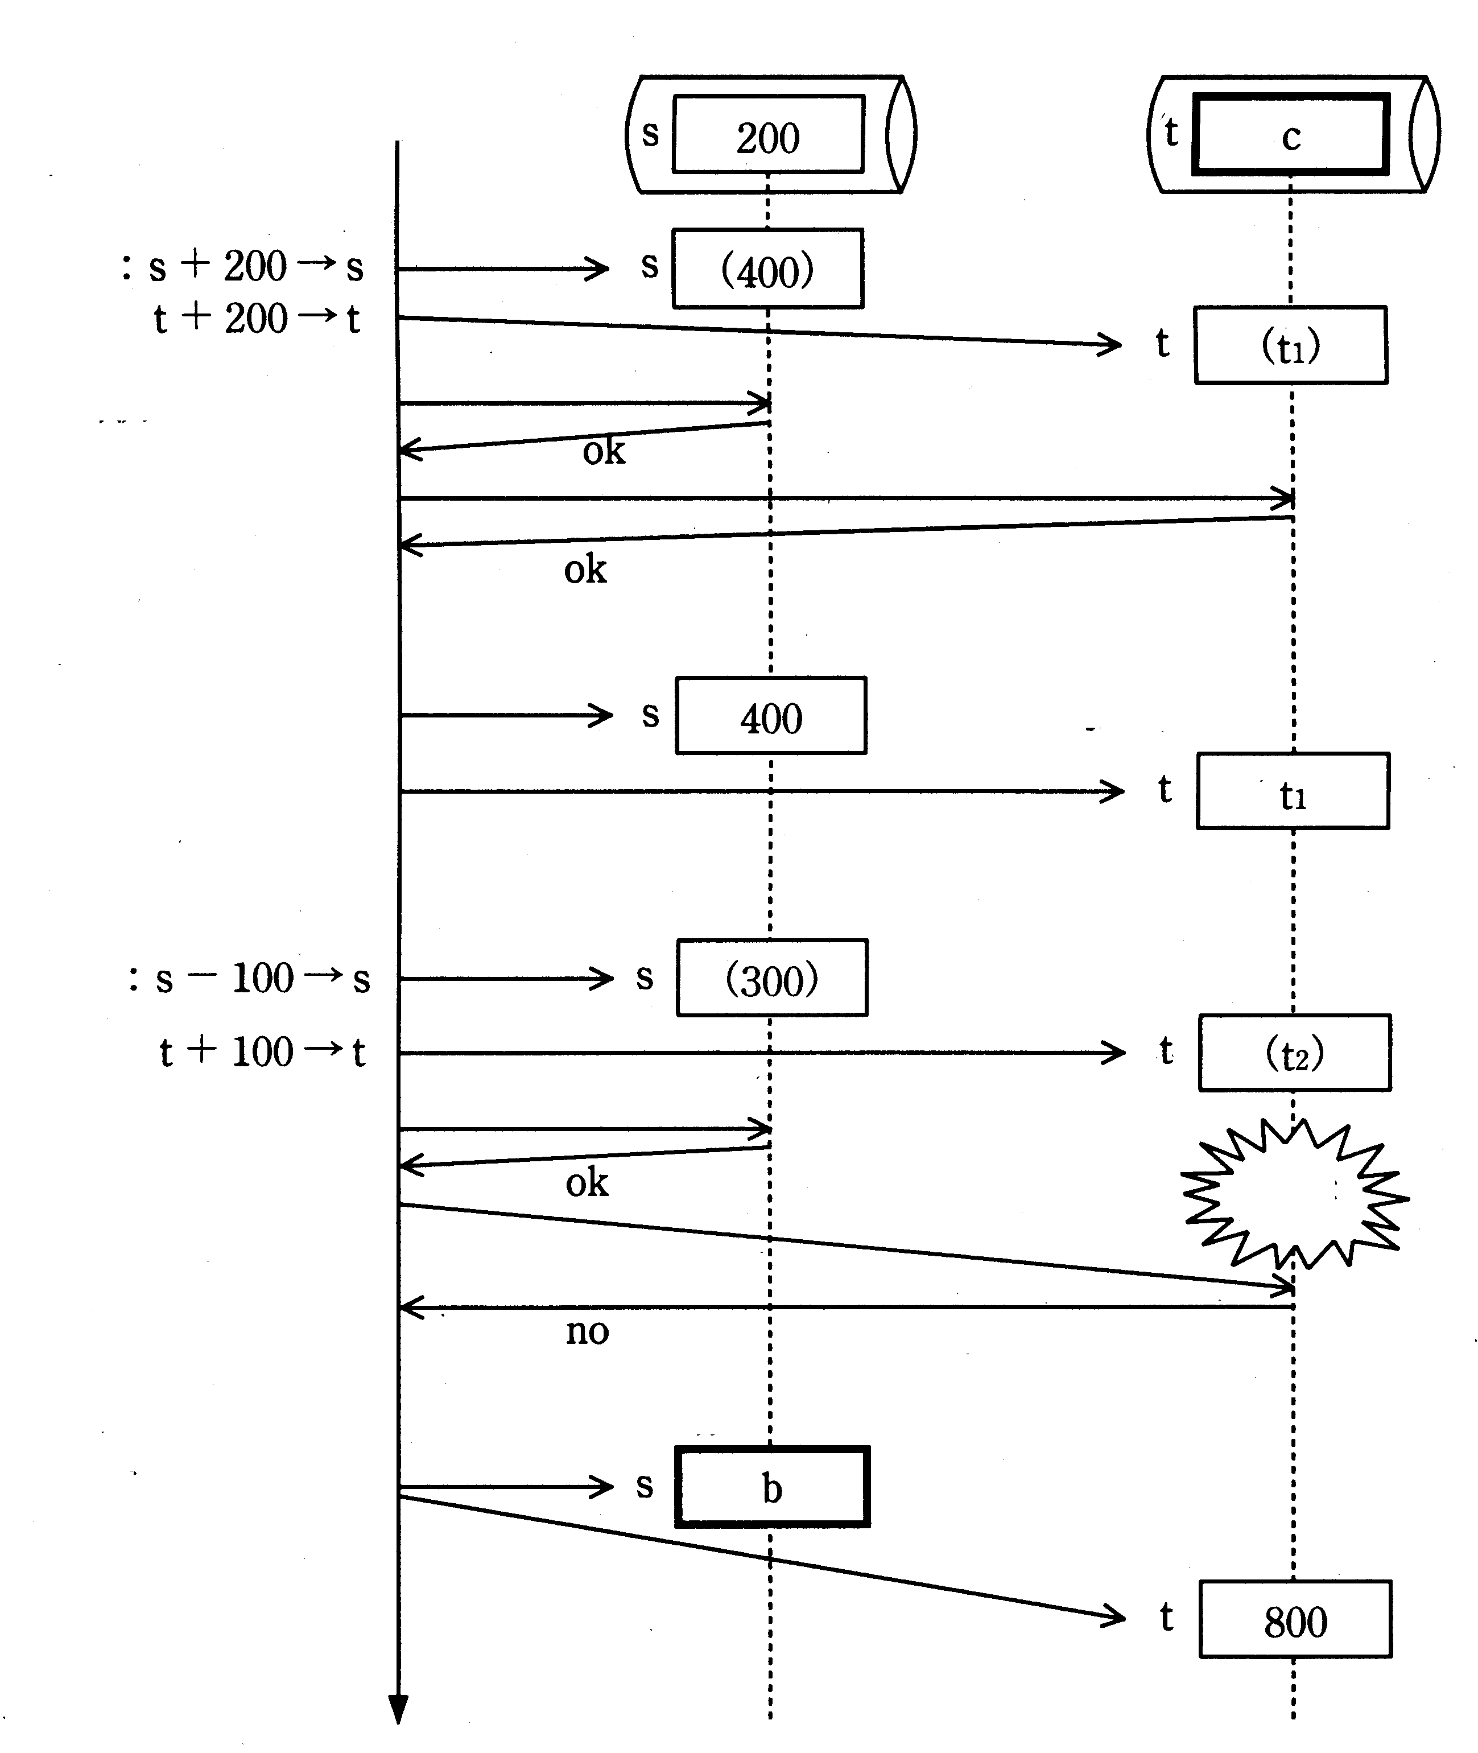
Main site
Update
Intermediate state
confirmation
Commitment
<Finalization of update>
<Finalization of update>
Site B
Site A
Time
Rollback
Intermediate state confirmation
Update
Fault
<Cancellation of update>
<Cancellation of update>
"ok" and "no" in this
diagram indicate the
success and failure,
respectively, of an
update.
Fig. 3Distributed Data Base Update 2

Sub-question. Select the correct answers to insert in the in Figs. 2 and 3 from the choices provided.

Answer group for a:
A. n | B. (n) | C. n’ | D. (n’) | E. n”

Answer group for b and c:
A. 200 | B. 300 | C. 400 | D. 500 | E. 600
F. 700 | G. 800 | H. 900

Ans: Đáp án a-A, b-C, c-E. Về phần a, ta thấy khi xảy ra lỗi thì DB sẽ được rollback lại giá trị cũ trước khi xảy ra lỗi, a ở đây là n (đáp án a-A). Còn phần b, thì giá trị đó sẽ là giá trị s của transaction trước = 400 (đáp án b-C). Tương tự, giá trị khi rollback sẽ là giá trị t1, và t1 ở đây = t + 200 -> t = 600( đáp án c-E).

Q5. Carefully read the following explanation of parallel processing of a program, and then answer the sub-question.

Consider a program that processes image data consisting of 600 lines, with 800 dots per line. This program processes the image in units of lines, with the result of processing for one line having no effect on the processing of any of the other lines. The overall time needed to execute can be reduced by dividing the task of processing each of these 600 mutually independent lines among multiple computers and processing the lines in parallel. System X is a single computer with a processor with 200MFLOPS processing capability, memory, and disk drive. System Y consists of four computers with the same processing capability as system X, all running in parallel. As shown in Fig. 1, each of the four computers has its own processor and memory, but all four share a single disk drive.

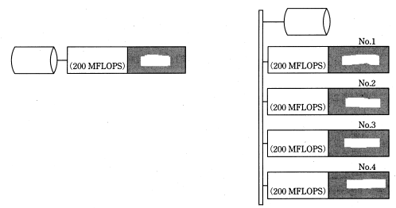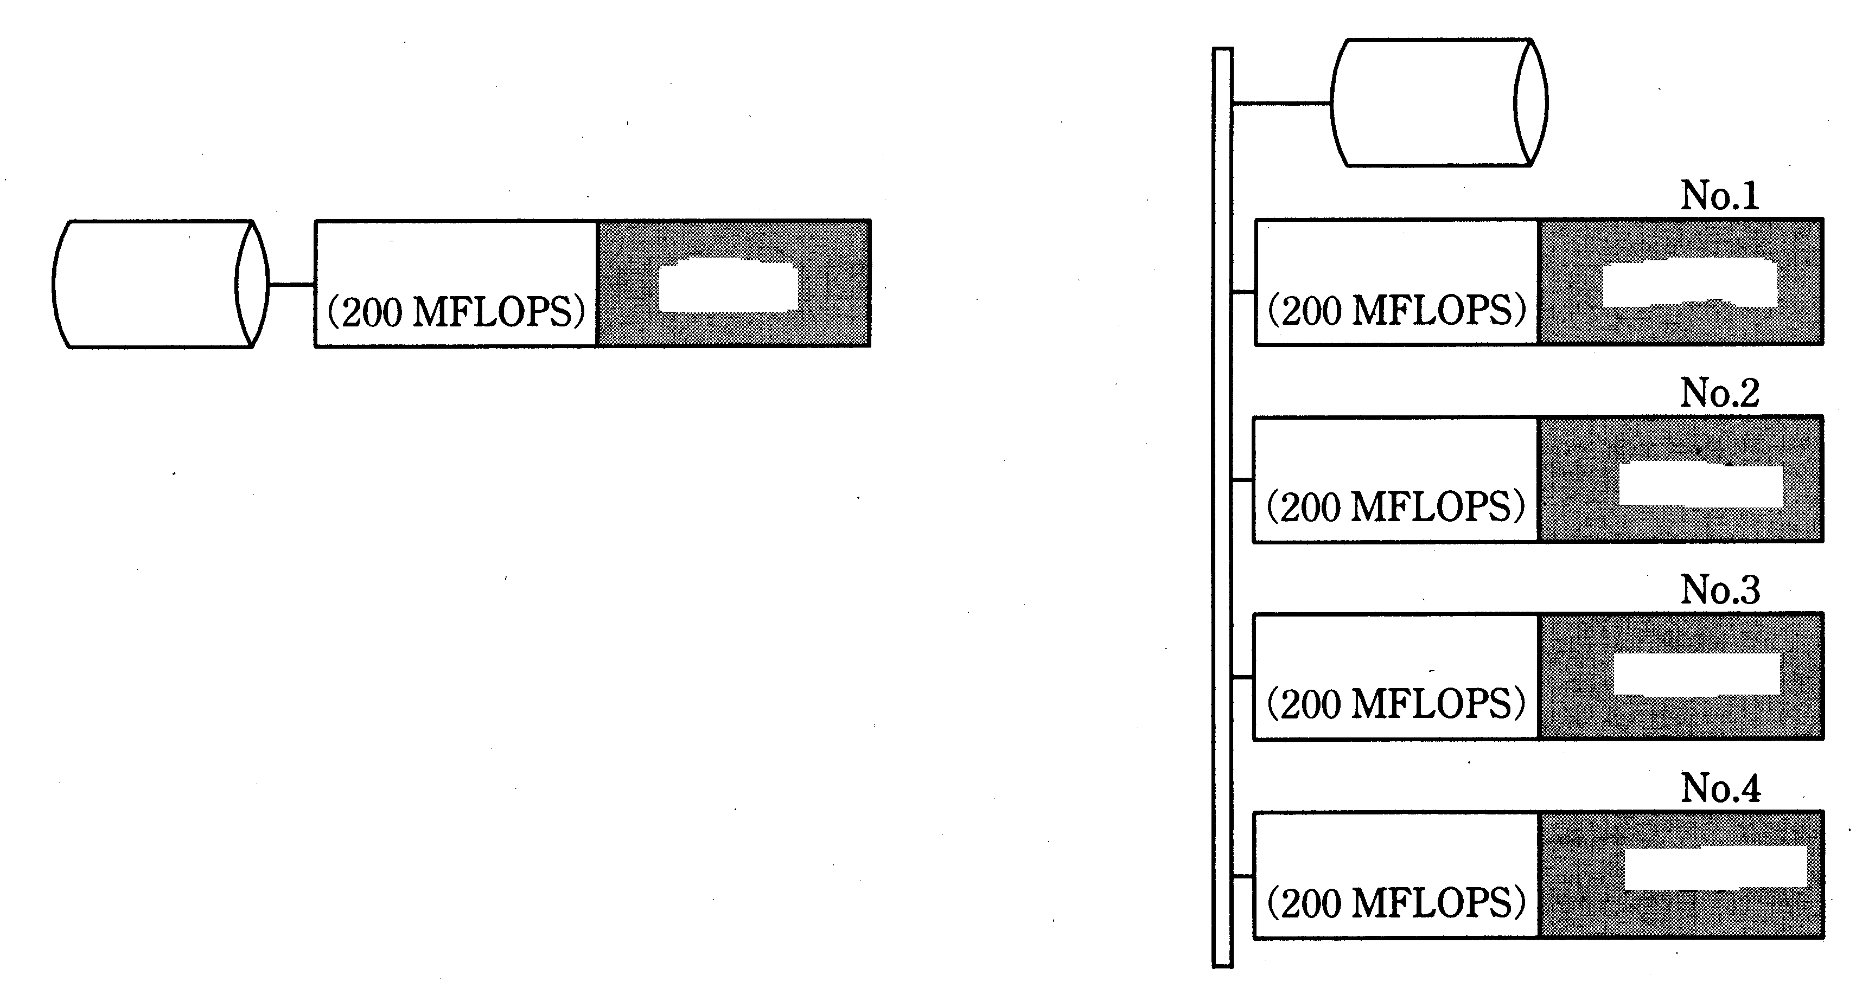
Disk
Processor
Memory
Bus
Shared
disk
Processor
Parallel Computer System Y
Processor
Processor
Processor
Memory
Fig. 1 System Configuration

Memory
Memory

System X

Memory

Sub-question. Select the correct answer to insert in the in the following description from the choices provided.

The program consists of three parts: ① an image data reading section, ② the one-line computation section, ③ a result output section (Fig. 2). ① requires 40 ms to execute. ③ requires 120ms to execute. ② requires execution time equivalent to 400,000 floating point operations. The computation section needs to be executed for 600 lines in order to process the image. Running the program on system X will require a ms to execute.

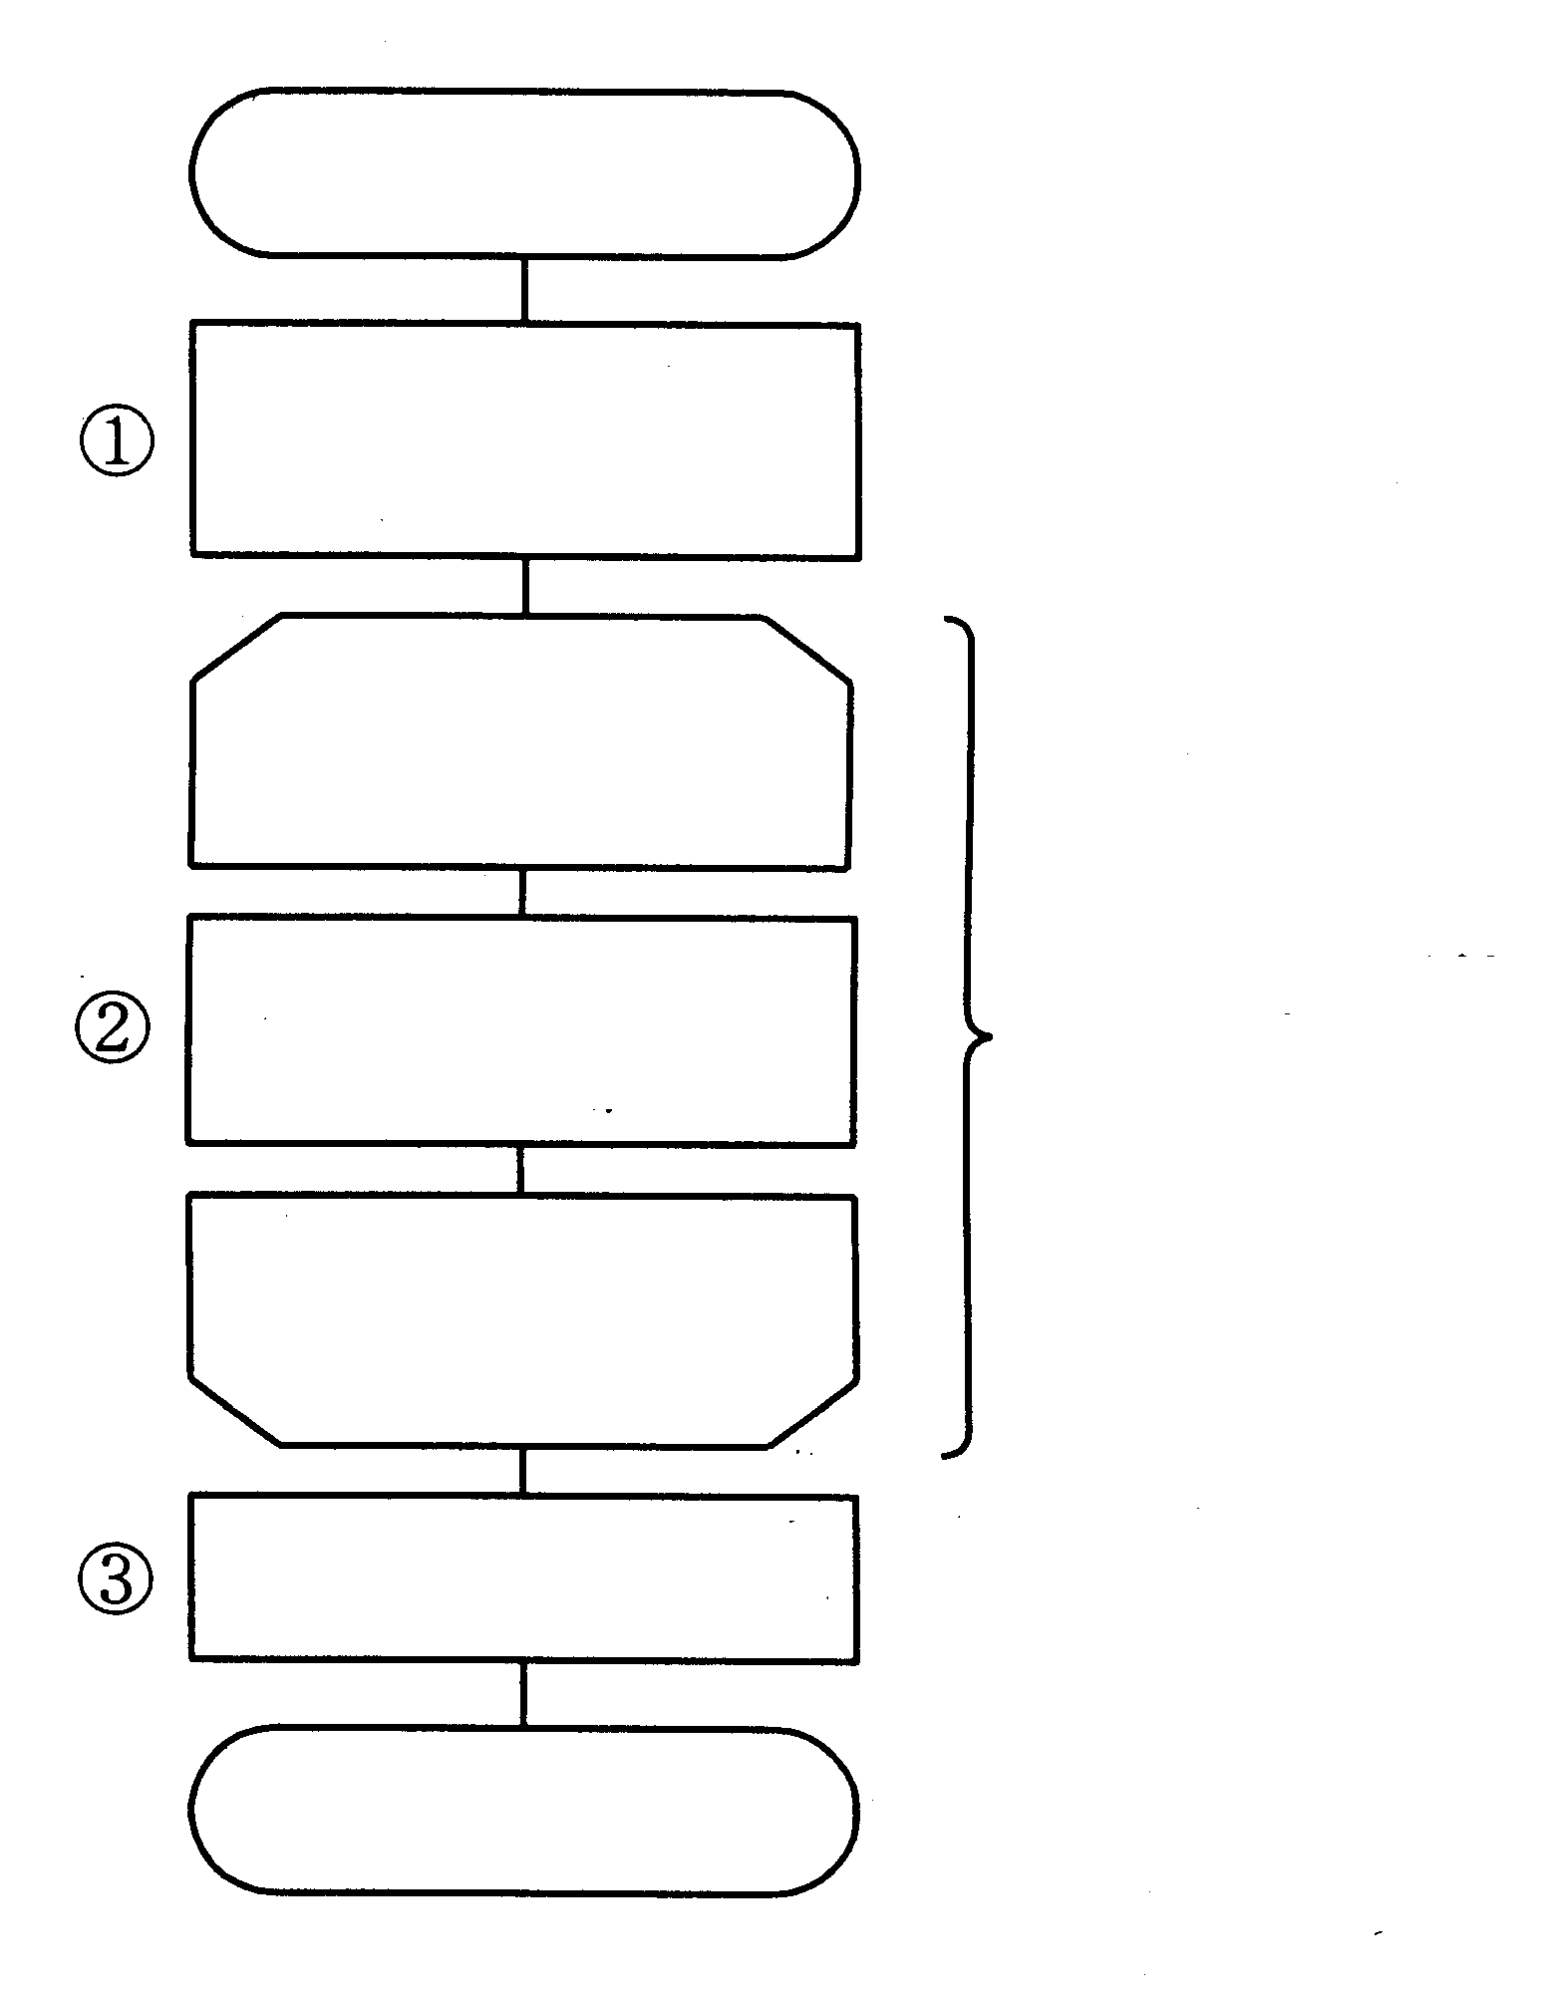
Start

Image data
reading section

Image processing
One-line
computation section
Repeat 600 times
(can be executed in parallel)

Image processing
Result output section

End
Fig. 2 Processing Procedure

If we execute the same program on system Y, sections ① and ③ cannot be performed in parallel, so they will be performed by computer No. 1. Section ②, which needs to be executed 600 times, can be processed in parallel since the processing for each of the 600 lines is independent of all the other lines. Therefore, this processing can be divided equally among the four computers. The time needed by computer 1 to exchange data with the other three computers (the communications time) is 150ms to distribute the data to all of the computers, and 150ms to collect the results from all of the computers. Running the program on system Y will require b ms to execute.
It is possible that if the amount of arithmetic operations that need to be performed in
section ② is small, the communications time becomes long on a comparative basis, so that parallel processing actually requires more time to execute. Converting the processing in
section ② to floating point operations, if the number of floating point operations is fewer than
c operations, running the program on system Y will actually take longer than running the program on system X.
Answer group for a and b:
A. 300 | B. 340 | C. 460 | D. 610 | E. 760
F. 1,200 | G. 1,320 | H. 1,360
Answer group for c:
A. 5 | B. 10 | C. 13 | D. 30 | E. 6,000
F. 8,000

Ans: Đáp án a-H, b-E, c-C. 1 giây thực hiện được 200 triệu lệnh, thực hiện 400000 lệnh trong thời gian là 400000/ 200000000 = 4/2000 = 2ms. Thời gian thực hiện ở hệ thống X sẽ là 40 + 120 + 2*600 = 1200 + 160 = 1360 ms (Đáp án a-H). Do hệ thống Y chạy song song và các dòng được phân bố đều trên các máy nên số lượng dòng mỗi máy thực hiện là 600/4 = 150 dòng. Như vậy thời gian thực hiện in các dòng trên mỗi máy là 150 * 2 = 300 ms. Thời gian thực hiện trên hệ thống X = thời gian thực hiện công việc 1 + thời gian thực hiện công việc 3 + thời gian công việc 2 trên mỗi máy + thời gian phân phối và tập hợp dữ liệu = 40 + 120 + 300 + 150 + 150 = 760 ms (Đáp án b-E). Thời gian tương ứng với số câu lệnh của phần 2 của hệ thống X là y * 600 (ms)+ 160 (ms), còn với hệ thống Y là y * 150 + 460 (ms). Thời gian trên hệ thống X nhỏ hơn thời gian trên hệ thống Y khi y * 600 + 460 > y * 150 + 160 -> 450 * y < 300(ms) -> y < 2/3 (ms) -> số lệnh thực hiện = 400000 /2 * 2/3 = 400000/3 ~ 13 vạn lệnh (Đáp án c-C)

Q6. Carefully read the following explanation of inventory management, and then answer Sub-questions 1 and 2.

The plant where Mr. Y works recently decided to revamp its inventory management systems, which previously depended on the experience and hunches of the manager in charge of inventory. Mr. Y has been asked for his recommendations concerning the raw materials ordering system.

Sub-question 1. There are 100 different raw materials used at the plant where Mr. Y works. Mr. Y decided to select the most vital items and propose a review of inventory management for those items. After studying various documents, it became clear that the best approach would be to closely manage (as vital items) those materials for which the plant's annual expenditures (unit cost of the raw material x amount consumed yearly) were high, while expending little on inventory management for those materials for which annual expenditures were low. After researching the annual expenditures for each raw material, Mr. Y produced the following table.

No. | Item code | Unit cost | Annual consumption | Annual expenditure
1 | AA01 | 30 | 56,380 | 1,691,400
2 | AA07 | 200 | 1,500 | 300,000
3 | AC01 | 1,500 | 23,400 | 35,100,000
… | … | … | … | …
100 | ZQ80 | 10 | 2,875 | 28,750
Total annual expenditure |  |  |  | 231,730,960

Next, in order to select from the table as vital items those materials that accounted for the largest percentage of annual expenditures, Mr. Y analyzed the data according to the following procedure:

① He sorted all of the materials by annual expenditure, starting from the highest.
② He determined the cumulative annual expenditure for the list, position by position, starting from the top.
③ He drew a bar graph with the position of each material on the x axis, and the annual expenditure on the y axis.
④ He plotted a graph, indicating the cumulative annual expenditure from position to position.

From the choices provided, select the correct answer for the name of this type of chart or graph.

Answer group
A. Arrow diagram | B. Gantt chart | C. Control chart
D. Pareto diagram | E. Portfolio graph
Sub-question 2. Typical inventory management systems include the "periodic reordering system" and the "fixed-order quantity system." In order to consider which of these systems might be best suited for the list of vital items he created in Sub-question 1, Mr. Y summarized the characteristics of each system. From the choices provided, select the correct answers to be inserted in the in the description below.

In order to select an ordering method, it is necessary to consider numerous factors, including the unit cost of the raw materials, the amount of consumption of raw materials in a given time, the size of fluctuations in consumption and the ease with which such fluctuations can be forecast, the length of the procurement interval (the time from when a material is ordered until it is accepted into inventory), costs associated with ordering (such as the transport costs and administrative costs incurred for one order), and the cost of maintaining inventory.
Because the "periodic reordering system" requires determining a regular interval for ordering based on the raw material procurement time, forecasting the consumption of the raw material over the period following each regular interval for ordering, and then determining a on
the basis of that information, it becomes possible to manage inventory very closely. This method carries little risk of running out of material even when there are large fluctuations in consumption. This method is effective if there are large changes in demand in the market for a product, resulting in frequent changes to the production plan. This method is also effective for managing inventories of raw materials that carry a high unit cost.
The "fixed-order quantity system" orders quantities (predetermined on the basis of the procurement interval) of materials that have fallen to b . Compared to the "periodic
reordering system," this method is simpler. However, there is a danger of running out of a material that undergoes a large fluctuation in consumption. This method is suitable for management of materials when there is product demand and the raw material procurement interval are stable, and when it is possible to accurately know the current inventory level at any time.

Answer group
A. the safe inventory level | B. 50% of the safe inventory level | C. the ordering time
D. the ordering point | E. the ordering quantity | F. the average inventory level
Ans: Đáp án Sub1 – D, Sub 2 – a – E, b – D. Việc sử dụng biểu đồ dạng tổng tích lũy của các item có giá trị từ cao đến thấp là sử dụng lược đồ Parero (Đáp án Sub1 – D). Phần 2 hỏi về hệ thống đặt hàng định kỳ và hệ thống đặt hàng số lượng cố định. Câu a là E, số lượng đặt hàng. Còn câu b là D, điểm đặt hàng.

Select one question from Question 7 to Question 10, and mark which question you have selected on your answer sheet.
If you select two or more questions, only the first question will be graded.

Q7. Carefully read the explanation of the following C program, and then answer the sub-question.
C

[Explanation of Program]
This program orders and outputs in ascending order the array "Stu" in the structure "STUDENT", using "Height" as the key.
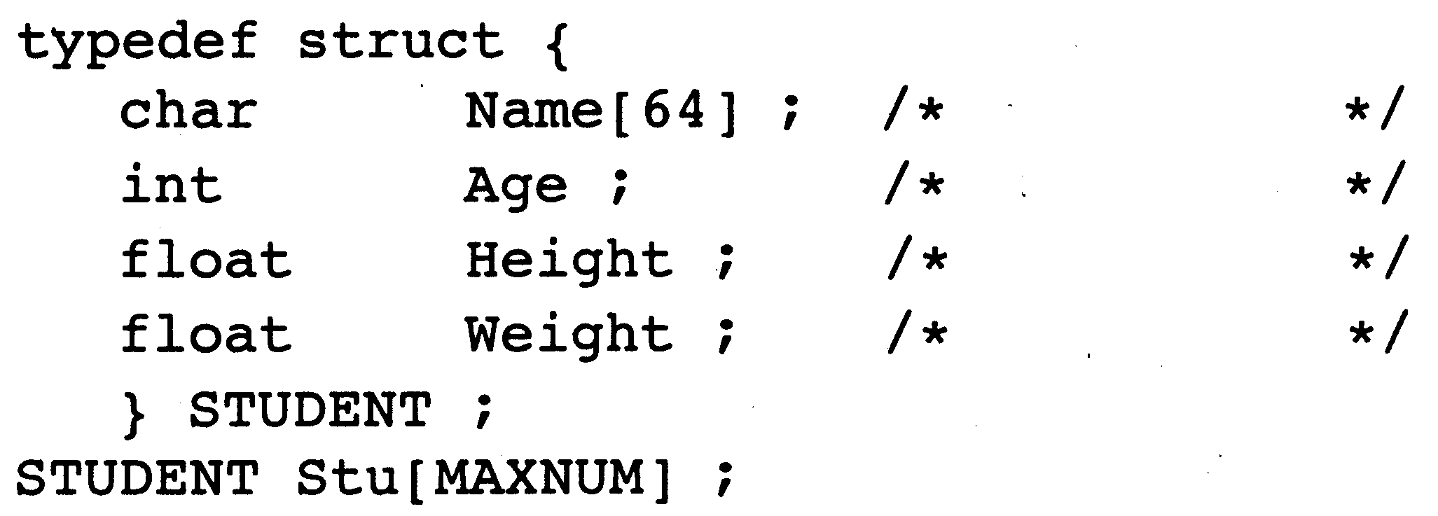
Name
Age
Height
Weight

The program creates a binary tree that indicates the order without sorting the array data. The following array variables are defined to represent the binary tree.
Fig. 1 illustrates the case where the elements are arranged in ascending order, with the element numbers in the sequence 3, 1, 0, 5, 2, 4. Fig. 2 shows the contents of the arrays "Lower" and "Upper". The value "–1" indicates that there is no element connected next.
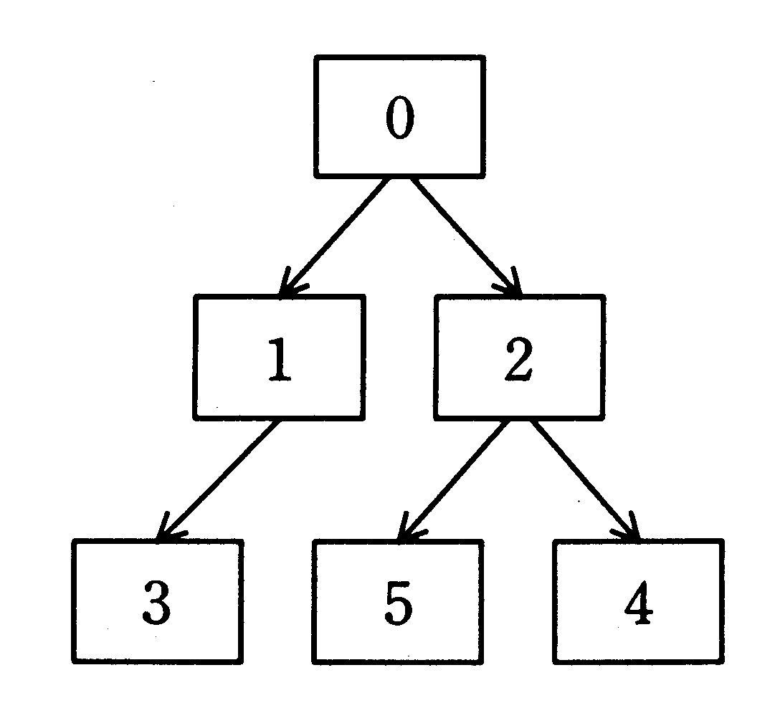
Element No. | Lower | Upper
0 | 1 | 2
1 | 3 | –1
2 | 5 | 4
3 | –1 | –1
4 | –1 | –1
5 | –1 | –1

Root

Fig. 1 Example of the Element
Connection Status
Fig. 2 Contents of Arrays Representing
the Binary Tree in Fig. 1

Initially, the elements are connected on the "Upper" side in the order in which they appeared in the definition of the structure array "Stu", creating the binary tree shown in Fig. 3.
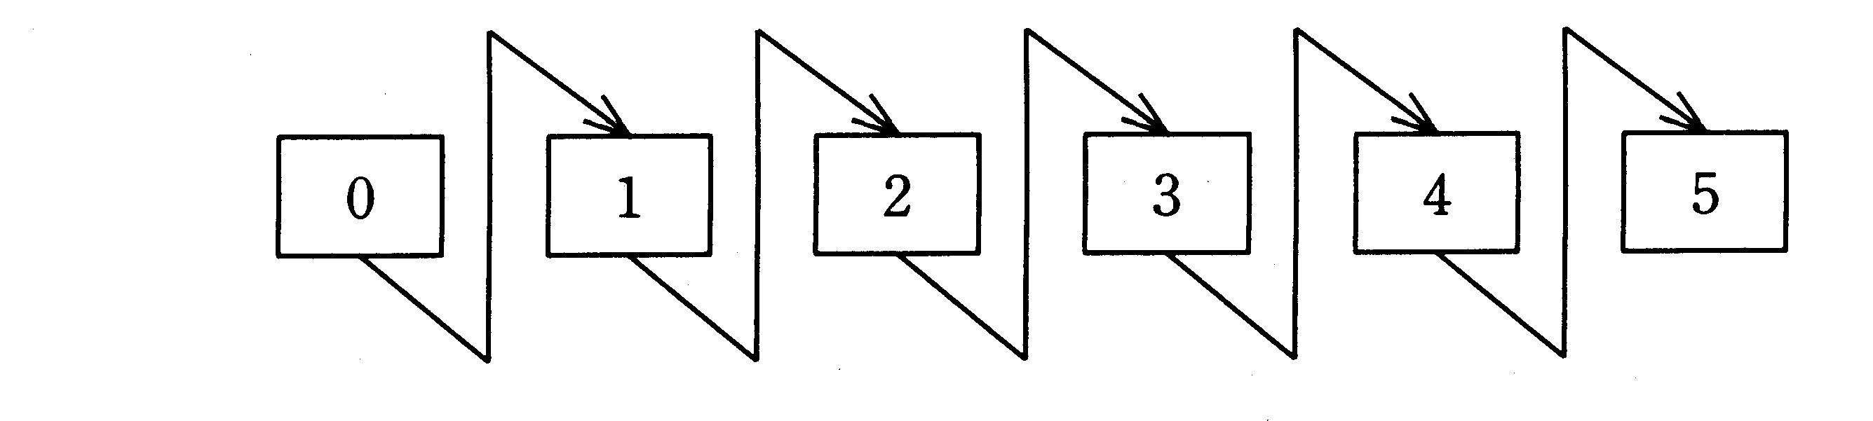
Root
Root

C
Fig. 3 Connection Status Prior to Sorting

Next, the program calls the recursive function "BinTreeSort" and sorts the elements in the binary tree according to height in ascending order. The parameter is the element number of the root. The prototype for the function "BinTreeSort" is as follows:
Lastly, the program calls the recursive function "DisplayData" and outputs the contents of the structure array in ascending order according to height, following the binary tree. The parameter is the element number of the root. The prototype for the function "DisplayData" is as follows:

[Program]
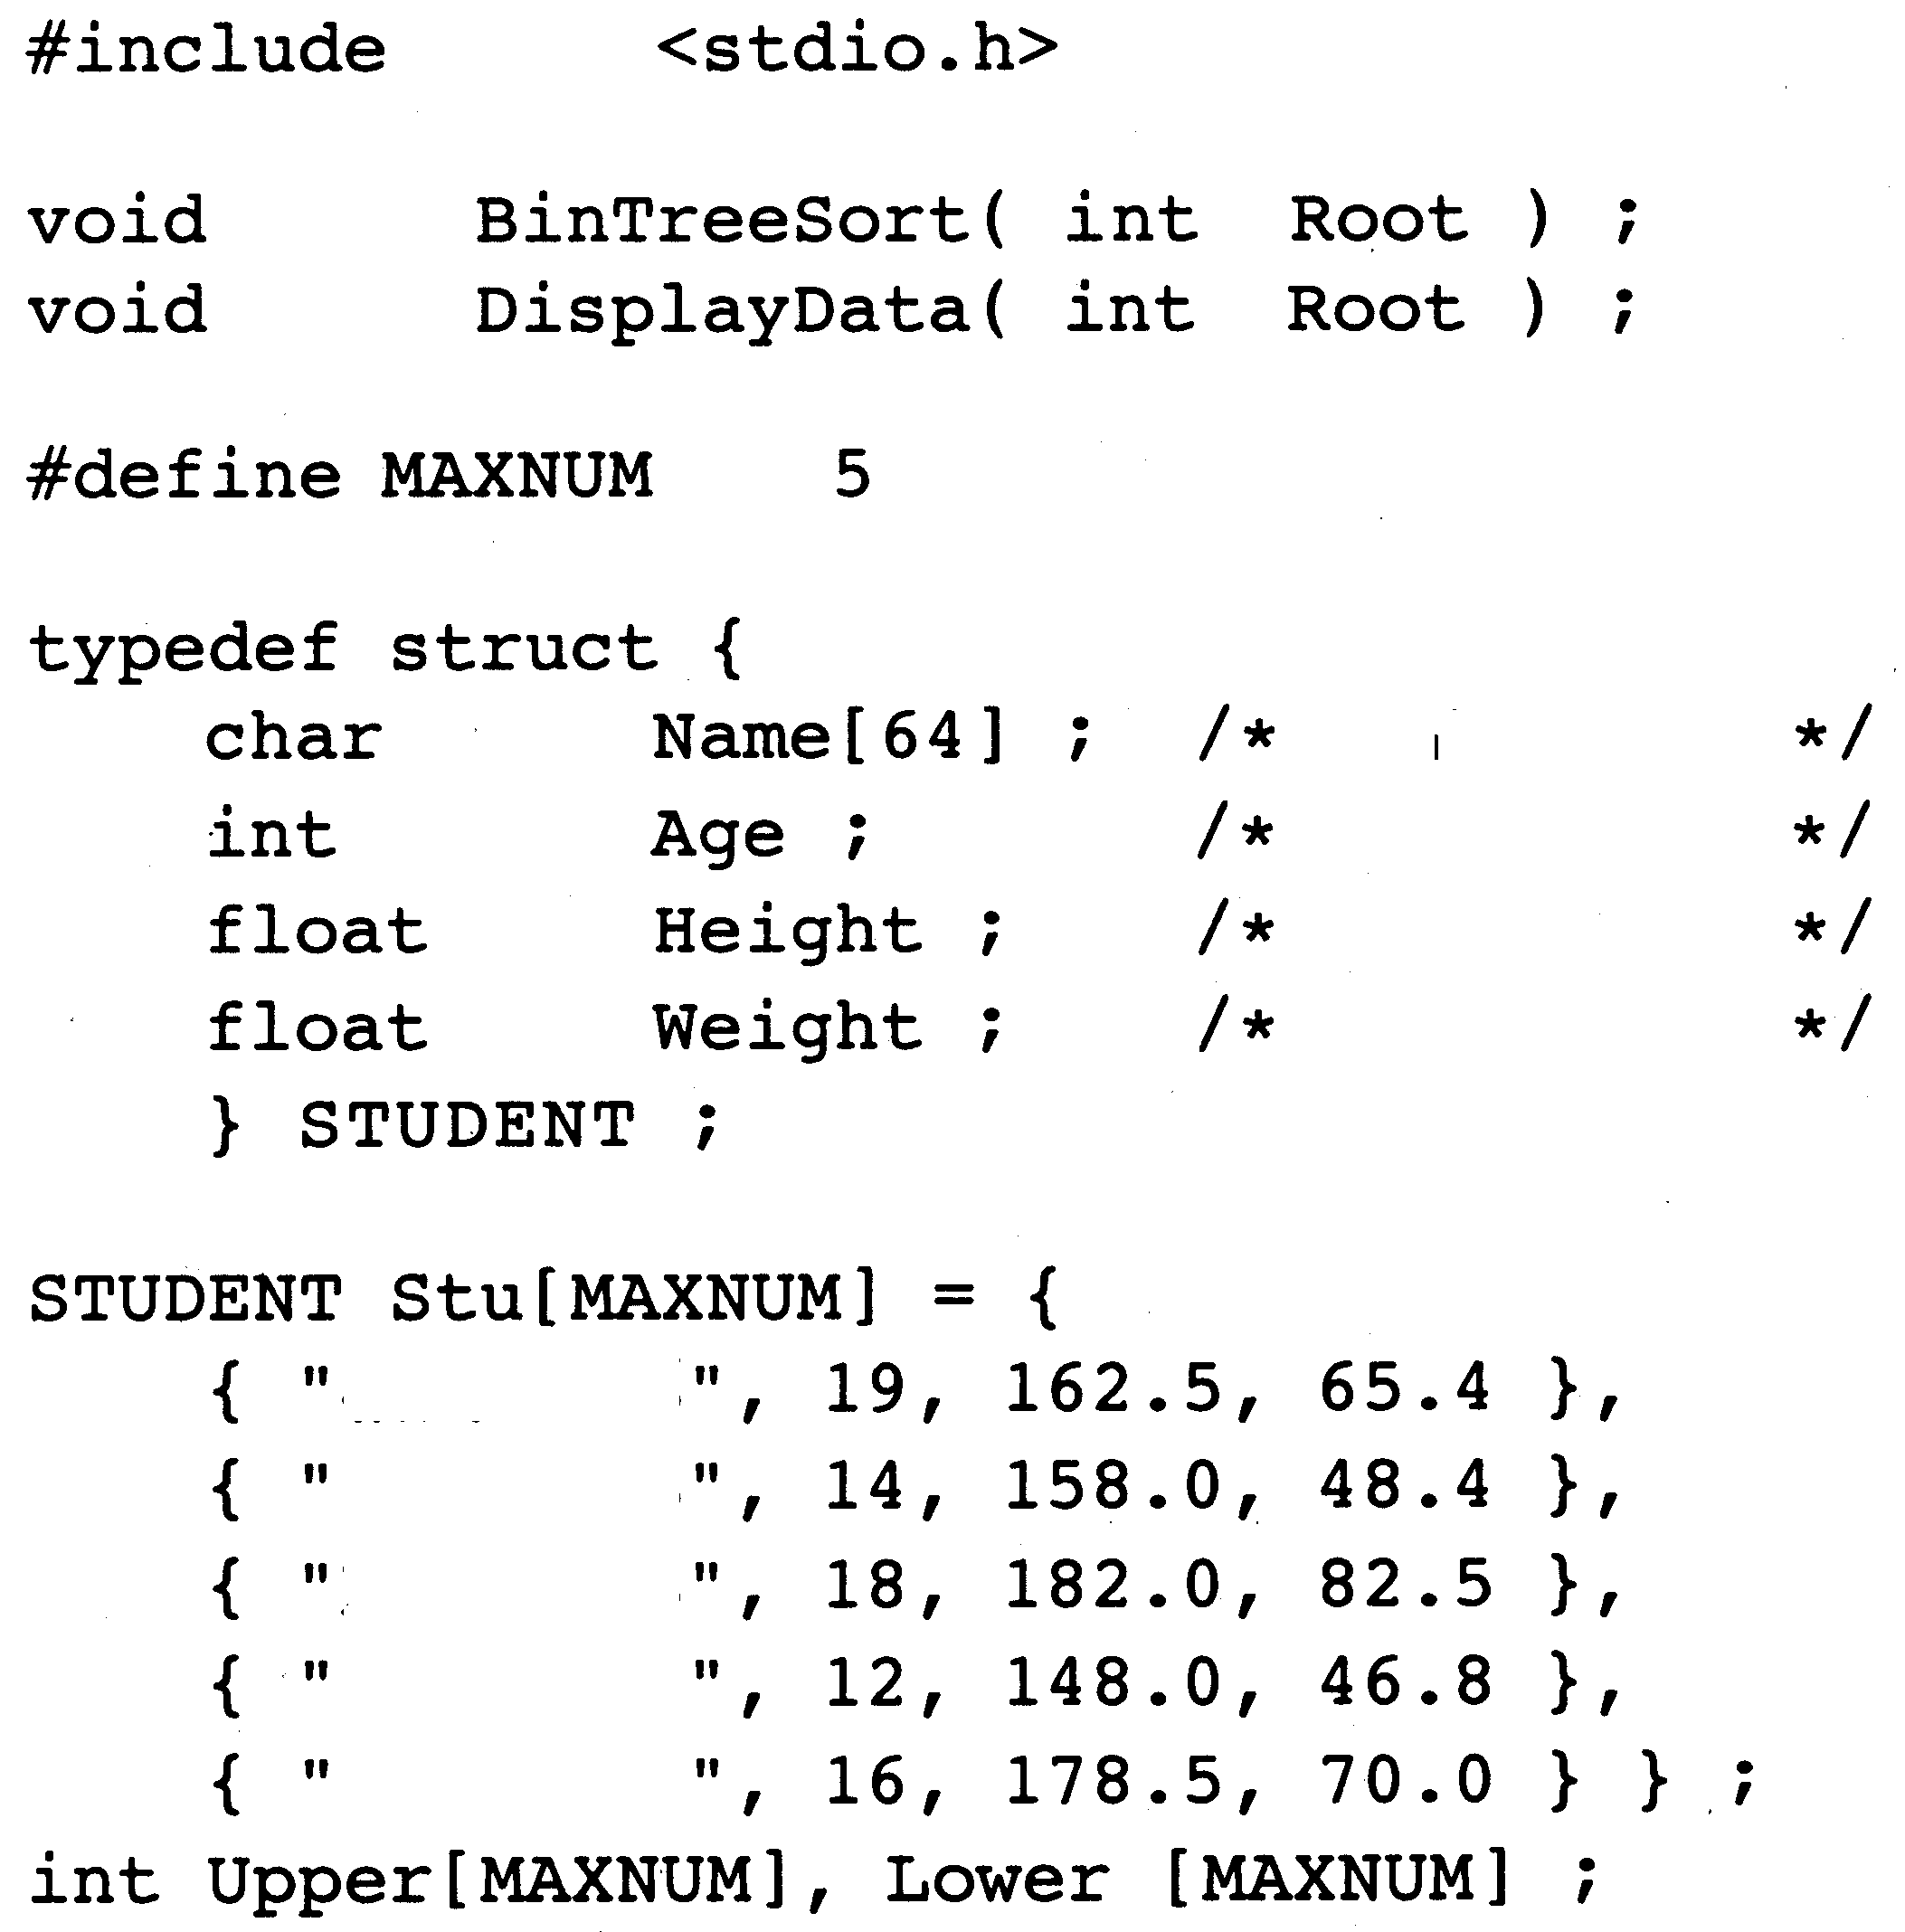
Name
Age
Height
Weight

Aikawa Taro
Ito Shiro
Kato Goro
Tanaka Saburo
Yamanaka Jiro

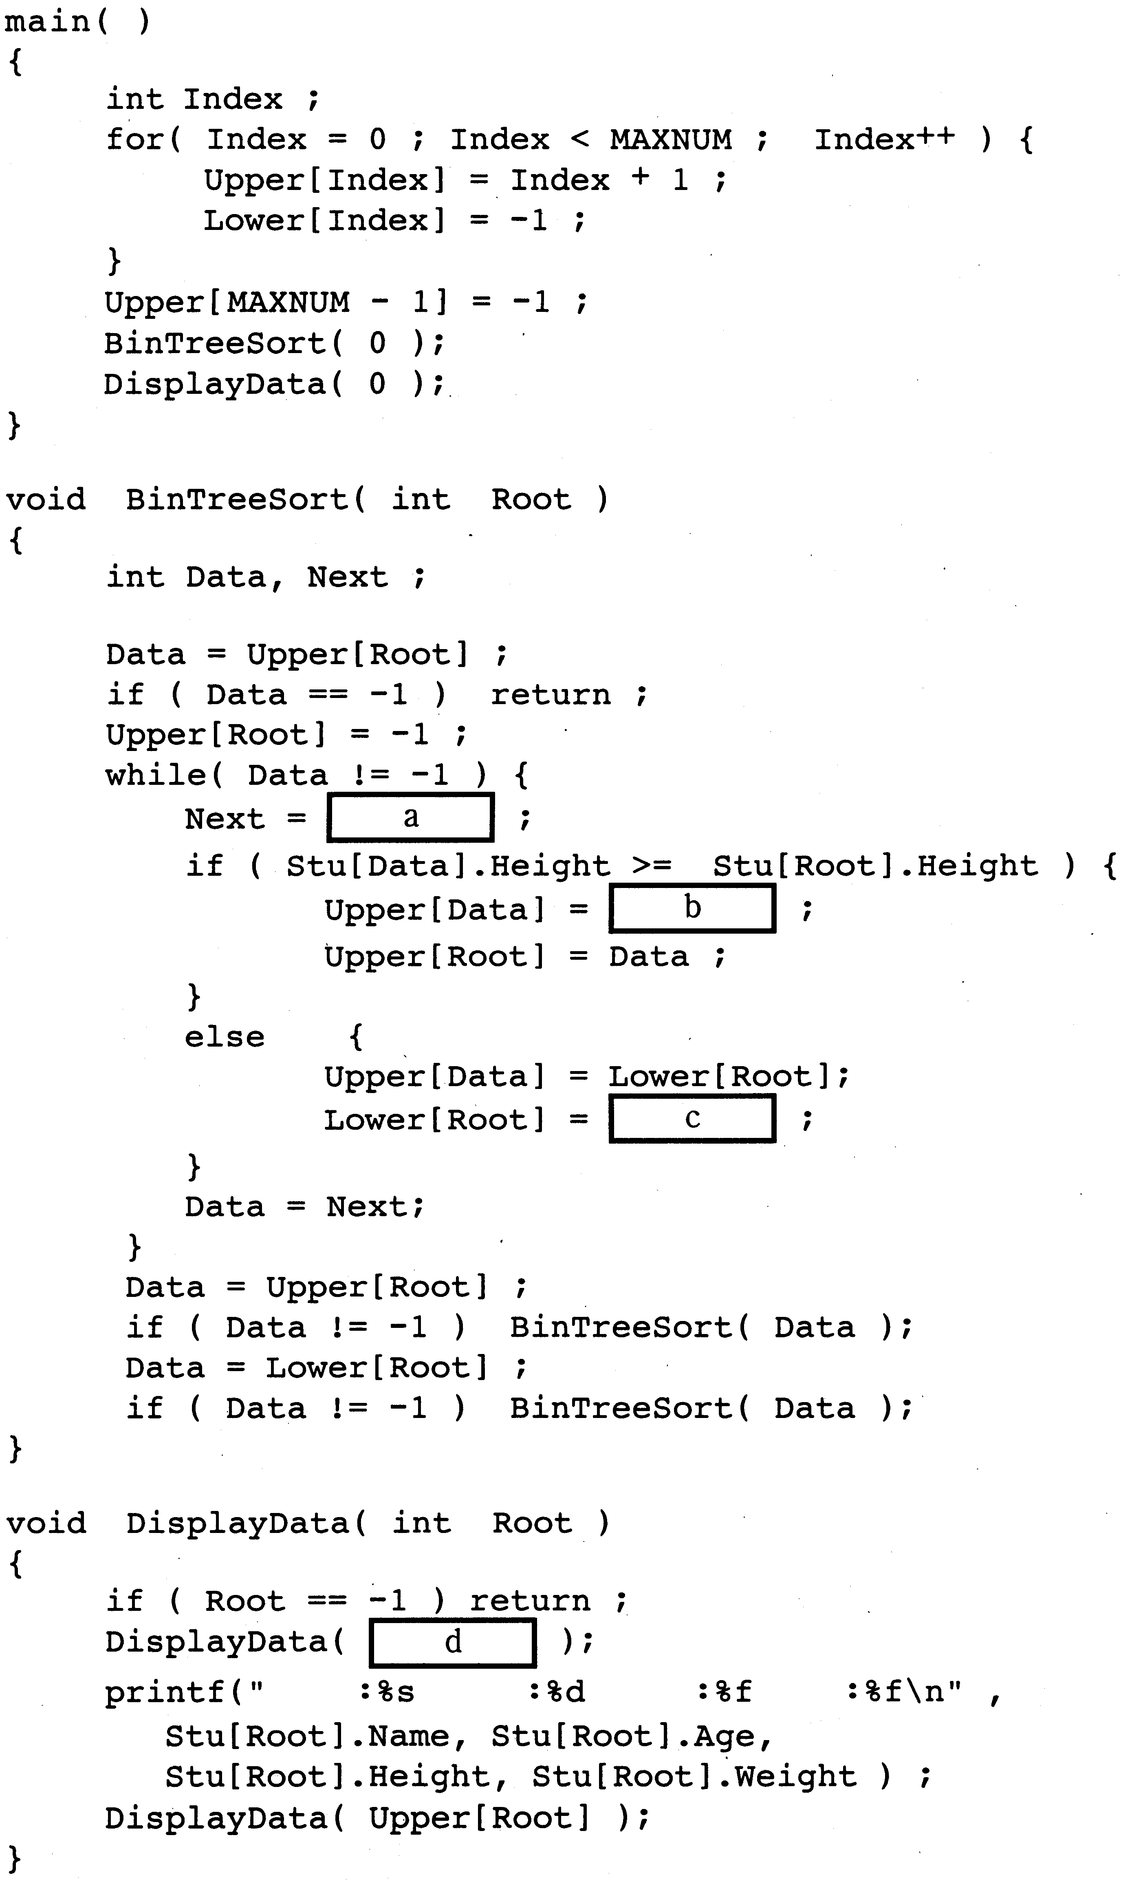
Name Age Height Weight

C

Sub-question: Select the correct answer to insert in the in the program from the choices provided.
C

Answer group

A. –1 | B. Data | C. Lower[Data]
D. Lower[Root] | E. Next | F. Root
G. Upper[Data] | H. Upper[Root]

Ans: Đáp án a – G; b – H; c – B; d – D. Tư tưởng của thuật toán này là xét tất cả các nút bên phải nút ROOT, nếu nó lớn hơn nút ROOT thì chèn vào nút con bên phải nút ROOT, còn không thì chèn vào nút con bên trái nút ROOT. Sau khi sắp xếp hết, ta sẽ xét đệ quy các nút con của nó.

Q8. Carefully read the explanation of the following COBOL program, and then answer the sub-question.
[Explanation of Program]
This program creates a sales performance file from sales files in which the departmental sales amounts generated by each store and each department are recorded separately. The program then ranks each department according to the size of its departmental sales amounts.
(1) The format of each record in the sales file is shown below.
Store code | Departmental sales amounts
 | Department A | Department B | Department C | Department D | Department E
5 digits | 9 digits | 9 digits | 9 digits | 9 digits | 9 digits
① Each store has five departments, A through E.
COBOL
② Assume that there are no records that have duplicate store codes within the sales file.
③ Assume that the departmental sales amounts will not exceed nine digits.
④ Assume that the sales file does not contain more than 9,999 records.
(2) The format of each record in the sales performance file is shown below.
Store code | Department A |  | Department B |  |  | Department E
 | Department rank | Departmental sales amount | Department rank | Departmental sales amount |  | Department rank | Departmental sales amount
5 digits | 4 digits | 9 digits | 4 digits | 9 digits |  | 4 digits | 9 digits
① The department rank (with "1" as the highest) is assigned according to the sales amount of the department compared to the same departments in the other stores.
② If there are several stores with the same departmental sales amount, they each get the same rank. After the same department rank has been assigned, the next rank is one greater than the number of stores that have been ranked up to that point.
(3) A work file is used to determine the departmental sales amount rank of each department.

[Program]
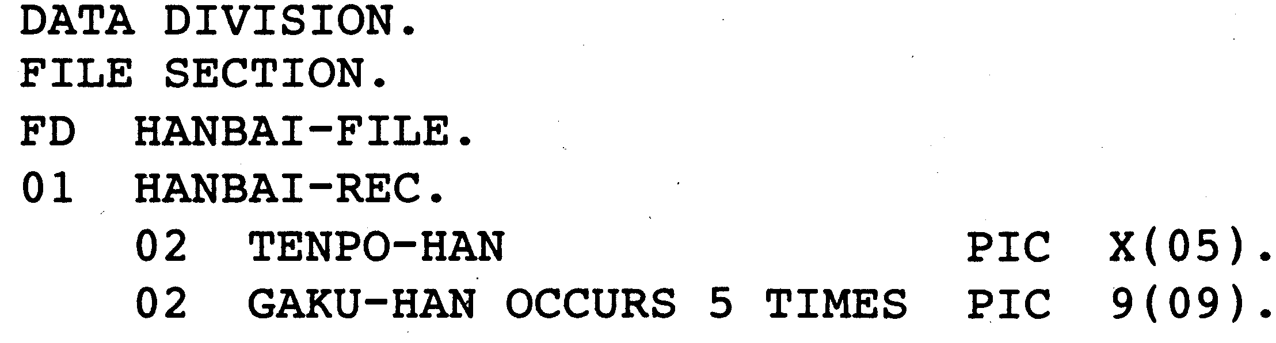

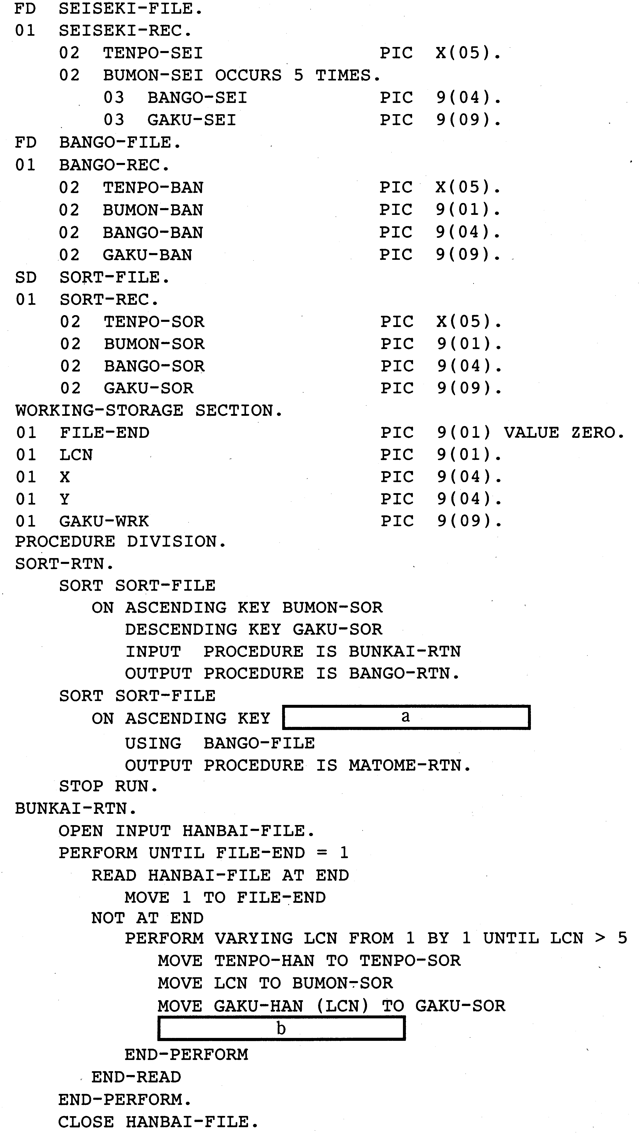
COBOL
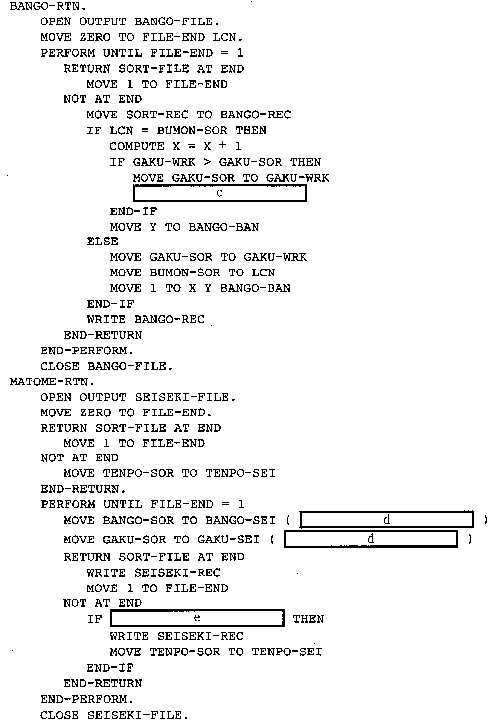
COBOL
Sub-question: Select the correct answer to insert in the in the program from the choices provided.
COBOL

Answer group for a and d:
A. BANGO-BAN B. BANGO-SOR C. BUMON-BAN
D. BUMON-SOR E. GAKU-BAN F. GAKU-SOR
G. TENPO-BAN H. TENPO-SOR

Answer group for b:
A. MOVE BANGO-REC TO SORT-REC
B. MOVE GAKU-WRK TO GAKU-SOR
C. READ SORT-FILE
D. RELEASE SORT-REC
E. RETURN SORT-FILE
F. WRITE SORT-REC

Answer group for c:
A. MOVE BUMON-SOR TO LCN B. MOVE LCN TO BUMON-SOR
C. MOVE X TO BANGO-BAN D. MOVE X TO Y
E. MOVE Y TO BANGO-BAN F. MOVE Y TO X

Answer group for e:
A. TENPO-SEI = TENPO-BAN B. TENPO-SEI NOT = TENPO-BAN
C. TENPO-SEI = TENPO-SOR D. TENPO-SEI NOT = TENPO-SOR
E. TENPO-SOR = TENPO-BAN F. TENPO-SOR NOT = TENPO-BAN
Q9. Carefully read the explanation of the following Fortran program, and then answer the sub-question.
[Explanation of Program]
A problem with the handling of matrices in the field of computing is that the volume of calculations and the amount of main memory used increases with the size of the matrix. Here we will consider a method for compressing a band matrix, a type of sparse matrix that contains a large number of zero elements, for storage by omitting zero elements.
This program determines the bandwidth of the band matrix, stores the bandwidth data for each line in an array, and then outputs the contents of that array. Here, a "band matrix" is a square matrix with non-zero elements distributed in the vicinity of the opposite corners, as shown in Fig. 1.

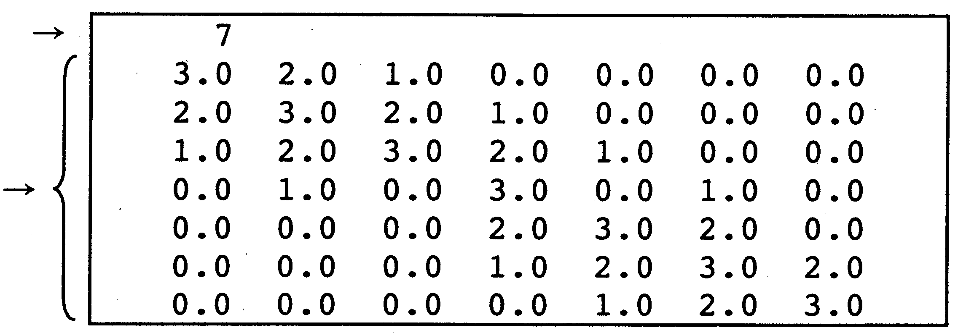
Matrix dimension

Matrix

Fortran
Fig. 1 Sample Input Data
(1) A band matrix with non-zero elements distributed in the vicinity of the opposite corners is input in the array "wa". The program deems any element with an absolute value greater than 10⁻⁶ as being a non-zero element.
(2) The program determines the bandwidth of the matrix.
For the row numbered "row":
① The program searches from the left edge to the "row–1" column, and assigns the column number of the first non-zero element that it encounters to "kl".
② The program searches from the right edge to the "row+1" column, and assigns the column number of the first non-zero element that it encounters to "kr".
③ The program assigns the larger of "row–k1" and "kr–row" as "length".
The bandwidth is derived by doubling the largest "length" value and adding one to the result, using the "length" values derived for each row as described above. For example, in the third line of the band matrix shown in Fig. 1, row = 3, kl = 1, and kr = 5, so row–kl = 2 and kr–row = 2. In the case of this band matrix, the largest "length" value for all of the rows is "2," so the bandwidth is "5."
(3) The program then allocates an area for the array wb(number of rows, bandwidth) to store a number of elements equal to the bandwidth.
(4) The program stores a number of elements equal to the bandwidth in "wb", ordering them so that the diagonal element of "wa" will become the center column of "wb". A "wb" element is set to 0 (nought), if no wa element corresponds.
- Fig. 2 shows the output results produced from the input data shown in Fig. 1.
Fortran
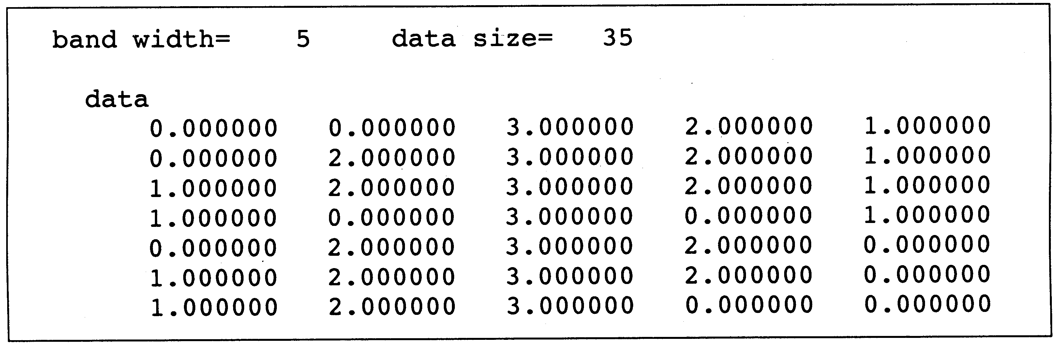
Fig. 2 Sample Output Results

[Program]
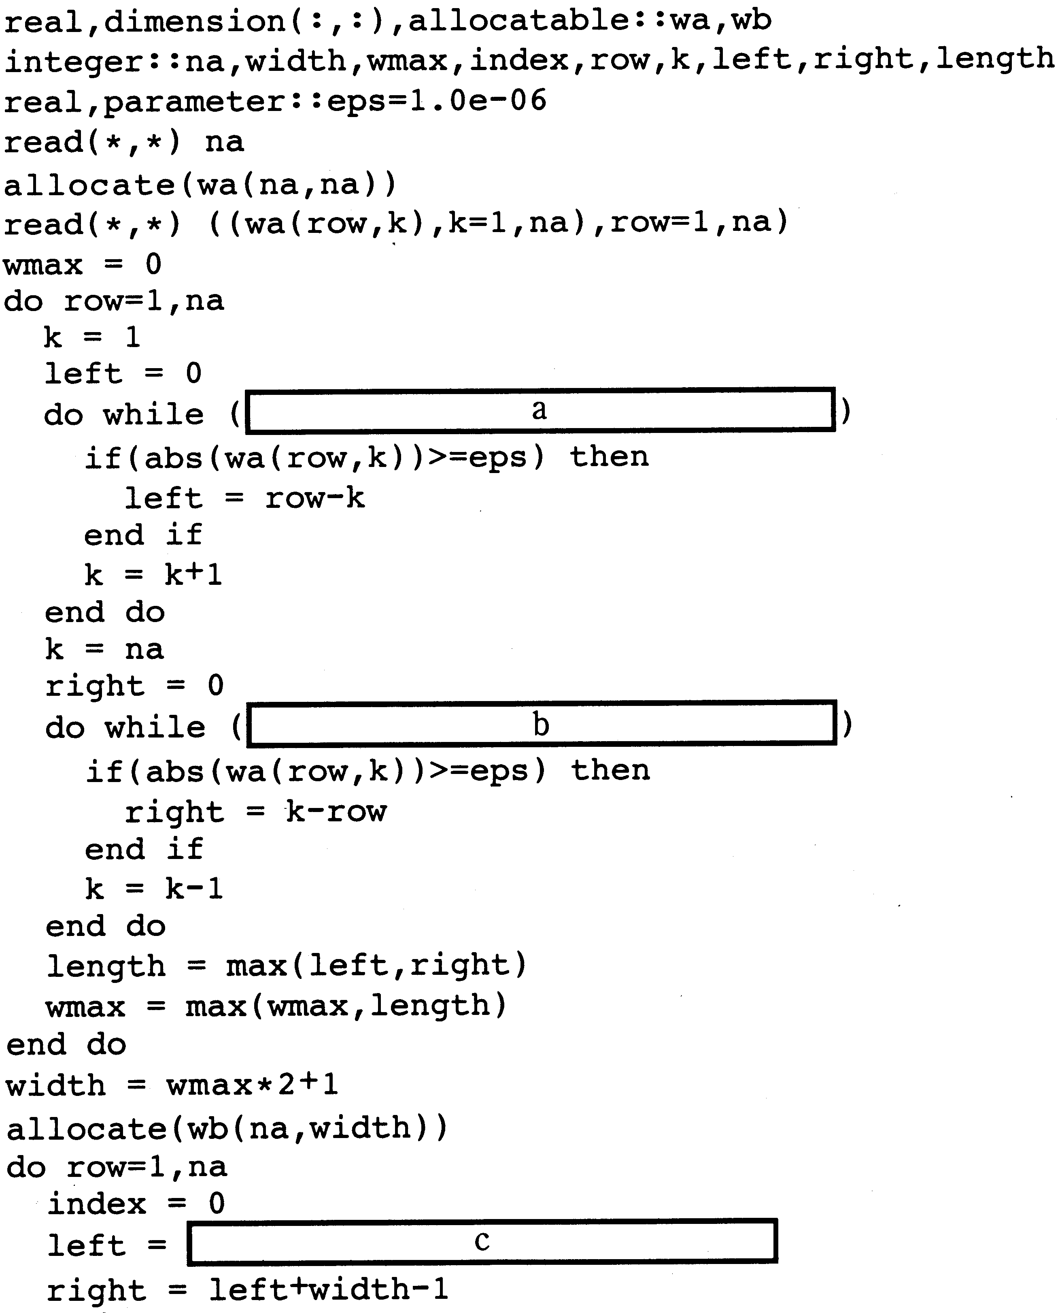
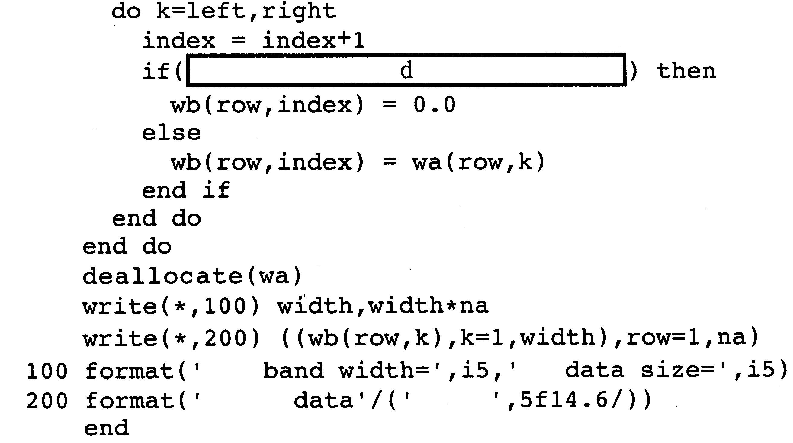

Sub-question: Select the correct answer to insert in the in the program from the choices provided.
Answer group for a and b:
A. k<row .and. left==0 B. k<row .and. right==0
C. k<row .or. left==0 D. k<row .or. right==0
Fortran
E. k>row .and. left==0 F. k>row .and. right==0
G. k>row .or. left==0 H. k>row .or. right==0

Answer group for c:
A. row B. row+max
C. row+wmax-1 D. row-wmax
E. row-wmax+1 F. row-wmax-1

Answer group for d:
A. index<1 .and. index>na B. index<1 .or. index>na
C. index>1 .and. index<na D. index>1 .or. index<na
E. k<1 .and. k>na F. k<1 .or k>na
G. k>1 .and. k<na H. k>1 .or. k<na

Q10. Carefully read the explanation of the following assembly line program and the program itself, and then answer the sub-question.

[Explanation of Program]
This program treats data stored in sixteen consecutive words as a 16 x 16-bit graphic. The subprogram ROTATE rotates the graphic 90 degrees.
(1) The starting address of the graphic is stored in GR1, which is passed from the main program.
(2) Either "1" or "–1" is stored in GR3, which is passed from the main program. When GR3 is "1," the graphic is rotated 90 degrees to the right; when GR3 is "–1," the graphic is rotated 90 degrees to the left.
(3) The program stores the rotated graphic in the area specified by GR2.
(4) Assume that the areas specified by GR1 and GR2 do not overlap.
(5) Fig. 1 shows an example of the execution of the subprogram ROTATE.
Assembler
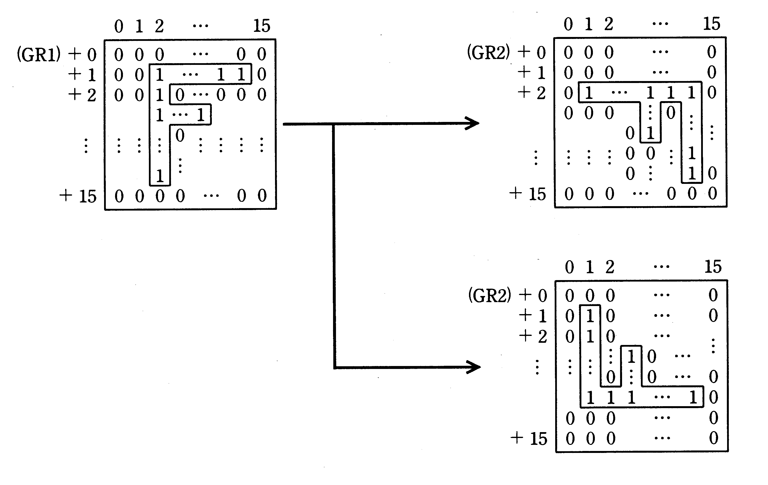
Original graphic
Bit
When GR3 = 1
Bit
Bit
Resulting graphic
Fig. 1 Execution Example of the Subprogram ROTATE
Original graphic
When GR3 = –1
Resulting graphic

- When rotating the graphic to the right by 90 degrees, as shown in Fig. 2, the bit string in the first word ① in the original graphic is shifted in the direction indicated by the arrow one bit at a time to the bit column "a" (at the right edge of the resulting graphic). Similarly, ② is then shifted to "b," ③ is shifted to "c," etc. When rotating the graphic to the left by 90 degrees, as shown in Fig. 3, the bits are shifted starting from the last word ①, which is shifted to bit column "a," then ② is then shifted to "b," ③ is shifted to "c," etc.

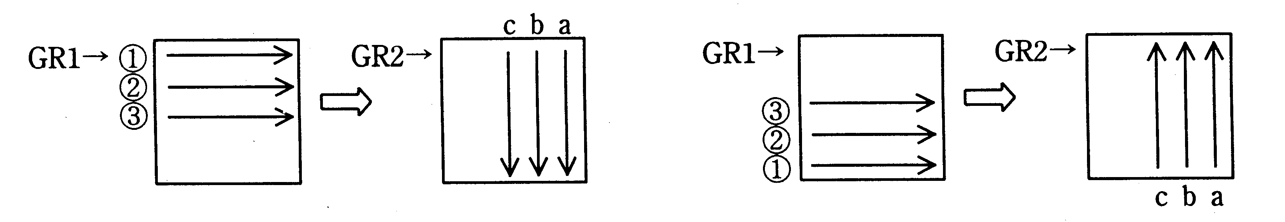
Fig. 2 Sequence of Processing When Rotating to the Right
Fig. 3 Sequence of Processing When Rotating to the Left

(7) When control returns to the main program, the contents of the general-purpose registers GR1 through GR3 are returned to their original states.

Assembler
[Program]
Assembler
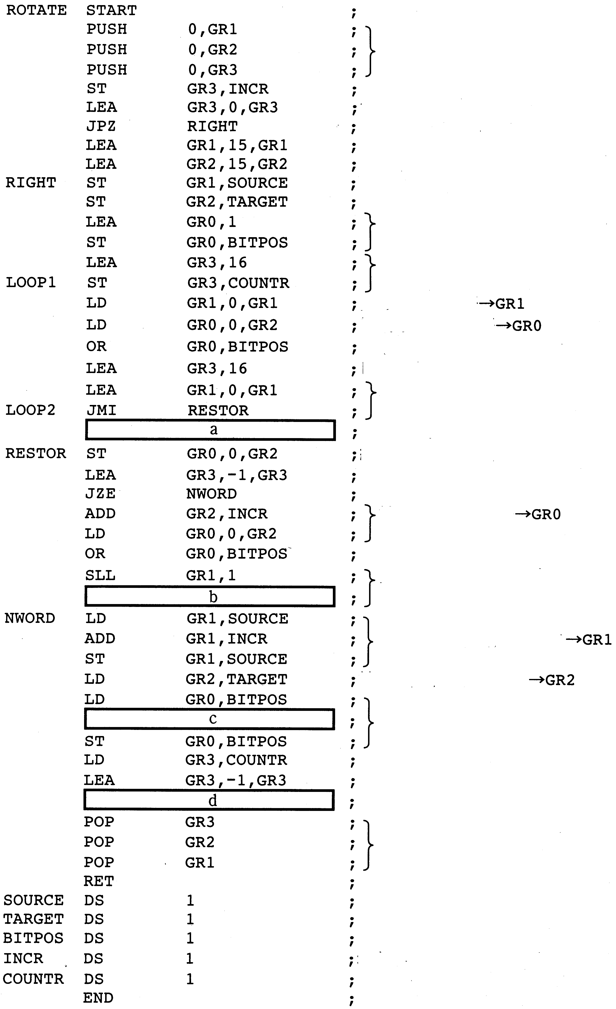
Register save
Bit position initialization

Word counter
Word 1 in original graphic → GR1
Word 1 in resulting graphic → GR0
Sets bit in word 1 of result
Bit counter

Bit check in original graphic

Clears bit that was set
Stores in resulting graphic

Next word in resulting graphic→ GR0
Sets bit in word 1 of result

Bit check in original graphic

Next word address in original graphic → GR1
Bit position update

Address of resulting graphic → GR2

Register restore
Increment (+1 or –1)
Sub-question: Select the correct answer to insert in the in the program from the choices provided.

Answer group for a and c:
A. AND GR0,0,GR2 B. AND GR0,BITPOS
C. EOR GR0,0,GR2 D. EOR GR0,BITPOS
E. LEA GR0,0 F. LEA GR0,32768
G. SLL GR0,1 H. SRL GR0,1

Answer group for b and d:
A. JMI LOOP1 B. JMI LOOP2
C. JMP LOOP1 D. JMP LOOP2
E. JNZ LOOP1 F. JPZ LOOP2
G. JZE LOOP1 H. JZE LOOP2
Assembler

Select one question from Question 11 to Question 14, and mark which question you have selected on your answer sheet. If you select two or more questions, only the first question will be graded.

Q11. Carefully read the explanation of the following C program, and then answer Sub-questions 1 and 2.

[Explanation of Program]
The function "wordwrap" outputs English text so that a word is not divided in the middle at the end of a line.
(1) The parameters for the function "wordwrap" are: "str[]", an array for the input string in which the English text is stored; and "max", the maximum number of characters per output line (not including the line feed character).
(2) Words in the input string are delimited by a single space. There are no spaces at the beginning and end of the string.
C
(3) If the maximum number of characters per line is going to be exceeded in the middle of a word, that word is output at the beginning of the next line.
(4) Assuming "wx" as the maximum word length and "sx" as the length of the input string, assume that the following relationship is true:
0 < wx < 16 < max < sx < 1024

Sample input string:

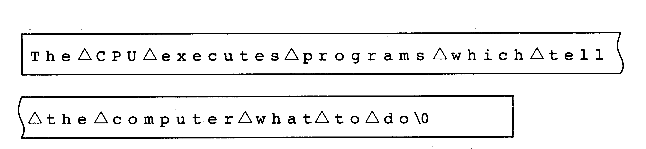
(Δ: space character)

Maximum number of characters per line: 30

Output:
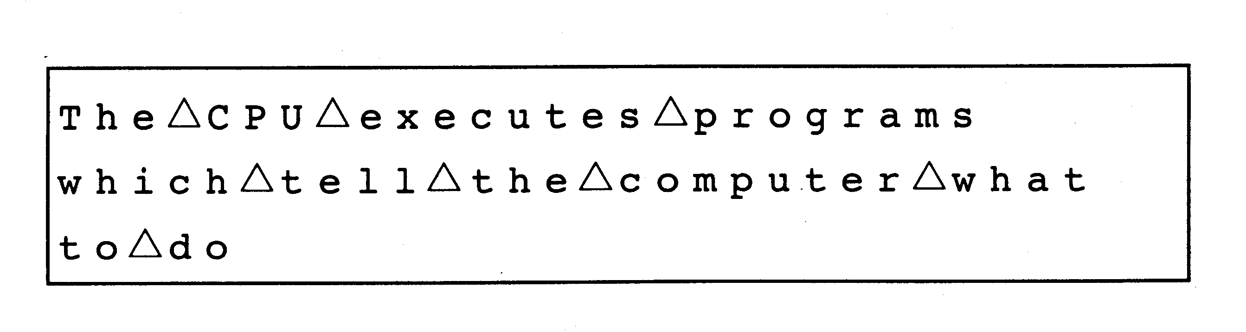
[Program]
(Line number)
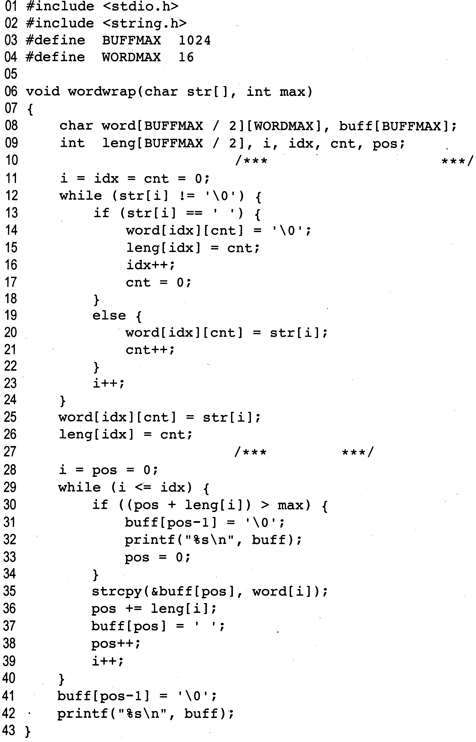
C
/*** Divides the character string into words ***/
output
Sub-question 1. Select the correct answer to insert in the in the following description from the choices provided.
Given the input character string and the maximum number of characters per line shown below, line 21 is executed a times. The value of the variable "pos" when the program ends is
b .
Input character string:
Maximum number of characters per line:18

Answer group
A. 5 B. 7 C. 8 D. 12 E. 13
F. 15 G. 16 H. 22 I. 27

Sub-question 2. Select the correct answer to insert in the in the following description from the choices provided.

We will now change the program so that it will include any leading spaces in the character string as part of the first word (so that spaces at the start of the character string are output as is), and so that it will output only one space between words even if there are multiple spaces.
C
This change is accomplished by inserting "α" immediately before line 12, and by inserting "β" immediately before line 18.
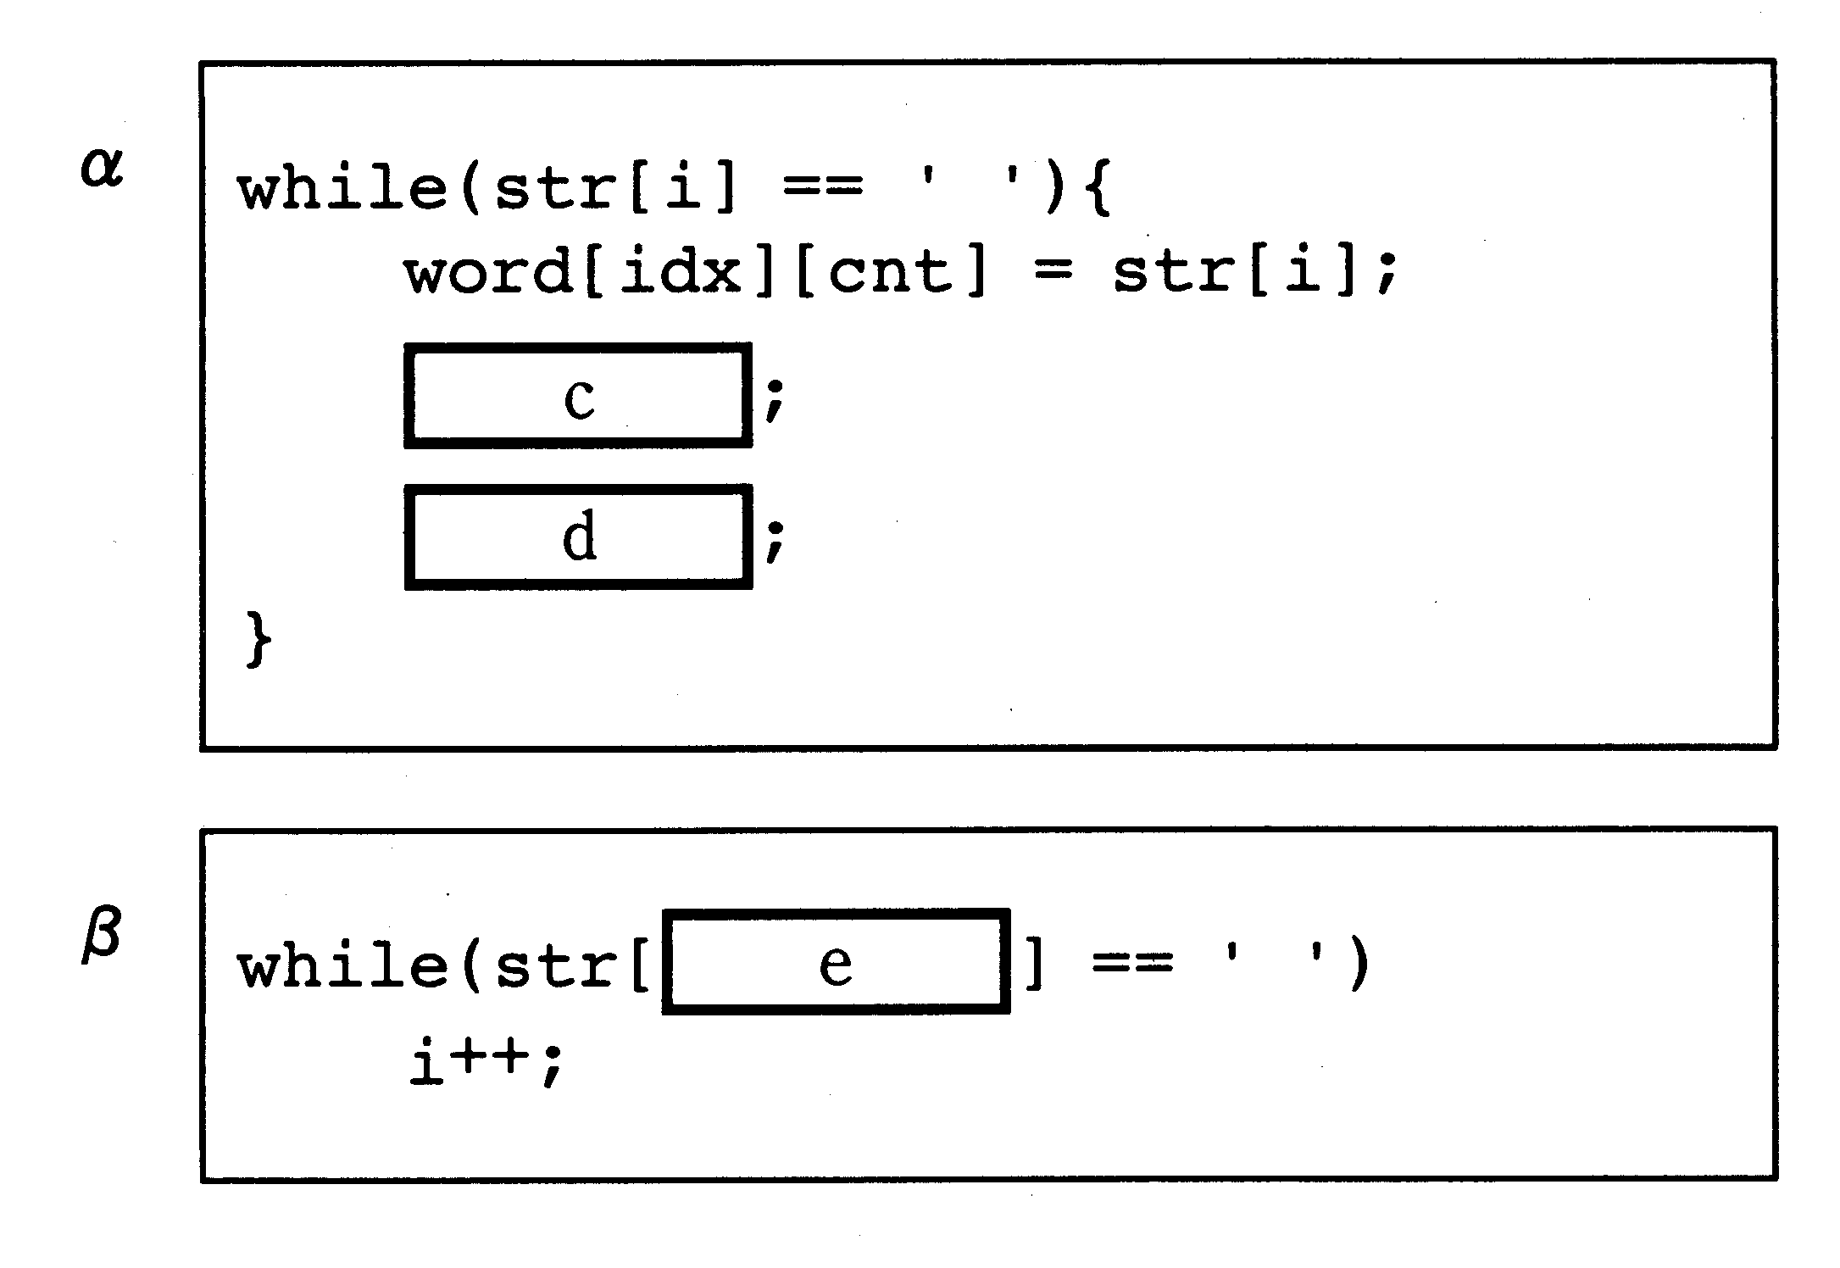
Answer group
A. Cnt++ B. cnt-- C. i D. i++ E. i--
F. i+1 H. i-1 I. idx++ J. idx--
Ans: Đáp án Sub1 – a – H, b – E Sub 2 – c – A, d-D, e-F. cnt đóng vai trò đếm số ký tự trong 1 từ -> trong toàn bộ chương trình dòng 21 được thực hiện = số ký tự khác trắng trong xâu input = 22 (Đáp án Sub1- a-H). Biến pos ở đây đóng vai trò là chỉ số của ký tự đang được đọc vào buffer để output. Dễ thấy output ra sẽ là:
Dòng 1: AAAA_BBBBB_CCC
Dòng 2: DDDD_EEE_FFF\0 (pos – 1 = \0 -> pos là số ký tự trong dòng cuối cùng khi kết thúc chương trình = 13) (Đáp án Sub1 – b –E)
Với phần 2 thì ta sẽ cho các dấu trắng đầu vào xâu đầu tiên, ở đây c-A, d-D. Khi kiểm tra ta sẽ loại bỏ các ký tự trắng tiếp theo có thê do đó e- F.

Q12. Carefully read the explanation of the following COBOL program, and then answer Sub-questions 1 and 2.
[Explanation of Program]
This program outputs a bar graph that indicates the number of students at a given school that have selected each of the foreign languages offered.
(1) The number of students that have selected each language can be obtained by calling a program named "KEISAN"; the results are then stored in SENTAKU-T in the following order:
French (F), German (G), Chinese (C), Russian (R), Spanish (S)
(2) The printing format for the bar graph is as follows:
①The languages are listed on the Y axis, and the number of students is plotted on the X axis.
② The number of students can range from 0 to 30; one asterisk "*" represents one student.
COBOL
③ The following output sample shows that 30 students selected French, 15 selected German, 20 selected Chinese, 0 selected Russian, and 5 selected Spanish.
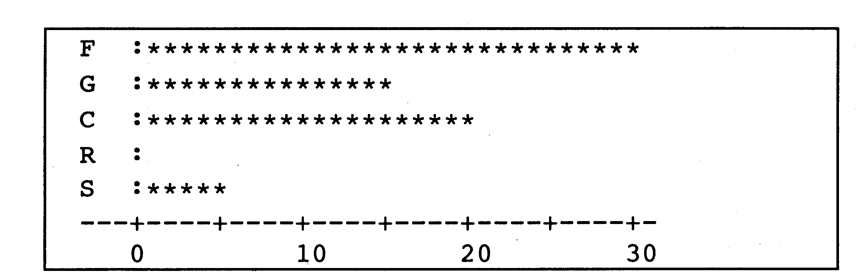
Fig. Output Sample for Number of Students Selecting Each Language
[Program]
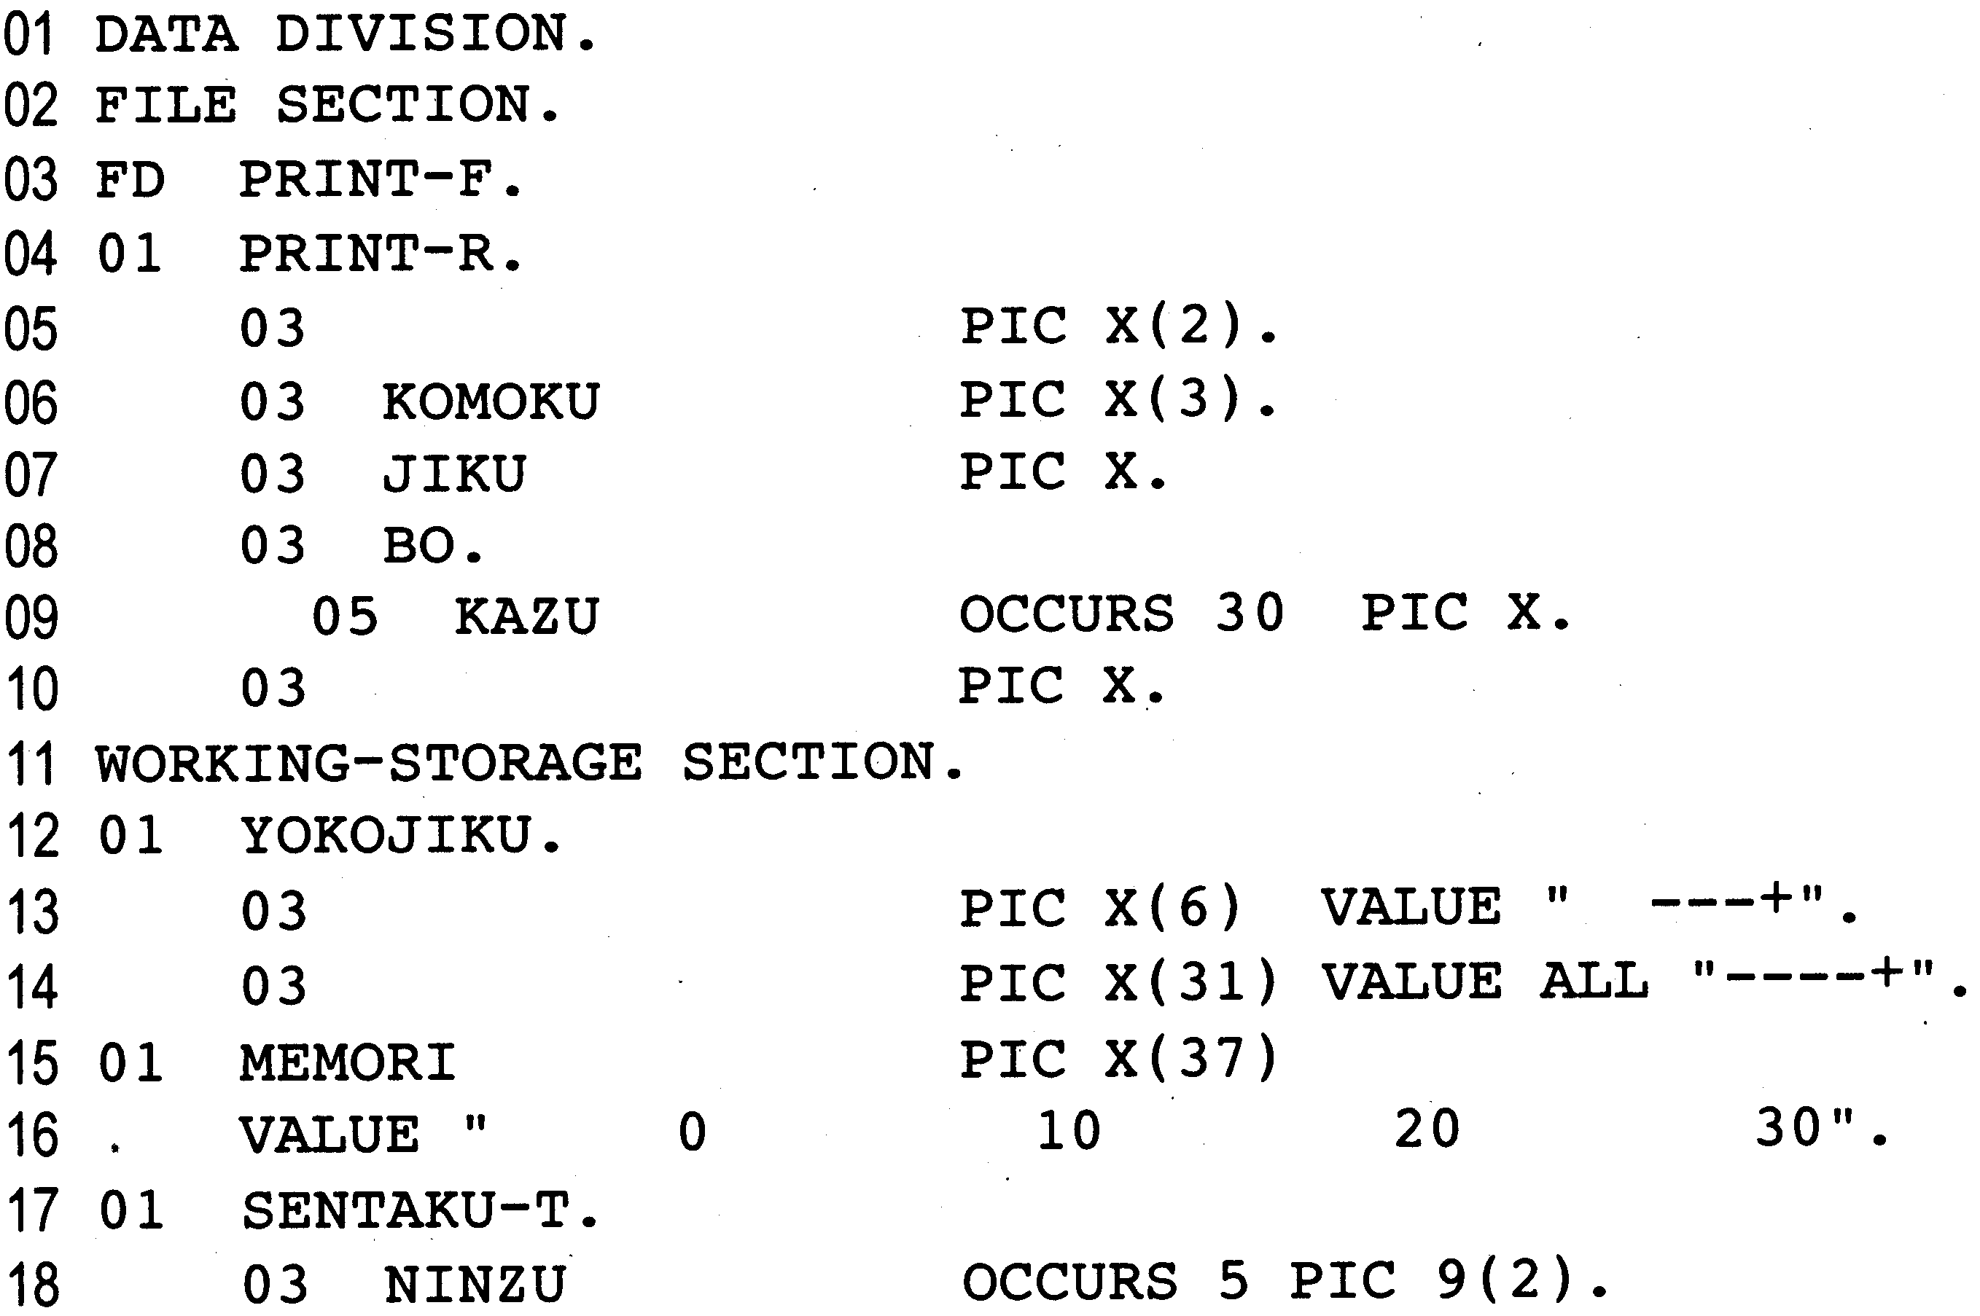
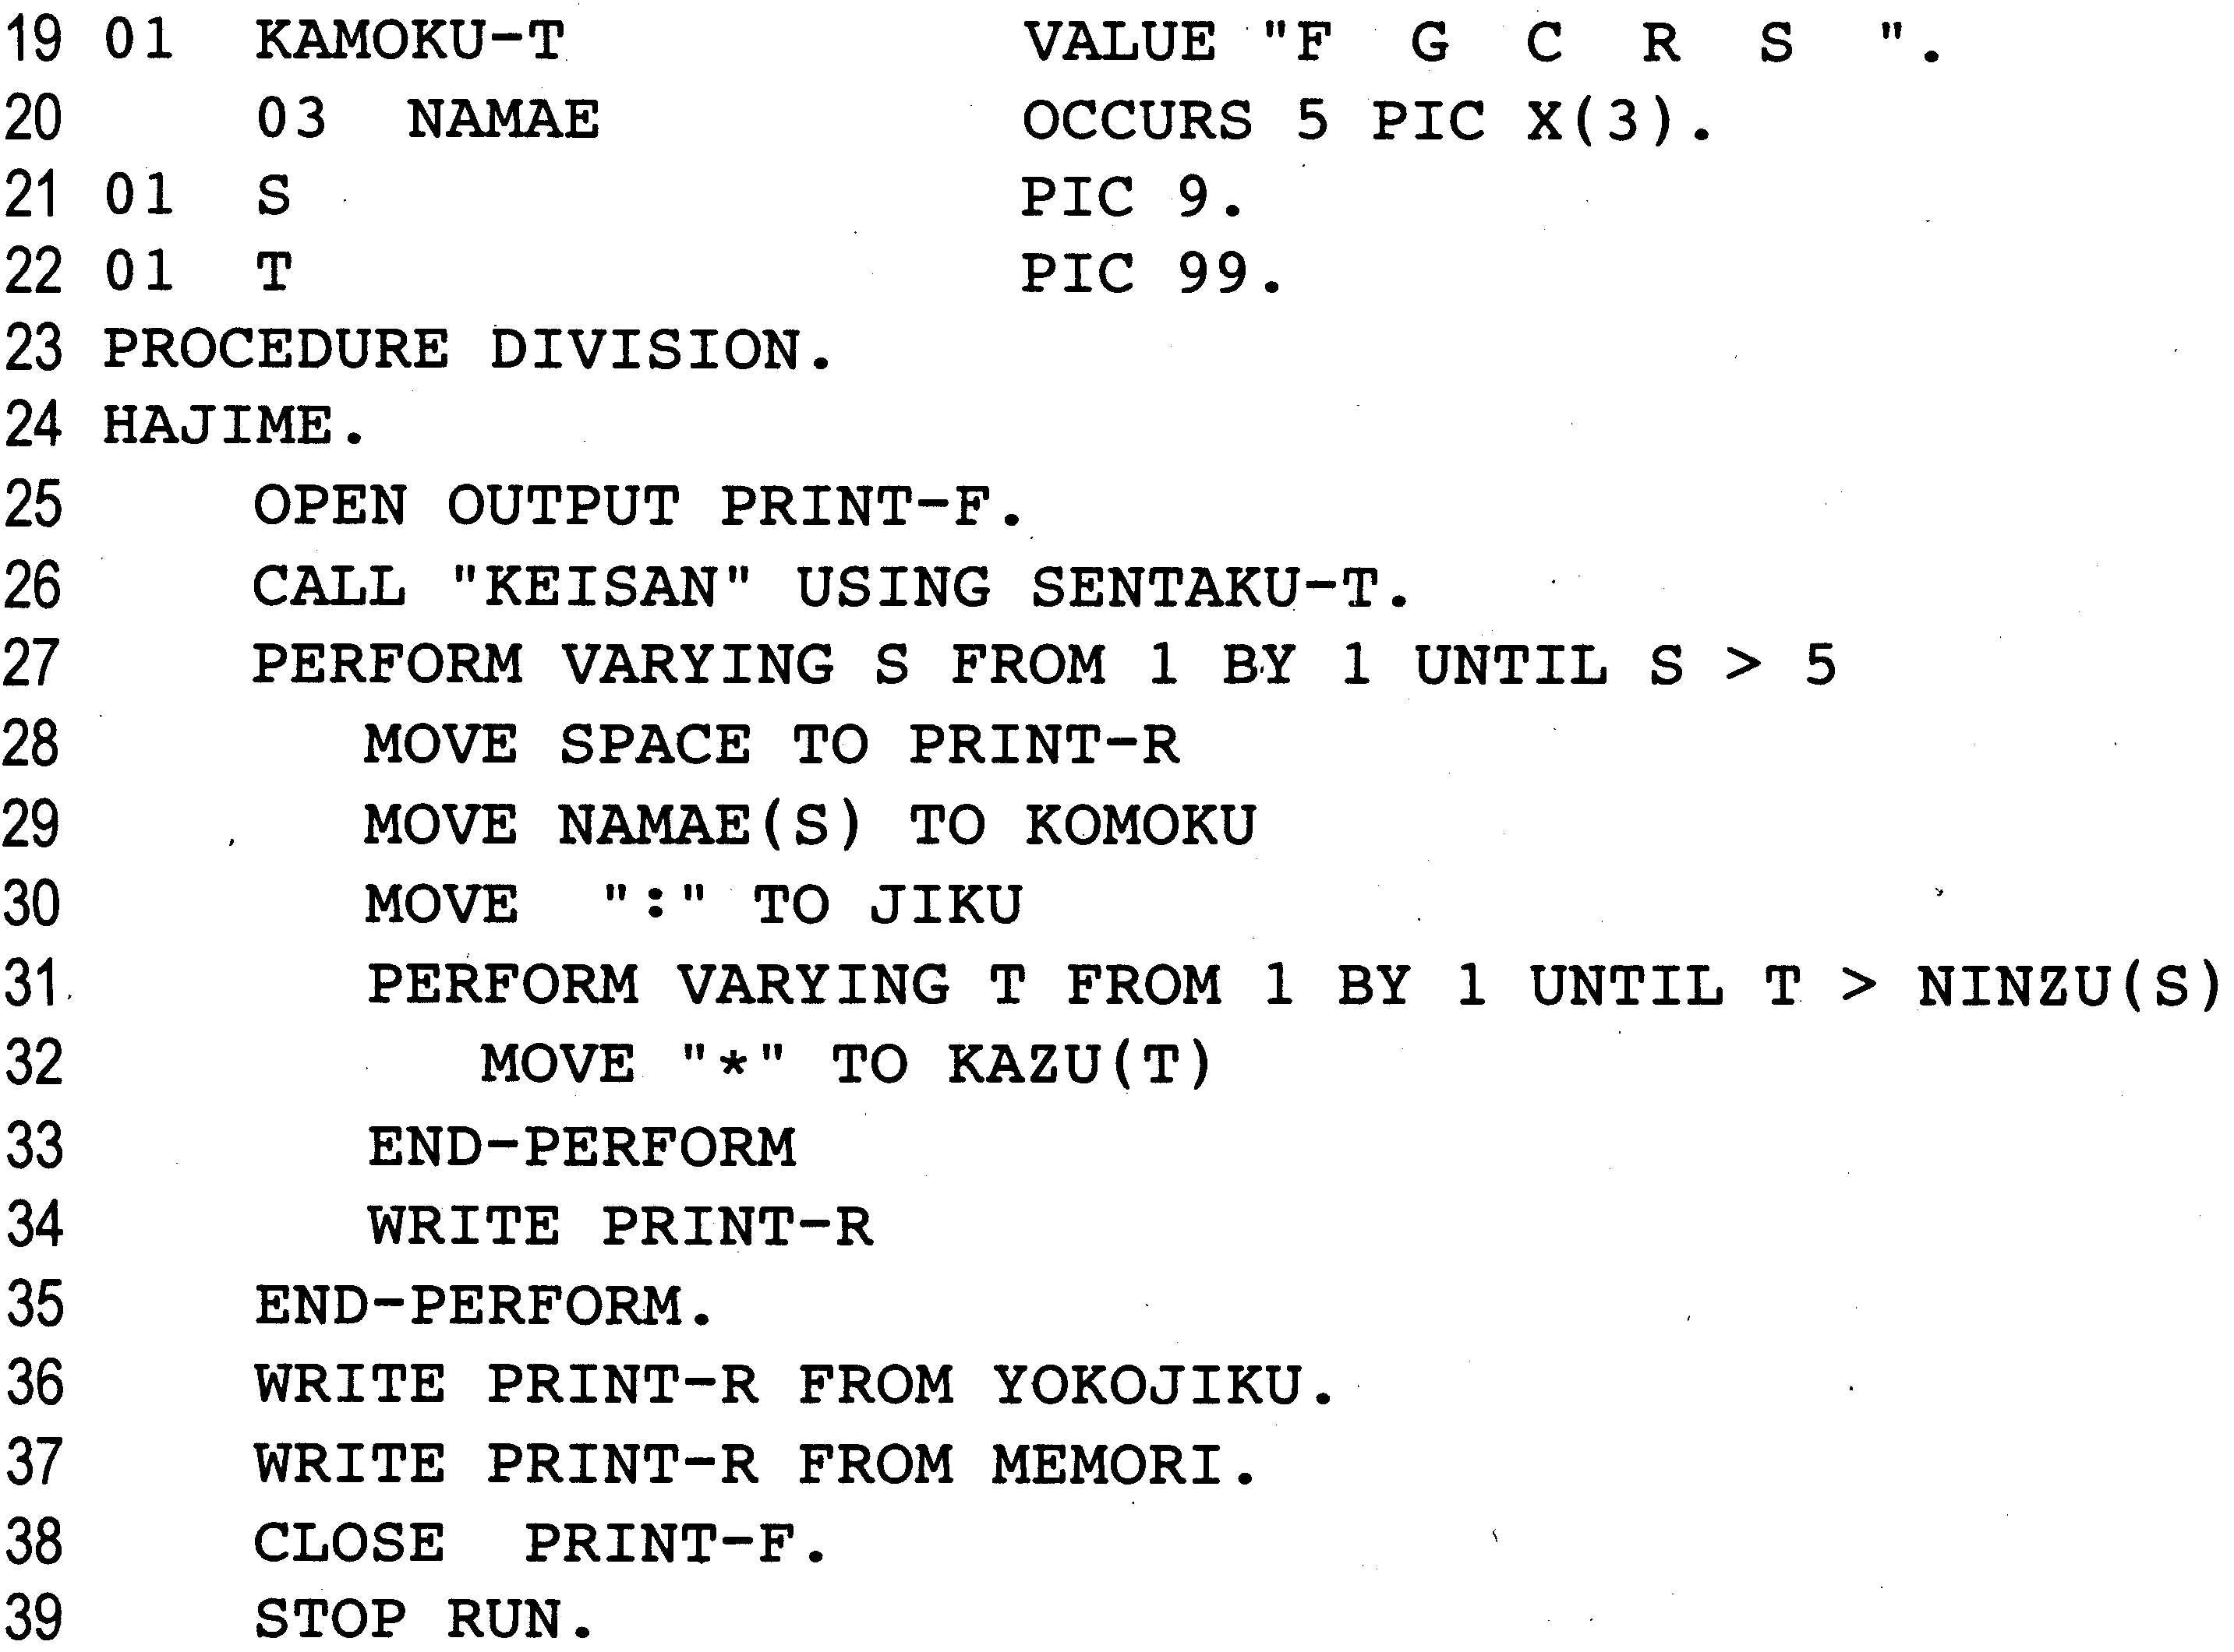
COBOL

Now the school modifies the program so that the bar graph is oriented vertically instead of horizontally. The data section is changed as shown below, and the three alternatives a, b, and c shown in the table are considered for lines 27 through 35 in the procedure section.

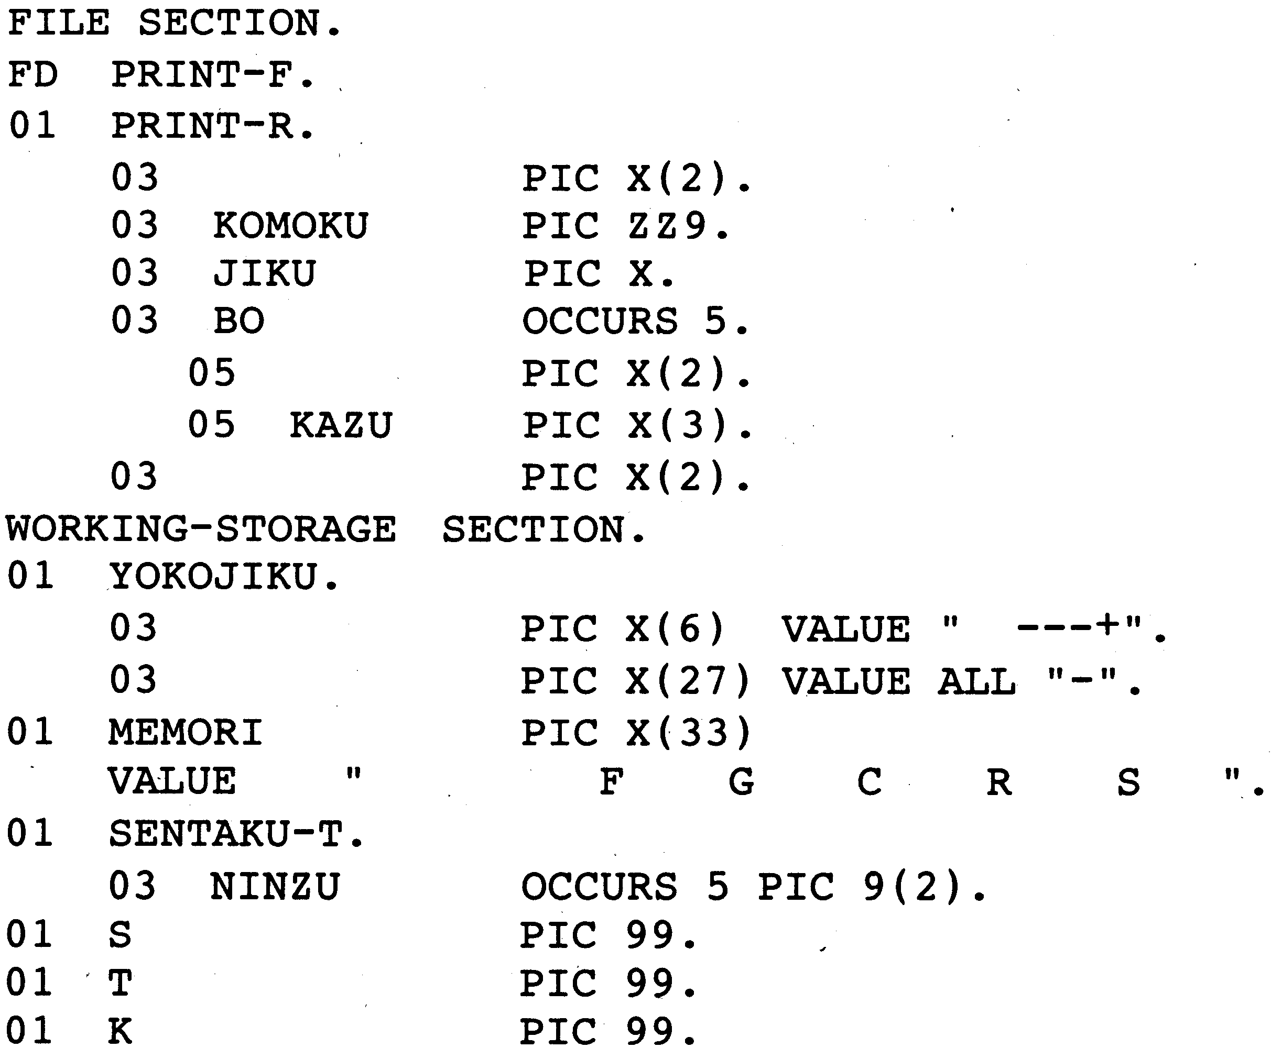

Table Changes to the Procedure Section (Substitutions for Lines 27 through 35)
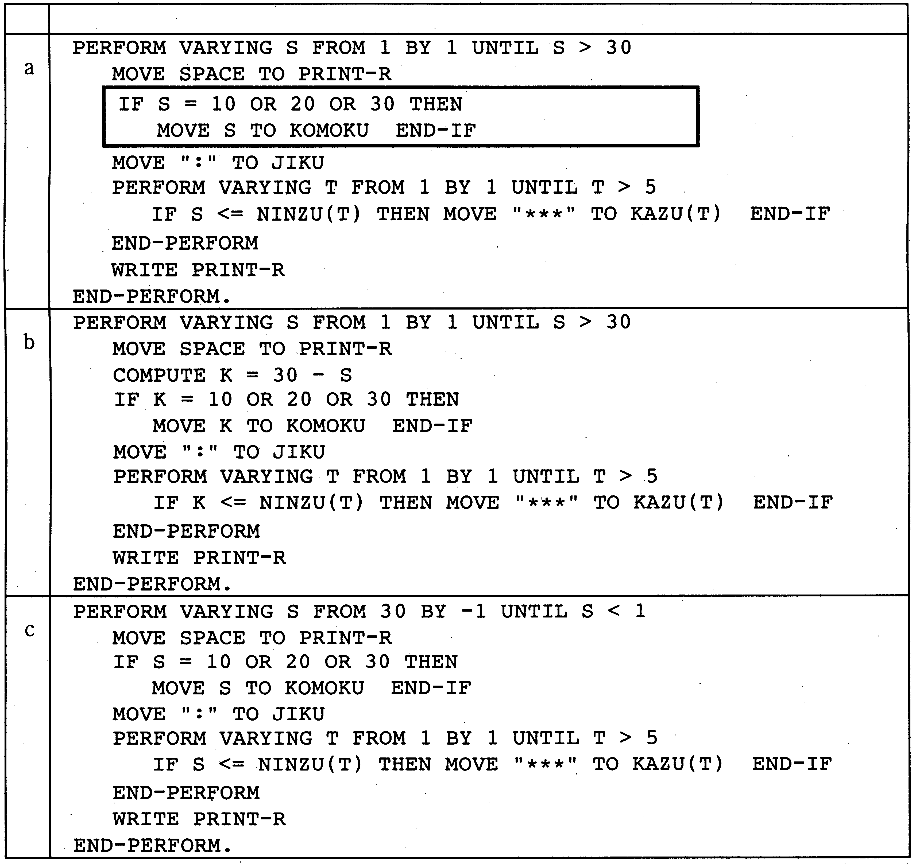
COBOL
Statements

Sub-question 1. How should the "IF" statement enclosed in the box in the table be changed so that the condition would be "when the value is a multiple of 10"? Select the correct answer from the choices below.
Answer group
A. COMPUTE K = S / 10
IF K = 0 THEN MOVE S TO KOMOKU END-IF
B. COMPUTE K = S / 10
IF S = K * 10 THEN MOVE S TO KOMOKU END-IF
C. COMPUTE K = S / 10
COMPUTE K = S / K
IF K = 10 THEN MOVE S TO KOMOKU END-IF
D. COMPUTE K = S / 10
COBOL
COMPUTE K = K * 10
MOVE K TO KOMOKU
Sub-question 2. Which graph will be printed when the changes made in a, b, and c, respectively, are incorporated into the program? Select one graph for a, b, and c from the choices provided. Assume that the student data from the sample output (item (2) in the explanation of the program) is used.
Answer group
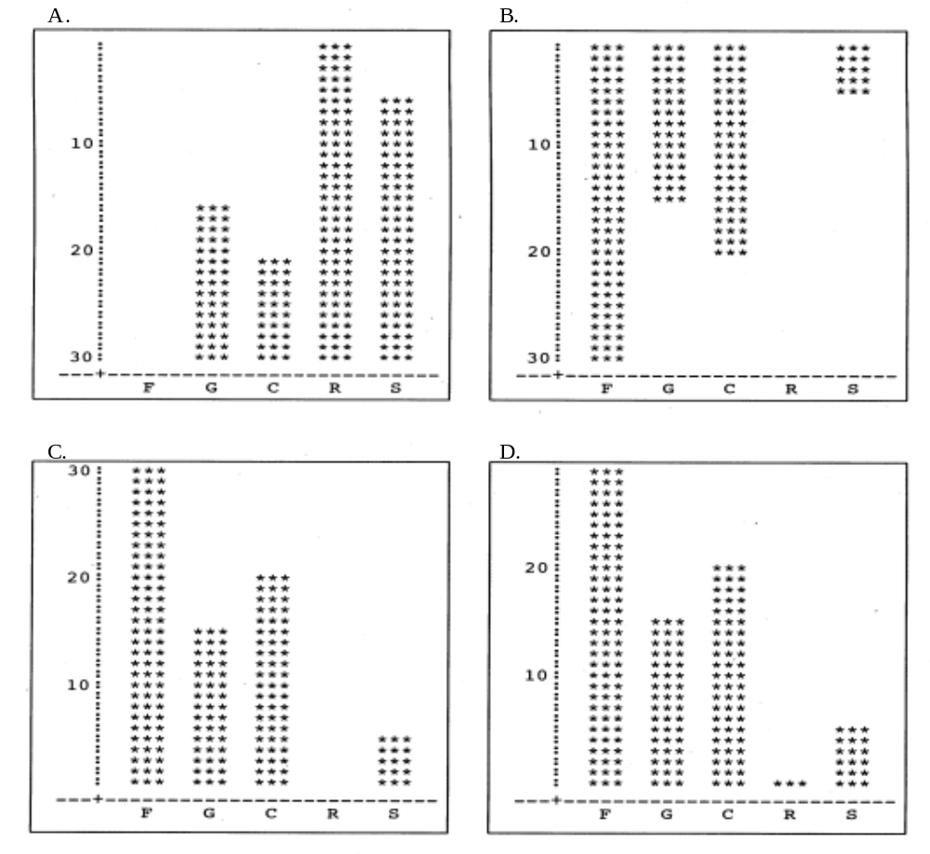
Q13. Carefully read the explanation of the following Fortran program, and then answer Sub-questions 1 through 3.
[Explanation of Program]
A survey on food preferences was conducted. This program determines the correlation coefficient for preferences among different foods and prints out the results.
(1) The number of respondents is between 2 and 100.
(2) The survey asked the respondents to rate how much they liked nine different foods on a scale from 1 to 10.
(3) Table 1 shows sample survey results. The survey results file contains each respondents number and the score they gave to each of the nine food items.
Table 1 Survey Results
Respondent No. | Food 1 | Food 2 | Food 3 | Food 4 | Food 5 | Food 6 | Food 7 | Food 8 | Food 9
001 | 5 | 3 | 7 | 6 | 8 | 2 | 7 | 2 | 5
002 | 10 | 3 | 7 | 10 | 10 | 3 | 6 | 4 | 6
003 | 7 | 3 | 1 | 7 | 4 | 2 | 7 | 9 | 2
Fortran
(4) The program calculates the correlation coefficient for preferences among food items as described below.
① Assuming the average score for food s as Hs, the scores that respondent n assigned to food j and food k as P_{nj} and P_{nk}, and the number of respondents as M, then C_{jk} is calculated as follows:
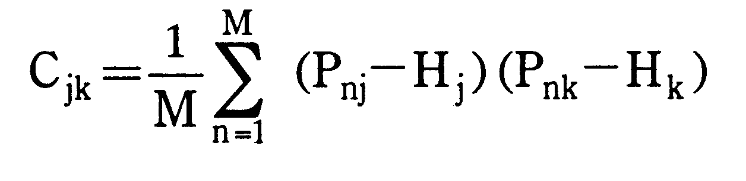

② The correlation coefficient R_{jk} for food j and food k is calculated according to the following formula. Assume that the values C_{jj} and C_{kk} are not zero.
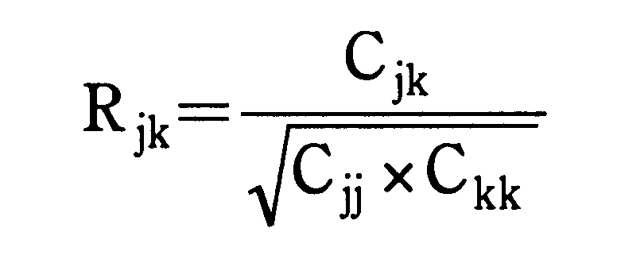

- Sample output results are shown below.

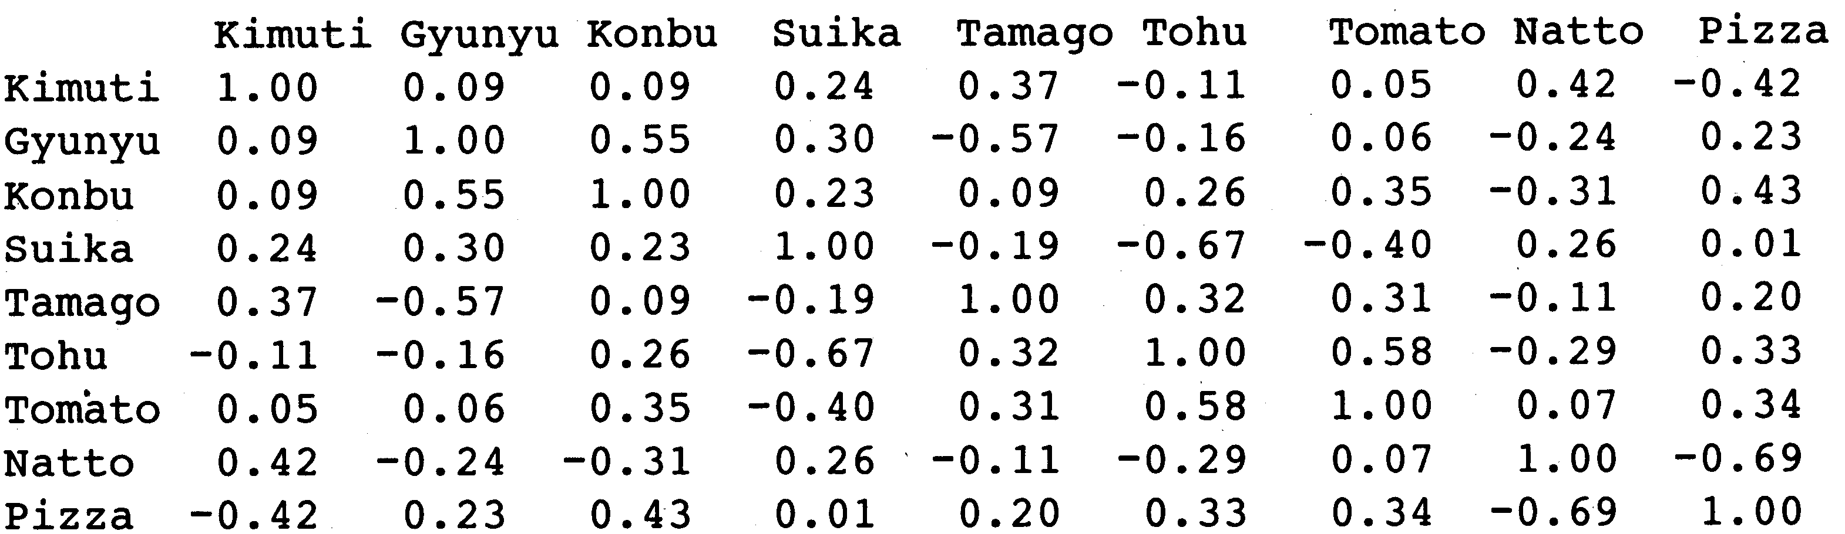

[Program]
Fortran
(Line number)
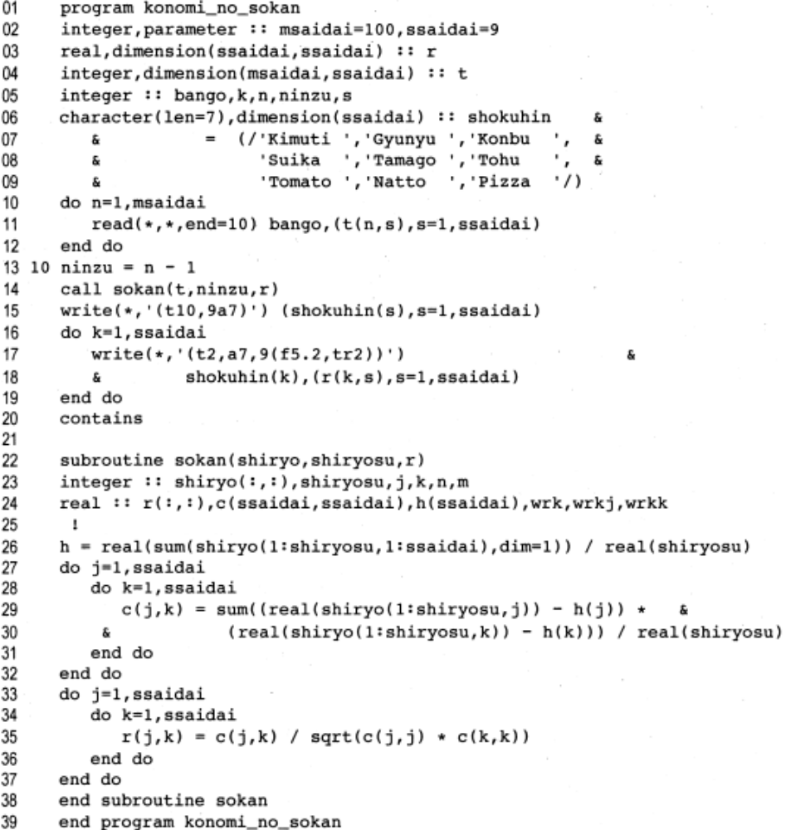
Sub-question 1. What would happen if data from 101 people was given to this program? Select the correct answer from the choices below.

Answer group

A. When data for the 101st and subsequent people is input, the data that will be discarded is undefined. Therefore, it will be unclear which respondents' data was used to calculate the correlation coefficient.
B. The calculation of the correlation coefficient will include the data from the 101st and subsequent respondents.
C. Because the data from the 101st and subsequent respondents will be stored outside the area that was allocated for the array, the results cannot be forecasted.
D. The correlation coefficient will be calculated on the basis the data from the last 100 respondents.
E. The correlation coefficient will be calculated on the basis the data from the first 100 respondents.
Fortran

Sub-question 2. Select the answer that will produce results equivalent to lines 27 through 32 in the program from the choices provided.
Fortran
Answer group
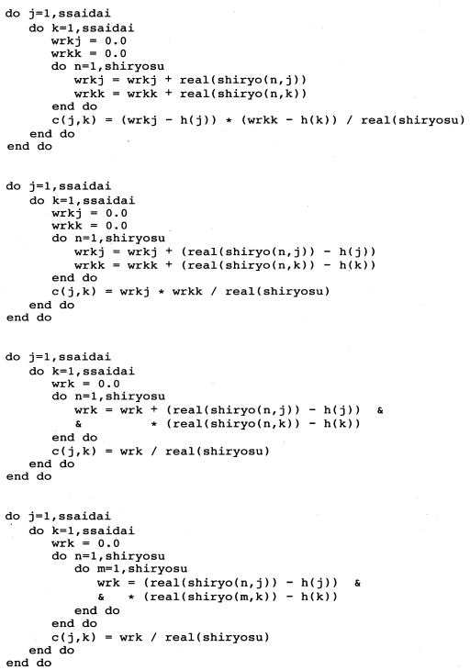
B.
A.
C.
D.

Sub-question 3. Assume that the two changes described below are made to the program. Select the correct answer to insert in in Table 2 from the choices provided.
(1) Assumes the correlation coefficient between the same food items is 1.0 instead of calculating it.
(2) Uses the symmetry of the result matrix to skip calculating the correlation coefficient for a combination of foods in which the items are simply reversed from an earlier pair, substituting the appropriate result instead.
Table 2 Program Changes
Position | After change
Line 28 | do k=l, j
Lines 32 to 36

Answer group
Fortran
B.
A.
C.
D.
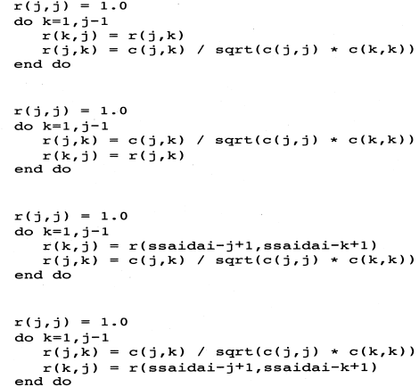

Q14. Carefully read the explanation of the following assembly language program and the program itself, and then answer Sub-questions 1 and 2.
[Explanation of Program]
The subprogram ADDP accepts two integers a and b (α≥0, b≥0) in BCD notation from the main program, and then calculates the sum of a and b in BCD notation.
(1) BCD notation expresses each digit of a decimal number as a four-digit binary number. For example, the decimal number 5973 would be expressed in BCD notation as follows:
Thousands digit Hundreds digit Tens digit Ones digit
5 9 7 3
↓ ↓ ↓ ↓
0101 1001 0111 0011

(2) a and b are both four-digit (16-bit) numbers. They are stored in GR1 and GR2 respectively, and are passed from the main program.

(3) An example of the execution of the subprogram ADDP is shown below.

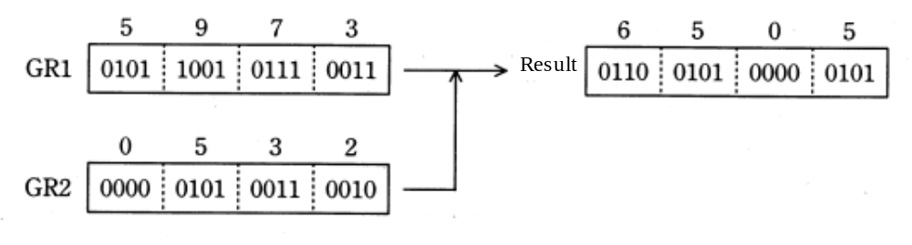
Fig. Sup-program ADDP Execution Example

(4) When control returns to the main program, the contents of the general-purpose registers GR2 and GR3 are returned to their original states.
Assembler
[Sub-program ADDP]
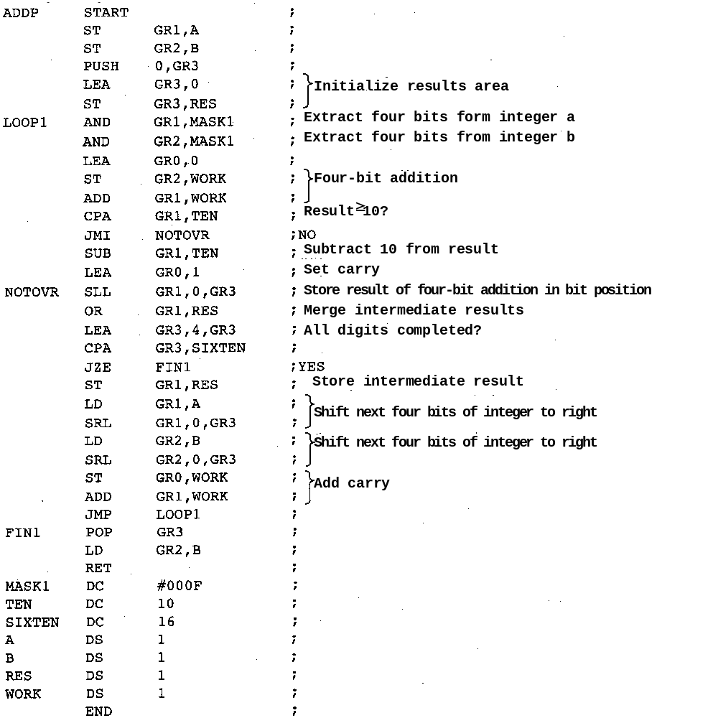
Assembler

Sub-question 1. Select the correct answer to insert in the in the following text from the choices provided.
If the contents of GR1 and GR2 passed from the main program are as follows, then after ADDP is executed the bit string a will be set in GR0 and the bit string b will be set in GR1 and passed back to the main program.
GR1 = 0101 0010 1001 1000
GR2 = 0100 1000 0101 0011

Answer group
Assembler
A. 0000 0000 0000 0000 B. 0000 0000 0000 0001
C. 0000 0001 0101 0001 D. 0100 1000 0101 0011
D. 0101 0010 1001 1000 E. 1001 1001 1001 1001
F. 1010 0001 0101 0001 G. 1111 1111 1111 1111

Sub-question 2. Using the sub-program ADDP, a sub-program CALC was created to perform a certain operation on two integers m and n expressed in BCD notation (and where m ≥0, n ≥ 0).
(1)m and n are stored in GR1 and GR2, respectively, and are passed from the main program.
(2)The operation result is stored in GR1.
(3) When control returns to the main program, the contents of the general-purpose registers GR2 and GR3 are returned to their original states.

The following table shows the values of m and n passed from the main program, the value in GR1 that is returned to the main program, and the number of times the sub-program ADDP was called. Note that all values shown in the table and in the answer group are given in decimal notation.
Select the correct answer to insert in in the table from the choices provided.
Table Correspondence of Each Value
Value passed from the main program |  | Value of GR1 returned from the main program | Number of times ADDP is called
m | n | Value of GR1 returned from the main program | Number of times ADDP is called
123 | 45 | c | d
51 | 3579 | e | f

[Sub-program CALC]
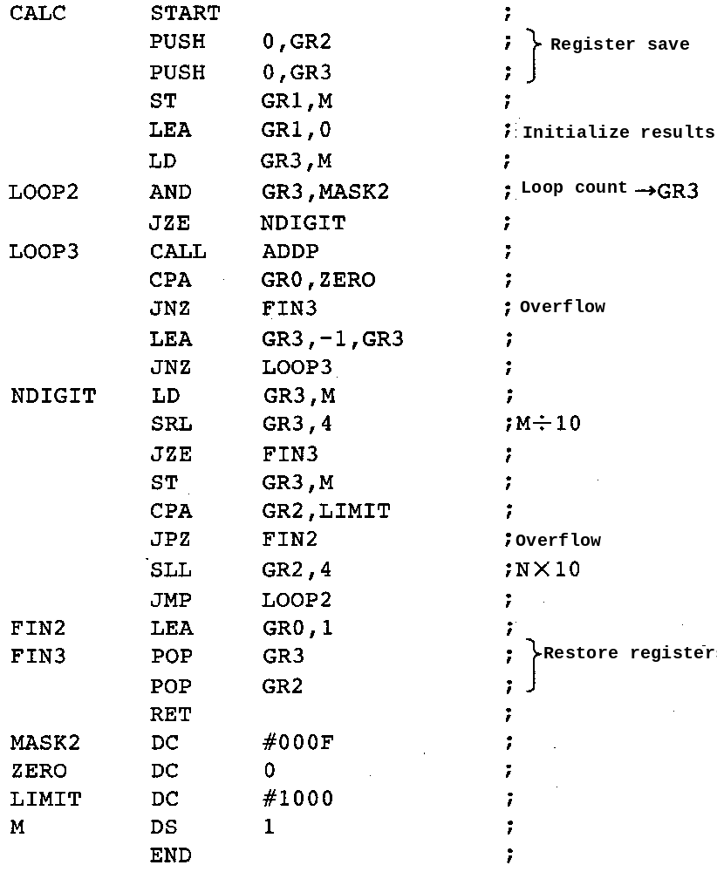
Answer group for c and e
Assembler
A. 0 B. 70 C. 78 D. 168
F. 737 G. 2529 H. 3528 I. 3579
J. 5535 K. 7158

Answer group for d and f
A. 0 B. 1 C. 2 D. 3
F. 6 G. 9 H. 45 I. 51
J. 123 K. 3579

Select one question from Question 15 to Question 17, and mark which question you have selected on your answer sheet. If you select two or more questions, only the first question will be graded.

Q15. Read the following description concerning internal design and then answer Sub-questions 1 through 3.
In the relational data base logic design stage, a normalized data structure is the data structure that data analysis leads to logically, but does not take into consideration how the data base will be used by the user or application program. Therefore, it is necessary to re-examine normalized data structures in the construction of data bases that are practical and efficient from a processing standpoint by considering how the data base will actually be used.
For example, if a table is integrated, integration processing is no longer needed when searching for data, reducing the amount of processing that must be performed, but this is offset by an increase in the processing that must be performed in order to maintain the consistency of duplicated data in the data base when the data is updated. When re-examining a data structure, it is sometimes necessary to confirm whether the table is one in which search processing is frequently conducted or not and whether the table is one that is frequently updated or not, and then to focus on eliminating normalization in those tables in which search processing is frequently conducted.
Company M is developing an order input system and is attempting to improve the efficiency of order input work. Company M has other work systems, and has decided to utilize data base tables that can be shared. The following tables are the result of data base logic design relating to order input work.
[Result of data base logic design]
(1) Customer table
Customer code | Customer name | Address | Telephone | State code
(2) Order table
Order number | Customer code | Order date | Delivery | Department code
(3) Order details table
Order number | Product code | Order quantity
(4) Product table
Product code | Product name | Unit price | Closing date
(5) Department table
Department code | Department name | Number of staff
(6) Region code table
Region code | Region name
(7) State code table
State code | State name | Region code
(8) Inventory table
Product code | Inventory quantity

The following tables are used only by the order taking system: customer table, order table, order details table, region code table, and state code table. In order taking work, for management purposes orders are divided into nine regions, and these regions are further divided according to their states.
The product table is updated once per week by the sales system.
The department table is updated once per year by the personnel system.
The inventory table is updated frequently by the inventory management system.
In order to better understand the processing involved in order taking and how each table is used, the company created the following table showing the relationships between processing and each table.
Relationships between Processing and Each Table
Processing name | Processing type | Frequency of processing | Table name
Processing name | Processing type | Frequency of processing | Customer | Order | Order details | Product | Department | Region code | State code | Inventory
Order taking | Online | 100 times/day | Ref | App | App | Ref | Ref | Ref | Ref | Updt
Order search | Online | 200 times/day | Ref | Ref | Ref | Ref | Ref | Ref | Ref | _
Customer search | Online | 130 times/day | Ref | Ref | _ | _ | Ref | Ref | Ref | _
Inventory search | Online | 150  times/day | _ | _ | _ | Ref | _ | _ | _ | Ref
Customer list output | Batch | 2 times/week | Ref | _ | _ | _ | _ | Ref | Ref | _
Customer table maintenance | Online | 20 times/day | App, Updt, Del | _ | _ | _ | _ | Ref | Ref | _
Ref: Reference; App: Append; Updt: Update; Del: Delete

Sub-question 1. If the company wants to intentionally reduce normalization and integrate two tables into one table in order to reduce integration processing, while also keeping mind the need to minimize increases in the amount of data, which two tables are the best candidates for integration? Select TWO answers from the choices provided.
Answer group
A. Customer table B. Inventory table C. Order table
D. Order details table E. Product table F. Department table
G. Region code table H. State code table

Sub-question 2. Order search processing generates the most processing requests in a day, and demands the fastest response time. Fig. 1 shows the order search results display screen. This screen is displayed when an order number is input.

Which data structure is the best candidate for re-examination in order to speed up the response time? Select the correct answer from the choices provided.

Order Search Results Screen

Product name | Quantity
 |  | ⬧
 |  | ⧫

Xx/xx/xxxx
Order No. Department name
Customer name
Region name State name
Order date Delivery

Fig. 1 Order Search Results Screen

Answer group
A. Add the state name to the data items in the customer table.
B. Add the state name and the region name to the data items in the customer table.
C. Add the customer name to the data items in the order table.
D. Add the customer name and the department name to the data items in the order table.
E. Add the product name to the data items in the order detail table.
F. Add the product name, unit price, and closing date to the data items in the order detail table.
Sub-question 3. Select the correct answer to insert in the in the following text from the choices provided.
Fig. 2 shows the customer search results screen that was designed for customer search processing. This screen is displayed when a customer code is input.
This screen displays the number of orders that were received from that customer's state in the previous month in the field "Previous month's orders" and the current number of customers in the customer's state in the field "Current number of customers."

Order number | Date of order | Delivery | Department name
 |  |  |  | ⬧
 |  |  |  | ⧫

Customer Search Results Screen
xx/xx/xxxx
Customer code Telephone
Customer name
Address
Region name State name
Number of orders

Previous month's orders Current number of customers

Fig. 2 Customer Search Results Screen
The company seeks to speed up the response to online queries by studying methods for calculating data items that can be derived from other data items.
The company studied the following three methods for calculating derivative data items:
(1) Calculation at the time of reference
Derivative data items are calculated at the time of reference. The results produced by these calculations are not stored in the data base.
(2) Calculation at the time of updating
Derivative data items are calculated when the data items from which they are derived are updated. The results produced by these calculations are stored in the data base.
(3) Asynchronous calculation
Derivative data items are calculated at some predetermined time, and are stored in the data base. Even if the data items from which they are derived are updated, the derivative data items are not recalculated.

The derivative data item "Previous month's orders" is a .
The derivative data item "Current number of customers" is b .

Answer group
A. calculated at the time of updating
B. calculated at the time of reference
C. calculated asynchronously

Ans: Đáp án Sub1 G, H, Sub2 B, Sub 3 a – C, b - A . Dễ thấy các bảng Region code và State code chỉ được dùng để tham chiếu trong các nghiệp vụ có số lượng bản ghi cố định có liên quan đến nhau bởi trường Region code. Chính vì vậy, khi kết hợp 2 bảng đó, chúng sẽ không làm tăng nhiều số lượng data theo thời gian.(Đáp án Sub 1 G,H). Phần 2, dễ thấy phần này nó tham chiếu 6 bảng theo thứ tự sau:
+ Order (1)
+ Order details (1)
+ Customer (2)
+ Department (2)
+ Product (2)
+ State code (3)
+ Region code (4)
Như vậy, ta thấy 2 bảng state và region được tham chiếu cuối cùng, làm tốn thời gian, do vậy ta sẽ đưa các trường state và region vào bảng customer. (Đáp án Sub2 B)
Phần 3 ta thấy giá trị của “Previous month's orders” được xác định theo 1 thời điểm xác định, do đó nó là tính toán không đồng bộ (Đáp án Sub3 a – C) còn “Current number of customers” được tính toán khi bảng Customer được update, do đó nó là tính toán khi update( Đáp án Sub3 b – A).

Q16. Read the following description of program design and then answer Sub-questions 1 and 2.
Company N is developing a program to perform job X that handles online transaction processing in real time. Fig. 1 shows the system configuration in which the job X program runs.

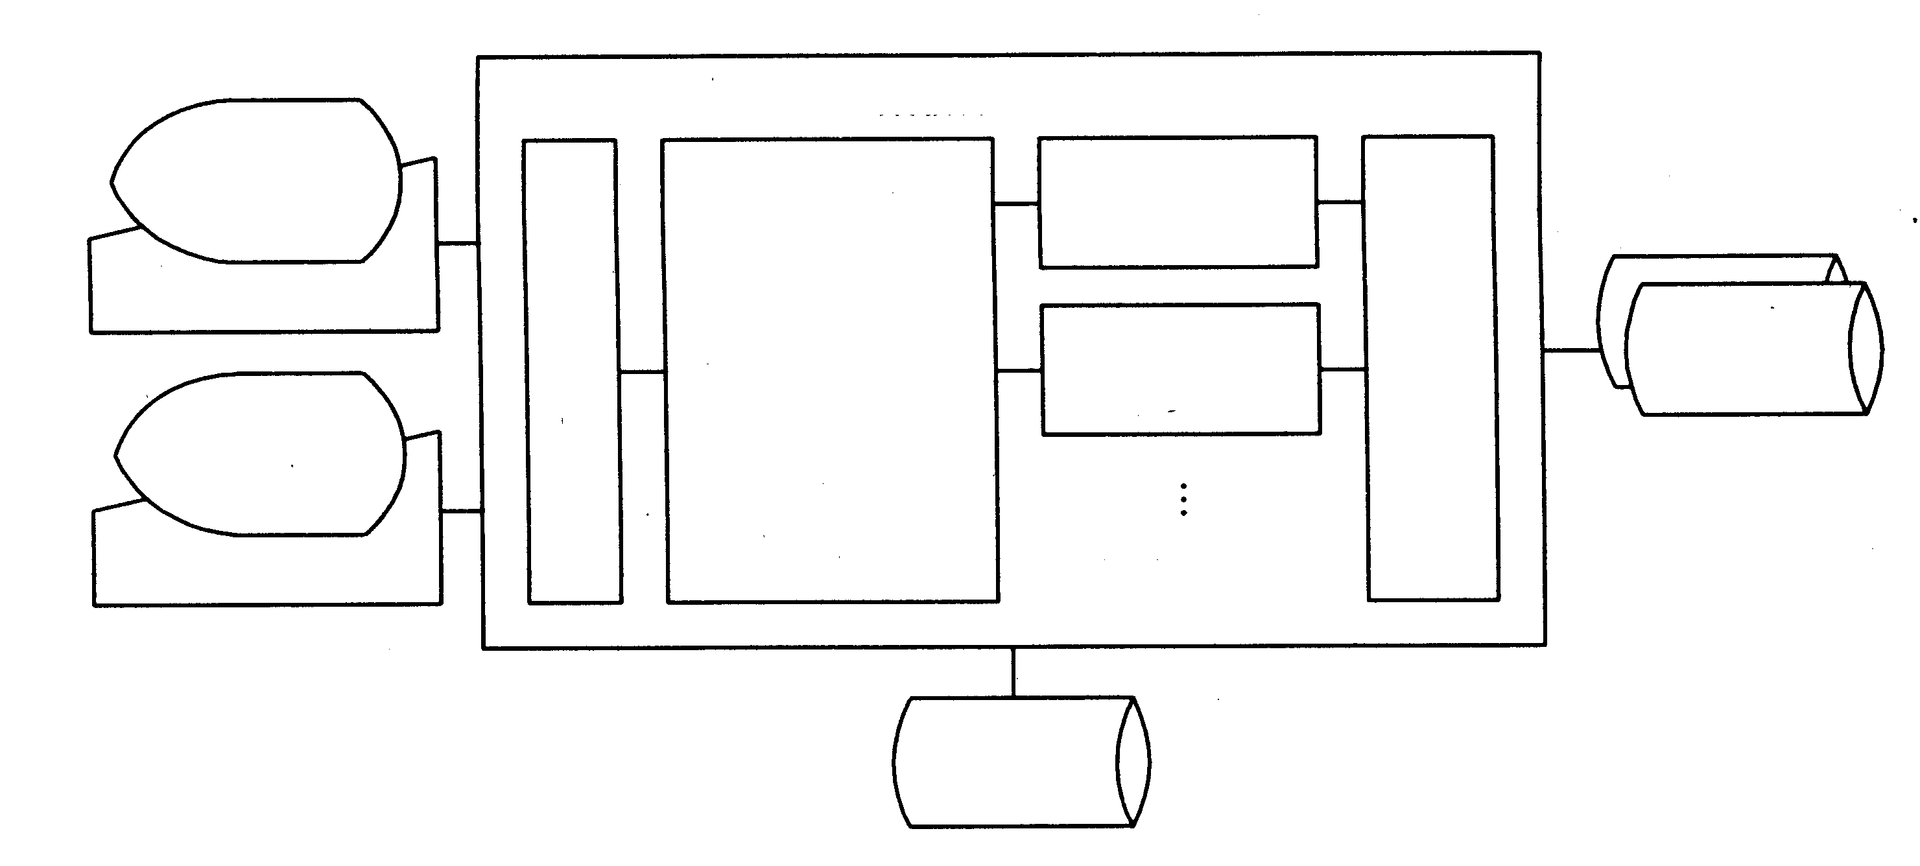
Server used for jobs
Database management program
Communications control program
Job X program
Terminal

Online control
program
Job Y program
Data base
Terminal

Log files
11) Fig. 1 System Configuration for Job X Program

Fig. 1 System Configuration for Job X Program
[Explanation of Flow of Transaction Processing]
(1) The online control program receives a message from a terminal through the communications control program.
(2) The online control program analyzes the message that it received and starts up the job program that is needed in order to perform the requested processing.
(3) If the job program in question requires any I/O transactions with the data base, it searches for the location where the required data is stored and performs read/write processing through the database management program.
(4) When the job program in question completes its processing, the online control program sends the response message from the job program to the terminal through the communications control program.

The following data bases and file are used by the job X program:
(1) Data bases
① Customer attribute data base
② Customer account data base
③ Special customer data base
(2) Log file

The data directory for the customer attribute data base is made resident in main memory by the database management program. Before reading records from the customer account data base and the special customer data base, input is required once from the disk in order to load the data directory. The log file is a sequential file, and must be output to the disk once per transaction.

[Overview of the Job X Program]
(1) The program reads the customer attribute data base, using as a key the customer code that is included in the message.
(2) If the corresponding customer record is not found in the customer attribute data base, the program generates an error message and terminates.
(3) If the corresponding customer record is found, the program edits the message using the items from the customer attribute data base.
(4) Using the message that it just edited, the program updates the customer's record in the customer account data base.
(5) If the items in the customer attribute data base include a flag that indicates that the customer is a special customer, the program uses the message that it just edited to also update the customer's record in the special customer data base.
(6) The program writes the log information in the log file.
(7) The program generates a response message and terminates.

Sub-question 1. Fig. 2 shows a flow chart for the job X program. Select the correct answer to be inserted in the in the flow chart when it is completed, selecting your answer from the choices provided.
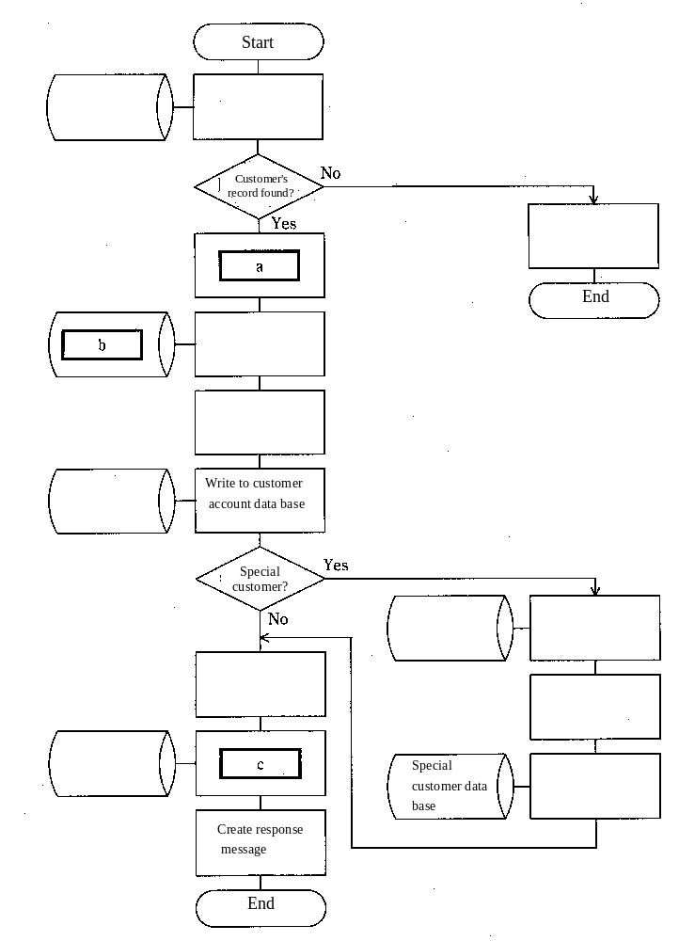
Fig. 2 Flow Chart for Job X Program
Answer group for a and c
A. Create error message.
B. Read customer attribute data base, using customer code as key.
C. Read customer account data base, using customer code as key.
D. Edit message using items from customer attribute data base.
E. Write to special customer data base.
F. Read special customer data base.
G. Use message to edit customer account record.
H. Use message to edit special customer record.
I. Create log information.
J. Write log information in log file.

Answer group for b
A. Customer attribute data base B. Customer account data base
C. Special customer data base D. Log file

Sub-question 2. Assume that the following table concerning disk I/O counts involving the file and data bases listed has been filled in for the case where a message concerns a special customer and no error occurs. Select the correct answers to be inserted in from the choices provided.

Table Table of Disk I/O Counts for Each Data Base and file
Data base/file name | Data directory input | Data base/file input | Data base/file output | Total
Customer attribute data base |  |  | 0
Customer account data base |  | 1
Special customer data base |  |  |  | d
Log file
Total |  |  |  | e
Answer group
A. 1 B. 2 C. 3 D. 4 E. 5
F. 6 G. 7 H. 8 I. 9
Ans: Đáp án Sub1 a – D, c – J, b-B Sub 2 d- C, e - H. Phần 1 từ sơ đồ luồng công việc ta dễ thấy a-D, c –J, b – B. Phần 2, ta thấy data directory input đều cần phải có trong trường hợp sử dụng các database, ta có bảng như sau:
Data base/file name | Data directory input | Data base/file input | Data base/file output | Total
Customer attribute data base | 1 | 1 | 0 | 2
Customer account data base | 1 | 1 | 0 | 2
Special customer data base | 1 | 1 | 1 | 3
Log file | 0 | 0 | 1 | 1
Total | 3 | 3 | 2 | 8

Như vậy tổng cộng trong sơ đồ luồng của chương trình ta thấy số lần cập nhật I/O sẽ là 8 lần. Đáp án Sub2 d – C, e-H.

Q17. Read the following description of a microcontroller-controlled fan and then answer sub-questions 1 through 3.

Fig. 1 shows the system configuration of the fan, and Table 1 lists the key functions of the fan. Table 2 describes the operating state transitions of the fan, indicating which operating state the fan will shift to from its current state when certain conditions are met. For example, if the ON/OFF button is pressed while the fan is in the "continuous operation" state, the fan will shift to the "off" state. Table 3 lists the LED lighting states for each operating state.

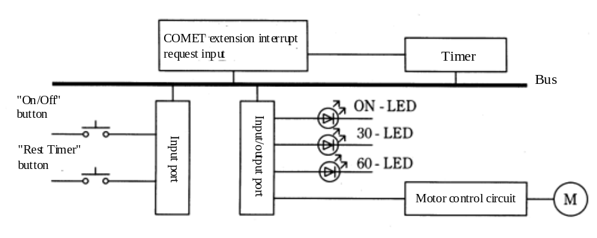
Fig. 1 Fan System Configuration

1Table 1. Button Functions
Button name | Function
On/Off | Switches between continuous operation and off.
Rest Timer | Sets/cancels the rest timer 30-minute mode and 60-minute mode settings.

1Table 2. Fan Operating State Transition Table
Operating state  Condition | Off | Continuous operation | 30-minute mode | 60-minute mode
"On/Off" button pressed | Continuous operation | Off | Off | Off
"Rest Timer" button pressed |  | 30-minute mode | 60-minute mode | Continuous operation
Rest timer remaining time = 0 minutes |  |  | Off
Rest timer remaining time = 30 minutes |  |  |  | 30-minute mode
Note: A blank space indicates a condition that is not possible or which has no effect.
Table 3. LED Lighting States for Each Operating State
Operating state | Off | Continuous operation | 30-minute mode | 60-minute mode
LED
ON-LED |  | On | On | On
30-LED |  |  | On
60-LED |  |  |  | On
A blank space indicates that the LED is off.

Sub-question 1. Table 4 explains the input/output port. This system allows the microcontroller to read data that is written to the input/output port. Select the correct answer to insert in in the text below from the choices provided.
When answering, note that in the case of the COMET extension, bit 0 is the MSB (most significant bit).

1Table 4. Explanation of the Input/Output Port
Bit No. | Connected to | Remarks
0 | ON - LED | 0: Off  1: On
1 | 30 - LED | 0: Off  1: On
2 | 60 - LED | 0: Off  1: On
3 | Motor control circuit | 0: Off 1: On
4~15 | Unused | Always "0"

In order to manipulate the bits in the input/output port, a program was written that reads the data in the input/output port, changes the target bit, and writes the new data back to the input/output port.
For example, in order to turn off the 30-LED and turn on the 60-LED, this program will AND the data from the input/output port with the hexadecimal value a and then OR the data with the hexadecimal value b , and then write the result back to the input/output port.

Answer group for a
A. 7000 B. B000 C. D000 D. E000 E. F000

Answer group for b
A. 1000 B. 2000 C. 4000 D. 6000 E. 8000

Sub-question 2. Fig. 2 shows a flow chart for the main program. From the choices provided, insert the correct answers in the in Fig. 2, assuming that interrupt processing has no effect on the program.

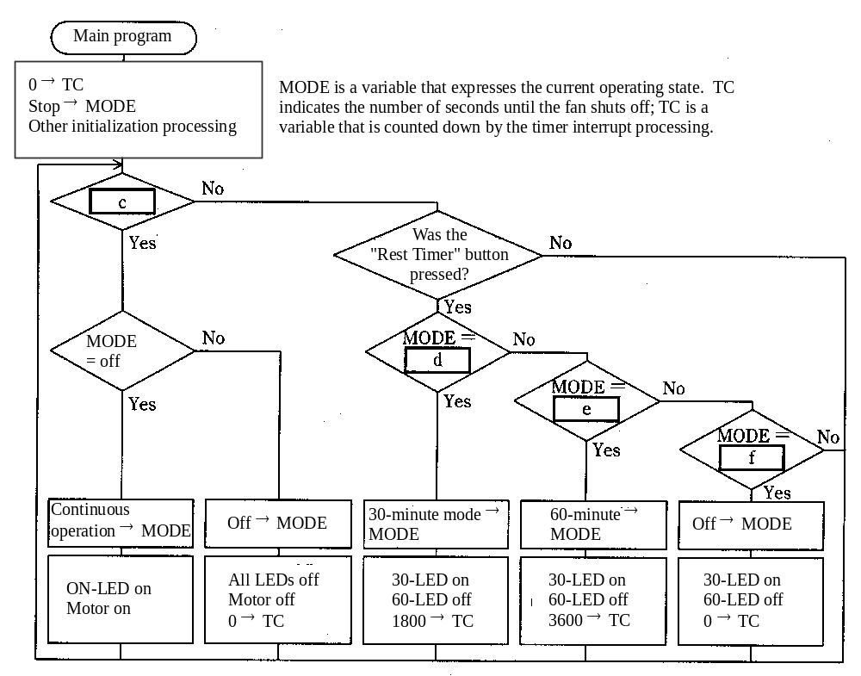
Fig. 2 Main Program Flow Chart
Answer group for c
A. Either button was pressed.
B. Neither button was pressed.
C. Both buttons were pressed.
D. "On/Off" button was pressed.
E. "On/Off" button was not pressed.

Answer group for d through f
A. 30-minute mode B. 60-minute mode
C. Off D. Continuous operation

Sub-question 3. Fig. 3 shows the flow chart for the timer interrupt processing. The timer interrupt is generated every 100ms. Select the correct answers to insert in the in Fig. 3 from the choices provided.

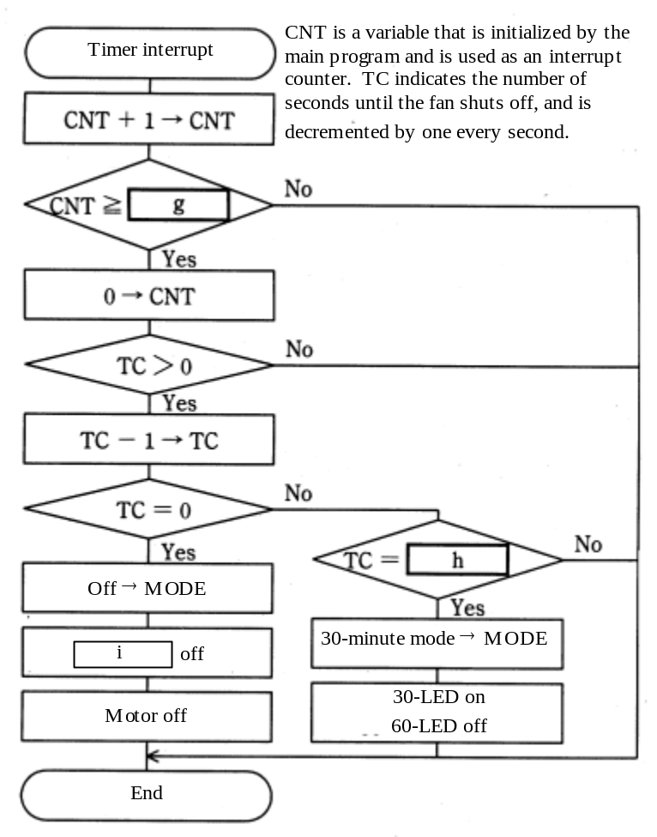
Fig. 3 Timer Interrupt Processing Flow Chart
Answer group for g
A. 6 B. 10 C. 60 D. 100 E. 1000
Answer group for h
A. 30 B. 60 C. 180 D. 1800 E. 3600
Answer group for I
A. 30 - LED B. 30 - LED and 60 - LED
C. 30 - LED and ON - LED D. 60 - LED
E. 60 - LED and ON - LED
Ans: Đáp án Sub 1 a- B, b – B; Sub 2 c – D, d – D, e – A, f – B Sub 3 g – B, h – D, I - cS. Với phần 1, giả sử ta có trạng thái bit i là x -> muốn bật bit thì ta sẽ OR với 1, tắt bit thì ta AND với 0, giữ nguyên bit thì ta AND với 1 hoặc OR với 0. Như vậy, ở đây ta cần thay đổi trạng thái input x₁x₂...x₁₆ , output là x₁01x₄0000...0. Số a ở đây sẽ là 1011000000000000 hay B000 còn b ở đây là 0010000000000000 hay 2000. Với phần 2, ta có c là đáp án D, nó là điều kiện kiểm tra xem quạt có bật không? d là đáp án D, từ chế độ chạy liên tục chuyển sang chế độ 30 minutes, e là đáp án A từ chế độ 30 minutes sang chế độ 60 minutes, f là đáp án B từ chế độ 60 minutes chuyển sang chế độ continues. Với phần 3, ta có CNT ở đây được đếm đến g thì sẽ khởi tạo lại và TC sẽ giảm đi 1 giây, vậy g ở đây tương ứng với 1 giây/100ms = 10. Đáp án B. TC ở đây được so sánh với h trước khi chuyển sang chế độ 30 minutes, vậy h ở đây chính là chuyển từ chế độ 60 minutes sang chế độ 30 minutes, hay h = 30 phút = 1800. Đáp án D. Còn I ở đây là chuyển từ chế độ 30 minutes sang chế độ OFF, cả đèn ON và 30-LED đều tắt. Đáp án C.

Assembly Language Specifications

1. COMET Hardware Specifications
1.1 Processor
(1) COMET is a one-word/16-bit computer, able to access an address space from 0 to 65535.
(2) The bit format of a word in the COMET computer is as follows:
Sign (Negative: 1, Positive: 0)
0 | 1 | 2 | 3 | 4 | 5 | 6 | 7 | 8 | 9 | 10 | 11 | 12 | 13 | 14 | 15
Bit No.

(3) Numeric values are expressed as 16-bit binary numbers. Negative numbers are expressed in two's complement.
(4) Control is sequential. COMET utilizes a two-word instruction word.
(5) The COMET has three types of registers: GR (16 bits), PC (16 bits), and FR (2 bits).
There are five GR (General Register) registers, GR0 through GR4. These five registers are used for arithmetic, logical, compare and shift operations. Of these, GR1 through GR4 are also used as index registers. GR4 is further used as the stack pointer.
The stack pointer is a register that is used to store the address currently at the top of the stack.
The PC (Program Counter) stores the first address of the instruction word that is currently being executed. Once the current instruction finishes executing, the first address of the next instruction word is set in the PC. Generally, when an instructions finishes executing, the PC is incremented by two by means of "address addition" (note); in the case of a branch, call, or return instruction, the new address to which control branches is set in the PC.
The FR (Flag Register) stores information on whether data stored in a GR register (as a result of executing a load address instruction or any of various arithmetic, logical, and shift operation instructions) is negative, zero, or positive, and also stores information resulting from the execution of a compare operation on the comparative size of two numbers.
In other words, the bits in the FR register can be set as shown in the following chart, depending on the result generated by certain operation instructions. (In the case of compare operations, however, refer to section 1.2(4), "Compare Operation Instructions.")
 | Data set in the GR register
 | Negative | Zero | Positive
Value of FR | 10 | 01 | 00

In the chart shown at right, when the sign bit in the GR register is "1," the value in question is negative. When all of the bits in the GR register are "0," the value is zero. When the sign bit in the GR register is "0," and at least one of the data bits is "1," the value in question is positive.
The first (leftmost) bit in the FR register shows the value in the GR sign bit. The second bit indicates whether the value in the GR register is zero or not.
The value in FR is referenced by conditional branch instructions.
The execution of instructions other than those mentioned above does not change the value in the FR register.
(6) Instruction word format
The COMET utilizes a two-word instruction word. The detailed format of instructions is not defined.
(7) Instruction notation
The following notation is used in the description of the instructions.
GR General-purpose register with the value of GR as its number (where 0 ≤ GR ≤4).
XR Index register with the value of XR as its number (where 1 ≤ XR ≤ 4).
SP Stack pointer (general-purpose register 4)
adr Label name (representing that corresponds to the label) or a decimal constant (where
–32768≤ adr ≤65535 ; adr can have a value from 0 to 65535, but the values from 32768 to 65535 can also be used to express negative decimal numbers).
Effective address A value produced by adding, through "address addition," adr and the contents of XR, or the address pointed at by that value.
(X) The contents of address X; if X is a register, then the contents of that register.
[ ] Square brackets ([ ]) indicate that the information contained in the brackets may be omitted.
If XR is omitted, modification by the index register is not performed.

(Note) "Address addition": Treats the data to be added as unsigned data; the result is the remainder that is obtained by adding the two values and then dividing the sum by 65536. (In other words, the result is the value of the 16 lower bits of the sum.) "Address subtraction" is defined in a similar fashion.
1.2 Instructions
Instructions and their functions are described in the following chart. Instructions are described in assembler notation.
Instruction | Format |  | Description of instructions
Instruction | Opcode | Operand | Description of instructions
(1) Load, store instruction
LoaD | LD GR,adr [,XR] | Sets (effective address) in GR.
STore | ST GR,adr [,XR] | Stores (GR) in the address indicated by  the effective address.
(2) Load address instructions
Load Effective Address | LEA GR,adr [,XR] | Sets the effective address in GR.  Sets FR in accordance with the value of GR.
(3) Arithmetic and logical operation instructions
ADD arithmetic | ADD GR,adr [,XR] | Performs the specified operation on (GR) and (effective address), and sets the result in GR.  Note that in the subtraction operation, (effective address) is subtracted from (GR).  Sets FR in accordance with the value of the operation result.
SUBtract arithmetic | SUB GR,adr [,XR]
AND | AND GR,adr [,XR]
OR | OR GR,adr [,XR]
Exclusive OR | EOR GR,adr [,XR]
(4) Compare operation instructions
ComPare Arithmetic | CPA GR,adr [,XR] | Performs an arithmetic compare or logical compare operation on (GR) and (effective address), and sets FR as follows, according to the result of the compare operation.
  Compare result | FR bit value
  (GR) > (effective address) | 00
  (GR) = (effective address) | 01
  (GR) < (effective address) | 10
ComPare Logical | CPL GR,adr [,XR]
(5) Shift operation instructions
Shift Left Arithmetic | SLA GR,adr [,XR] | Shifts GR (except for the sign bit) left or right by the number of bits specified by the effective address.  When a left shift is performed, those bits that are left vacant by the shift operation are filled with zeroes. When a right shift is performed, those bits that are left vacant by the shift operation are filled with the same value as the sign bit.  Sets FR in accordance with the value of the shift operation result.
Shift Right Arithmetic | SRA GR,adr [,XR]
Shift Left Logical | SLL GR,adr [,XR] | Shifts GR (including the sign bit) left or right by the number of bits specified by the effective address.  Those bits that are left vacant by the shift operation are filled with zeroes.  Sets FR in accordance with the value of the shift operation result.
Shift Right Logical | SRL GR,adr [,XR]
(6) Branch instructions
Jump on Plus or Zero | JPZ adr [,XR] | Branches to the effective address, depending on the value of FR. If control does not branch to a new address, execution continues with the next instruction.
Jump on MInus | JMI adr [,XR]
  Instruction | Value of FR in order to branch
  JPZ | 00, 01
  JMI | 10
  JNZ | 00, 10
  JZE | 01
Jump on Non Zero | JNZ adr [,XR]
Jump on ZEro | JZE adr [,XR]
unconditional JuMP | JMP adr [,XR] | Branches unconditionally to the effective address.
(7) Stack operation instructions
PUSH effective address | PUSH adr [,XR] | After subtracting (by means of "address subtraction") one from SP, this instruction stores the effective address in address (SP).
POP up | POP GR | After setting the contents of address (SP) in GR, this instruction adds (by means of "address addition") one to SP.
(8) Call and return instructions
CALL subroutine | CALL adr [,XR] | After subtracting (by means of "address subtraction") one from SP, this instruction stores the value resulting from adding (by means of "address addition") two to the current value of the PC in address (SP), and then branches to the effective address.
RETurn from subroutine | RET | After fetching the contents of address (SP), this instruction adds (by means of "address addition") one to the SP and then branches to the address that is indicated by the previously fetched contents. (The fetched contents are set in the PC.)

1.3 Character Set
COMET supports a JIS X0201 Romaji/katakana character set that uses 8-bit codes. Part of the character set is shown in the table below. If any characters not listed in this are needed to solve one of the problems, the bit configuration for that character will be given in the problem.
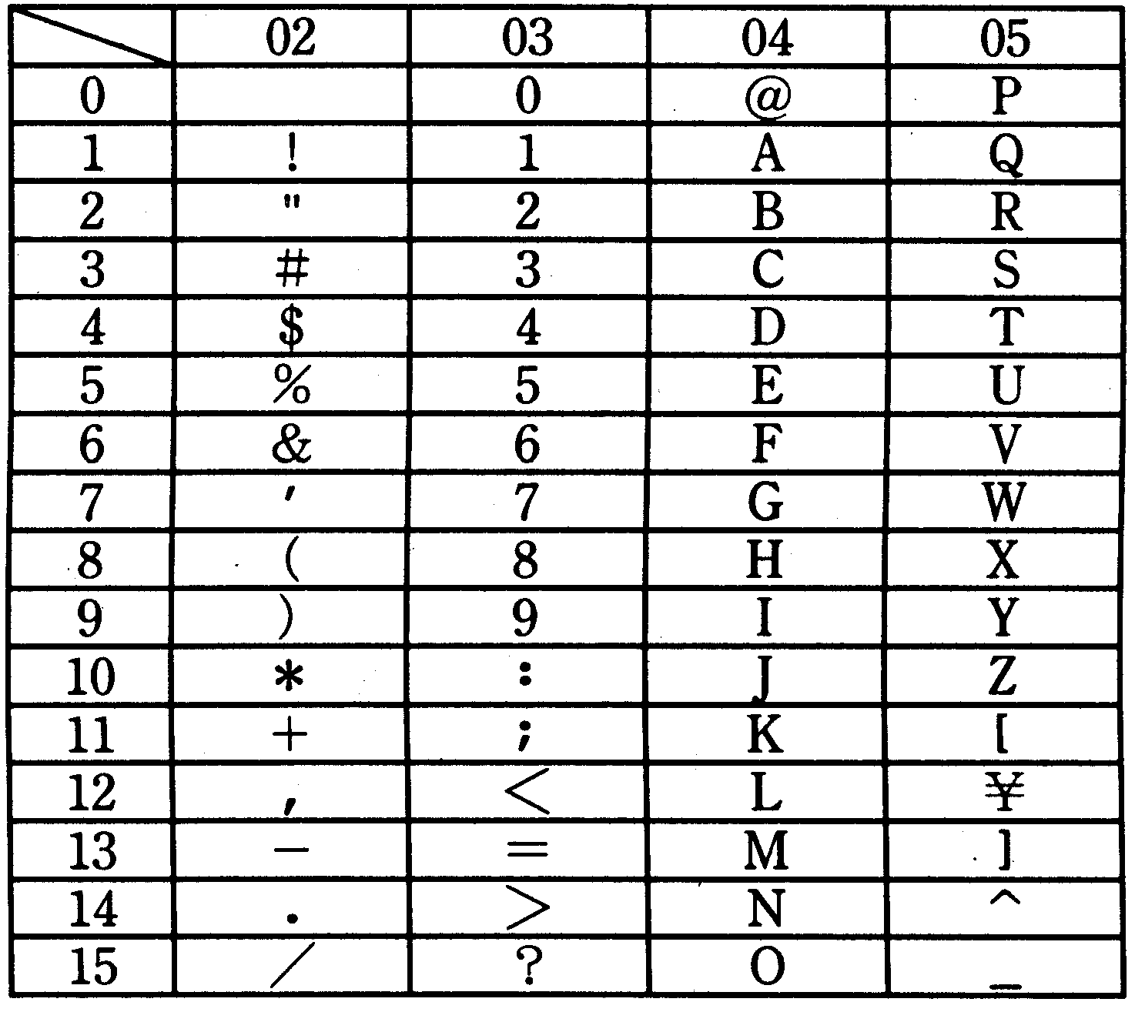
[Explanation of Table]
Column
Eight bits are used to represent one character; the upper four bits indicate the column in the table, and the lower four bits indicate the row. For example, the hexadecimal codes for the space character, "3," "F," and "Z" are 20, 33, 46, and 5A, respectively.
Row

Space
The characters that correspond to the hexadecimal codes 21 to 5F, 60 to 7E, and A1 to DF are called "graphics characters." This table omits the characters corresponding to codes 60 through 7E (defined as lower-case letters) and codes A1 through DF (defined as kana, etc.).
Graphics characters can be displayed (printed) as characters on an output device such as a monitor or a printer.
2. Specifications of the CASL Assembly Language
Assembly language for the COMET is called "CASL." The specifications for CASL are described below.
2.1 Instruction Types
CASL consists of four pseudo instructions (START,END ,DS,and DC),three macro instructions (IN, OUT,and EXIT) and machine language instructions (COMET instructions).

Pseudo instruction | Function
START | Defines the top of a program.  Defines the starting address for execution of a program.  Defines the entry for linking with other programs.
END | Defines the end of a program.
DS | Allocates an area.
DC | Defines a constant.

(1) Pseudo Instructions
Pseudo instructions are used for tasks such as assembler control, definition of constants, and creating data needed to link the program. The functions of the pseudo instructions are listed in the table at right.
(2) Macro instructions
Macro instructions use a pre-defined group of instructions and operand data to generate a group of instructions that performs a desired function.
CASL provides macro instructions for performing I/O, terminating a program, etc. Because machine language I/O instructions, etc., are not defined in CASL, such processing is left to the operating system. When a macro instruction is encountered, CASL generates a group of instructions that calls the operating system. Assume that the number of words in the group of instructions that is generated is undefined.
Macro instruction | Function
IN | Input
OUT | Output
EXIT | Terminates program execution.

When a macro instruction is executed, the contents of the GR registers are saved but the contents of FR are undefined.
The functions of the macro instructions are listed in the table at right
(3) Machine language instructions
There are 23 machine language instructions, as described in section 1.2, "Instructions."
2.2 Instruction Format
Pseudo instructions, macro instructions, and machine language instructions all have a label field, an opcode field, an operand field, and a comment field. Each field is defined below.
Label field The label consists of up to six characters, starting from the first character.
Opcode field ① When there is no label: Starts from the second or any other subsequent character position.
② When there is a label: Starts from any character position following at least one space
character after the label field.
Operand field Starts from any character position following at least one space character after the opcode field, up to the 72nd character. This field cannot be continued on the next line in the program.
Comment field When a semicolon (;) is encountered in a line, everything that follows until the end of the line is treated as a comment. (This does not apply to semicolons (;) encountered in a character string for a DC instruction, however.)
Note that if the first non-space character in a line is a semicolon, the entire line is treated as a comment.
Label | Instruction code | Operand | How to read
label | START | Execution start address | START
Blank | END | Blank | END
[label] | DC | Constant | Define Constant
[label] | DS | Length of area in words | Define Storage
[label] | IN | Input area,  input string length | INput
[label] | OUT | Output area,  output string length | OUTput
[label] | EXIT | Blank | EXIT
[label] | Machine language instruction (Refer to 1.2, "Instructions.")

Any character (that is allowed by the processing system) can be written in a comment field.

The format of each instruction in CASL is shown in the table at right.
When "blank" is indicated for a field, that field must not be described.

Specification by register symbol | General-purpose register number
GR0 | 0
GR1 | 1
GR2 | 2
GR3 | 3
GR4 | 4

(1) Register specification
In the operand field of a machine language instruction, the numbers 0 through 4 are used to specify a general register, but the symbols shown in the table at right can also be used.

(2) Label field
"label" in the label field represents a label. A label can consist of up to six characters; the first character must be an upper-case letter. Subsequent characters may be either upper-case letters or numbers. The labels assigned to DC, DS, IN, OUT, EXIT and machine language instructions indicate the address of the first word of the associated area or instruction word (or group of instructions, in the case of a macro instruction).
The label that is assigned to a START instruction can be referenced as an entry name from another program.

2.3 Pseudo Instructions
(1) START ⏐ [Execution start address]
This pseudo instruction indicates the top of a program. In other words, this pseudo instruction must be written at the very beginning of a program.
The label name that is defined within this program specifies the execution start address. If the label is omitted, execution begins at the start of the program.
(2) END
This pseudo instruction indicates the end of the program. This pseudo instruction must be written at the very end of the program.
(3) DC ⏐ Constant
This pseudo instruction stores constant data that has been specified as a constant. There are four types of constants: decimal constants, hexadecimal constants, character constants and address constants.

Type of constant | Format |  | Description of instruction
Type of constant | Opcode | Operand | Description of instruction
Decimal constant | DC | n | This instruction stores the decimal value specified by "n" as one word of binary data. If “n” is outside of the range of –32768 to 32767, just the lower 16 bits of n are stored.
Hexadecimal constant | DC | #h | Assume "h" is a four-digit hexadecimal number. (Hexadecimal notation uses 0 through 9 and A through F.) This instruction stores the hexadecimal value specified by "h" as one word of binary data. (0000 ≤ h ≤ FFFF)
Character constant | DC | 'character string' | This instruction stores each character in the character string, starting from the left end of the string, in the lower eight bits of consecutive words. In other words, the first character is stored in bits 8 through 15 of the first word, the second character is stored in bits 8 through 15 of the second word, and so on, so that the character data for each character in the string is stored sequentially in memory. Bits 0 through 7 of each word are filled with zeroes. Spaces and any of the graphics characters (refer to 1.3, "Character Set") can be written in a character string. Apostrophes (') cannot be written in character strings, however.  A character string can not have a length of zero (i.e., the character string cannot be empty).
Address constant | DC | Label name | This instruction stores an address value corresponding to the label name as one word of binary data. If the label name is not defined within this program, the assembler refrains from determining the address and entrusts that task to the operating system. (Refer to 3.1, "Undefined Labels.")
(4) DS Area word length
This pseudo instruction allocates an area of the specified word length.
The word length of the area is specified by a decimal number (≥ 0). If "0" is specified for the word length of an area, the area is not allocated, but the label name in the label field is valid.
2.4 Macro Instructions
(1) IN ⏐ Input area, input character length
This macro instruction inputs one record of data (character data) to the input area from a previously assigned input device. (For details on assigning an input device, refer to 3.1(3), "Input/output device assignment.")
Write label names for the input area and the input character length operands in the operand field.
The input area operand should be the label name of an 80-word work area (which is sufficient for 80 characters). The input data is input in this area (beginning at the starting address), one character per word. Zeroes are stored in bits 0 through 7 of each word (in the same manner as character constants with the DC instruction).
The length of the data that was input (the number of characters in the input record) is stored as binary data in the area (one word) specified by the input character length operand. No record delimiter code (such as a line return code, when using a keyboard) is stored.
If the input data is less than 80 characters long, the previous data (the data that was already there before this macro was executed) is left as is in the remaining portion of the input area. If the input data exceeds 80 characters, the excess characters are ignored.
"0" and "–1" are stored as the input character length in the following instances:
0: When inputting an empty record (for example, when only the return code was input from the typewriter terminal).
–1: When EOF (end of file) was detected (when using a card reader, etc.)
(2) OUT ⏐ Output area, output character length
This macro instruction outputs data stored in the output area as one record of data to the previously assigned output device. (For details on assigning an output device, refer to 3.1(3), "Input/output device assignment.") Write label names for the output area and the output character length operands in the operand field.
The output area operand should be the label name of the area where the data to be output is stored, one character per word (in the same manner as character constants with the DC instruction, except that bits 0 through 7 do not have to be zeroes). The output character length operand should be the label name of the area (one word) where the length of the data (the number of characters) that is to be output as one record is stored as binary data.
When the data is being output, the operating system will automatically insert any record delimiter code (such as a line return code, when outputting to a typewriter terminal) that may be needed. The operating system will also discard bits 0 through 7 of each word that is output.
(3) EXIT
This macro terminates program execution (and returns control to the operating system).
2.5 Relative Positions of Instructions and Areas
The relative positions of the instruction words and areas generated by the assembler conform with the order of the descriptions in the assembly language program. The instruction words and areas that are generated occupy a continuous area in main memory.
3. Guide to Using CASL
3.1 Operating System
The following arrangements exist between a user program and the operating system regarding program execution.
(1) Program startup
The program is started up by the operating system. Although the address where a program is stored is undefined, assume it is a location that places no hindrances on program execution, including the stack area described in (2).
(2) Stack area
During program startup, the operating system allocates a stack area, then adds (by using "address addition") one to the last address in the stack and sets that value in the SP. This area is used by the program as a stack.
Assume that adequate space has been allocated in the stack area for the needs of the program in the test problem.
(3) Input/output device assignment
The assignment of an input device to the IN instruction or of an output device to the OUT instruction is made by the operator before executing the program. Input/output devices include console display devices, typewriter terminals, card readers, and key punch devices.
(4) Input/output processing
The IN and OUT macro instructions are used to input and output data to and from the various input/output devices. The operating system handles all of the differences that may arise in input and output procedures due to the different media and devices involved; I/O is performed using the system’s standard procedures (including error handling) in a standard format. Therefore, the user of these macro instructions does not need to be concerned with differences among I/O devices.
(5) Undefined labels
Of those labels used in machine language instruction operands and those labels that are address constants for DC instructions, the assembler interprets any that are not defined within the program as START instruction labels for other programs (i.e., as entry names for other programs). In this case, the assembler refrains from determining the address and entrusts that task to the operating system. Before executing the program, the operating system performs link processing with the START instruction labels for other programs and determines the addresses (program linking).
3.2 Undefined Items
Assume that any items concerning program execution that are not defined in these specifications are handled by the processing system.

4. COMET Hardware Extension Specifications
4.1 Processor
The following functions are added to the COMET specifications.
(1) Interrupt function
① COMET has eight interrupt request lines; when an interrupt request signal on which an interrupt request was received falls, the interrupt request is retained.
② COMET has an interrupt mask function. When a bit in the MR (Mask Register) is "1," the corresponding interrupt request is masked. The correspondence between the bits in the MR register and the interrupt requests is as shown below.
0 7 15 ← Bit No.
Interrupt 0
Interrupt 7

③ Interrupts are enabled by executing the EI instruction, and are disabled by executing the DI instruction.
④ The meaning of each bit in the FR (flag register) is shown below.

Zero flag ("1" when the data that is set in GR is zero.)
Sign flag ("1" when the data that is set in GR is negative.)
Interrupt flag ("1" when interrupts are enabled, "0" when interrupts are disabled.)

Therefore, the flag register can have the following values, depending on the data that is set in GR and the interrupt status:
 | Data set in GR
 | Negative | Zero | Positive
Interrupts disabled | 010 | 001 | 000
Interrupts enabled | 110 | 101 | 100

⑤ When interrupts are enabled, interrupt requests are retained; if the corresponding bits in the MR are "0" (not masked), interrupt requests are accepted by priority.
(high priority) 0 > 1 > 2 > 3 > 4 > 5 > 6 > 7 (low priority)
⑥ When a retained interrupt request is accepted, it is cleared.
⑦ When an interrupt is accepted, interrupts are immediately disabled and the contents of the various registers are saved and updated according to the following sequence:
i. The contents of GR0 are saved in the address (SP)-1.
ii. The contents of FR are saved in the address (SP)-2 as follows:
0 13 15 ← Bit No.
All zeroes
FR value

iii. The contents of the PC are saved in the address (SP)-3.
iv. "3" is subtracted from SP by means of "address subtraction."
v. The contents of memory corresponding to the interrupt as shown below are stored in the PC.

Memory address
SVC instruction → | Address 6
Internal error → | Address 7
Interrupt 0 → | Address 8
Interrupt 1 → | Address 9
Interrupt 2 → | Address 10
Interrupt 3 → | Address 11
Interrupt 4 → | Address 12
Interrupt 5 → | Address 13
Interrupt 6 → | Address 14
Interrupt 7 → | Address 15

(2) The data bus has a parity bit. An even parity bit is added when writing data, and a parity check is made when reading data.
An internal interrupt caused by a parity error (an internal error) has a higher priority than all other interrupts, and is always generated in the event of a parity error, even if interrupts are disabled. The contents of the PC become the contents of address 7 in memory.
(3) I/O functions
① The I/O addresses that can be accessed range from address 0 to address 255. The I/O bus is shared with the memory bus; control signals are used to indicate whether the bus is being used for I/O or for memory.
② During I/O, when data is being transferred to the MPU, an even parity bit is added.
③ I/O addresses are output on the lower eight bits of the address bus; zeroes are output on the upper eight bits.
(4) Reset Function
If an external reset signal is input, the following occurs:
① Interrupts are disabled.
② All retained interrupt requests are cleared.
③ The value of FR is set to "0".
④ The contents of the interrupt mask register are set to #FF00 (hexadecimal).
⑤ Execution begins at address 0.

4.2 Additional Instructions
The instructions added to COMET and their functions are listed below. Instructions are described in assembler notation.
Additional instruction | Format |  | Description of additional instruction
Additional instruction | Opcode | Operand | Description of additional instruction
(1) I/O instructions
INPUT | INPUT I/Oadr | Inputs the contents of the I/O port indicated by I/Oadr to GR0. *
OUTPUT | OUTPUT I/Oadr | Outputs the contents of GR0 to the I/O port indicated by I/Oadr. *
(*) I/Oadr A label name or decimal number that indicates an I/O address (where 0 ≤ I/Oadr ≤ 255)

(2) Interrupt control
Enable Interrupt | EI | Interrupts are enabled immediately after executing this instruction.
Disable Interrupt | DI | Interrupts are disabled immediately after executing this instruction.
RETurn from Interrupt | RETI | Stores the contents of the address (SP) in the PC, the lower three bits of the contents of the address (SP) + 1 in FR, and contents of the address (SP) + 2 in GR0, and then adds three (by means of "Address addition") to the contents of the SP.

(3) Mask register control
LoaD Mask register | LDM GR | Sets the contents of MR in GR.  Writes zeroes in the lower eight bits of GR.
STore Mask register | STM GR | Sets the contents of GR in MR.  Ignores the lower eight bits of GR.

(4) Supervisor call
SuperVisor Call | SVC | Stores the contents of GR0 in the address (SP)-1, and stores the contents of FR in the lower three bits of the address (SP) -2. This instruction then adds two (by means of "address addition") to the current value in the PC, and then stores the result in the address (SP)-3. This instruction then subtracts three (by means of "address subtraction") from the contents of SP, and branches to the address pointed at by address 6.  Interrupts are disabled immediately after executing this instruction.

(5) Miscellaneous
No OPeration | NOP | Performs no operation.

(Reference) Sample Function Block Diagram for COMET
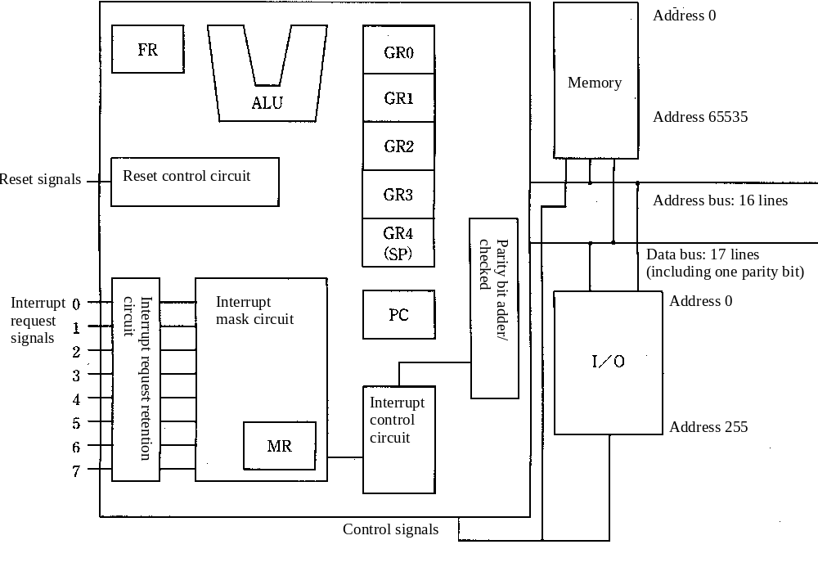
5. Extended Specifications of the CASL Assembly Language
The following pseudo instructions have been added to the CASL assembly language.
5.1 Additional pseudo instructions
(1) SECT
Description format: section-name SECT attribute
A section is defined as beginning with a SECT instruction and ending with either an END instruction or the last instruction prior to the next SECT instruction. Section names follow the label naming conventions, but a name that is used for a label name can also be used for a section name without generating an error. The attributes that can be specified are listed below. These attributes can be used by the operating system while the program is running.
CODE: Instruction area section
DATA: Data area section
STACK: Stack area section
If a portion of a program is not defined by a SECT instruction, it is assumed that the following instruction was specified: CODE SECT CODE
(2) START
Description format: START execution-start-address
The START instruction is described at the beginning of a section, and can only be used once in a program. The purpose of the START instruction is to indicate the execution start address of a program, which it does by means of a label name. If the START instruction is omitted, the top address of the program becomes the execution address.
(3) GLOBL
Description format: GLOBL label-name[, label-name, ..., label-name]
The CASL assembler assembles instructions in units called "modules." The GLOBL instruction is a pseudo instruction that is used to declare labels that can be referenced by other modules. Multiple label names can be written with the GLOBL pseudo instruction.
(4) EXTRN
Description format: EXTRN label-name[, label-name, ..., label-name]
The EXTRN instruction is a pseudo instruction that declares that the module will reference labels declared with the GLOBL pseudo instruction in other modules. Multiple label names can be written with the EXTRN pseudo instruction.
(5) EQU
Description format: label EQU constant
This pseudo instruction assigns the described constant (other than a character constant) to the specified label.
6. Assembler Function Extension
The following functions have been added to the CASL assembler.
6.1 Relocatable object program generation
This function outputs relocatable object programs that can be inputs for CASLLINK, described below.
6.2 Utilizing the Extended Specifications of CASL
Using CASLLINK, described below, allows you to take advantage of the extended specifications described in section 5., "Extended Specifications of the CASL Assembly Language."
6.3 Label Processing
If a label that is not declared by EXTRN and is not defined within the same module is encountered, an error is generated.
7. Linker CASLLINK Specifications
CASLLINK links multiple object programs created by the CASL assembler, determines their location addresses, and creates a single executable program.
7.1 Section Linking Method
(1) CASLLINK looks among multiple object programs for sections with the same attribute and the same name, and then links those sections.
(2) An error is generated if the START instruction appears more than once.
7.2 Assignment of Location Addresses
CASLLINK assigns location addresses to object programs according to the following rules:
(1) Location addresses can be specified for individual sections.
(2) CASLLINK calculates the location addresses after confirming the interrelationships among GLOBL labels and EXTRN labels in the linked sections.
(3) An error is generated if there are multiple GLOBL declarations of the same label name within the linked object programs.

(Reference)
A program that is created by CASLLINK can be executed through the operating system or as part of ROM.

